Unit 5
Reading Worksheet
5B6
Name No.: ______ Class: ________ Date: _____/ _____/ _____
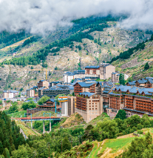
Read the texts.
Different sports-related holiday experiences

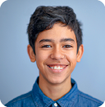

This year, my holidays were amazing! I had a great
time with two friends on a multisport activity holiday
in Andorra. We chose the programme Andorra: Hike,
Bike and Raft, so we joined a group of ten teens from
all over the world and an awesome Spanish guide,
Juan. We spent a week together doing extreme sports and exploring
the beautiful landscapes of Andorra. We visited the town of Soldeu,
we cycled along the trails of Port de Cabús, we trekked through the
Siscaro Reserve… But my favourite adventure was white-water rafting
through the Pyrenees because it was so thrilling and challenging! The
whole experience was just great with picnics in the wild and wonderful
sunsets. I loved the fact that it was so multicultural. I could practise
my Spanish and my French and I met new people. I would love to do it
again… Let’s see what my parents think about it…
Peter, 15 (London)

Claire
TEXT A

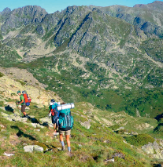

5

10

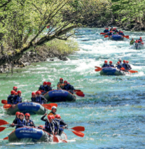

https://www.trailfinders.com/tours/europe/andorra/tour-andorra-hike-bike-and-raft
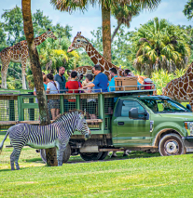
(abridged and adapted)

Tennis is my passion. I’ve played it since I was a child and my dream is to become a professional player. Therefore,
I asked my parents for a different holiday this year.
I joined a sports academy in Bradenton, Florida and
I had professional training for three weeks. I had two
training sessions per day, one in the morning and another one in the
afternoon, I could enjoy the campus and have fun with other athletes
for the rest of the day. I went on some excursions to the Busch Gardens,
the Disney Magic Kingdom and the Universal Studios in Orlando, but the
best part was my training sessions with expert coaches. The campus has
55 tennis courts and nutrition sessions for athletes! Isn’t that out of this
world? If you want to be a professional athlete, you need to practise hard
and have a lot of discipline while you’re having fun! I love tennis, so I’m
just hoping to come back next year!
Susan, 14 (New Jersey)
TEXT A



5

10



https://www.imgacademy.com/sport-camps/girls-tennis-camp
(abridged and adapted)

A. Read the titles below. Circle the numbers of the ones that best apply and then underline Text A or Text B.
1. Do you want to learn new languages? Andorra is waiting for you! Text A / Text B
2. Holidays and sports training: the perfect combination for athletes. Text A / Text B
3. Andorra: the ultimate experience for adventure lovers. Text A / Text B

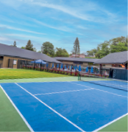
B. Tick (✔) the correct option(s).
Say who… Peter Susan
1. would like to repeat the experience.

2. went abroad on holiday.

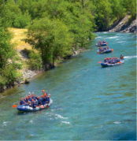
3. experienced nature and the wild.

4. thinks regular training and holidays are compatible.

C. Match the two halves to make true sentences.
1. Peter had a multicultural experience a) training with her coaches.

2. Andorra has b) because his group had people
from around the world.

3. Susan’s dream is c) to be a professional tennis player.

4. She loved d) fantastic places to visit and experience.

D. Tick (✔) the correct option to answer the questions.
1. What type of holiday did Peter go on?
a) Peter went on a visit to Andorra.

b) Peter went on a sports activity holiday in Andorra.

2. What was his favourite adventure?
a) Peter’s favourite adventure was having a picnic in the wild.

b) Peter’s favourite adventure was white-water rafting through the Pyrenees.

3. How many training sessions did Susan have every day?
a) Susan had two training sessions every day.

b) Susan had one training session in the morning.

4. According to her, why is the campus so amazing?
a) The campus is amazing because it has 55 tennis courts and nutrition sessions.

b) The campus is amazing because it offers many excursions.

