Name: ___________________________ Class: ______ No.: _____ Date: ______________________________
Teacher: _______________ Mark: ____________________ Enc. Educação: ____________________

Progress Test 1A – Year 8

I – Reading (20 minutes)

Read the blog posts below.

Summer holidays 2021: Did you pack your bags or did you stay put?
I was going on an interrail in Europe with my friends in the summer of 2020, but the pandemic situation didn’t allow it, so we decided to save money and do it in 2021. However, this summer we also had a “stay-cation”! There are so many nice places to visit in England. To be honest, my friends and I didn’t go on the interrail this year either because there is so much to discover around town. |  | We normally go on holidays to countries like Greece, Italy or Spain, but not this year. My family booked a holiday to Turkey and I had school trips to France and Spain, but they didn’t happen. I was so annoyed! But now I’m over it! I prefer to wait until it’s safer, so I spent summer with my cousins in the pool!
Carlos, 17 |  | Emilia, 14
I usually go to Spain on holiday with my family because we have relatives there. This summer we didn’t go due to the pandemic. I felt so frustrated about this situation and that we couldn’t enjoy summer as usual… But we have to make the best of every situation even when it seems impossible, so I took advantage of it to spend quality time with my family and instead of going abroad we travelled in the UK. |  | My family had plans to travel to Thailand in the summer of 2020, but there was absolutely no chance of doing that as we were stuck at home and there were strict restrictions. We thought we were going to do it in 2021, but we didn’t! In fact, this summer I didn’t do much! I just went to the beach in the first two weeks of August and saw my friends and family.
Luke, 12 |  | Natasha, 13

A. Match the pictures below with each teen’s post from above. Write their names under each.
Summer plans before the pandemic…
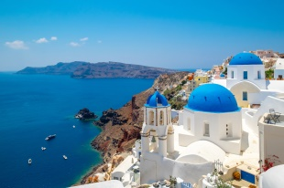
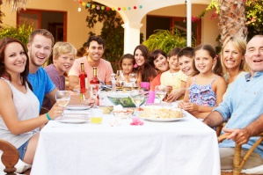
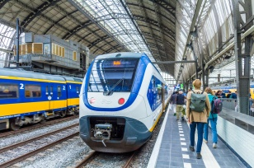


1. ________________ | 2. ________________ | 3. ________________ | 4. ________________

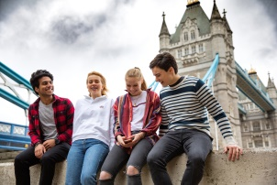
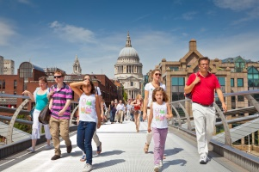
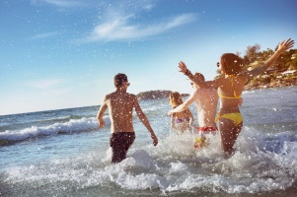
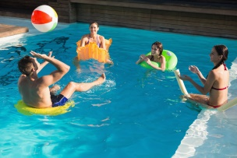
Summer holidays in 2021…

5. ________________ | 6. ________________ | 7. ________________ | 8. ________________

B. Tick () the correct option to complete the sentences about Carlos and Emilia.
1. Carlos and his friends didn’t go on an interrail in 2020, …
a) but they didn’t quit the idea and they wanted to do it the following year.
b) but they intended to do it later that year, as soon as the situation got better.
c) but they visited some countries in Europe.
2. They decided to stay in their country, since…
a) they were afraid of the restrictions.
b) they realised their country has many places to see.
c) they didn’t have enough money to go on the interrail.
3. Emilia’s school trips…
a) didn’t occur due to the pandemic.
b) were fantastic and the pandemic didn’t affect them.
c) changed to a different date.
4. She feels…
a) very annoyed now because she finds the restrictions exaggerated.
b) relieved now because the pandemic is over.
c) better now because being safe is what matters to her.

C. Answer the following questions according to the texts about Luke and Natasha’s posts.
1. Why does Luke usually go to Spain on holiday?
_____________________________________________________________________________
2. What was he frustrated about?
_____________________________________________________________________________
3. Where was Natasha planning to go in the summer of 2021?
_____________________________________________________________________________
4. When did she go to the beach?
_____________________________________________________________________________

II – Language (15 minutes)





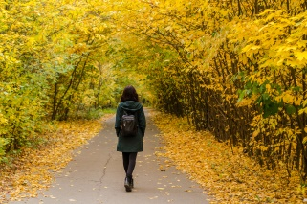
A. Looking for safe activities to do during a pandemic? Complete the leisure activities below.

1. going to _________ | 2. ________ out with _____ | 5. ________ the ______ | 6. going for a _______


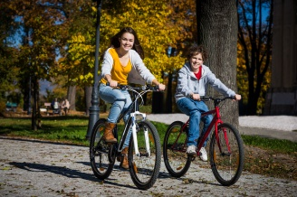


3. playing __________ | 4. going to a ___________ | 7. ________ a ______ | 8. __________ a book

B. Decide which answer – a), b), c) or d) – best fits each space.

Holidays
Most people enjoy going ¹ _________ for their holidays and having the opportunity to ² _________ time in an interesting city or appreciate different and astonishing scenery in the ³ _____________. You can ⁴_________ beautiful photos, go ⁵ ___________ and buy ⁶ ___________ to take home! Others prefer ⁷___________ holidays, where they can swim in the sea and get a ⁸ ___________. They go camping or stay at a holiday ⁹ ___________ with a ¹⁰ ___________ holiday.
And then there are others that…well, there are others that simply prefer to stay at home and relax!

1. | a) trip | b) abroad | c) foreign | d) travels
2. | a) spend | b) remain | c) stay | d) pass
3. | a) city | b) land | c) countryside | d) town
4. | a) have | b) make | c) give | d) take
5. | a) sightseeing | b) surfing | c) on a cruise | d) home
6. | a) ice creams | b) souvenirs | c) photographs | d) luggage
7. | a) winter | b) backpacking | c) hitchhiking | d) beach
8. | a) sunbathing | b) guided tour | c) tan | d) coach tour
9. | a) journey | b) resort | c) plane | d) campsite
10. | a) ecological | b) vacation | c) cultural | d) package

C. Choose the correct pronoun or determiner to complete the sentences.
- “Do you know much about football?”
“Actually, I / me / you am watching a documentary about its / his / her history at the moment.”
- “My grandparents live on the same street as they / you / your.”
“Really? Is the house with the lovely garden they / their / theirs?”
- My sister and I love it when we / our / ours mum makes pancakes for us / we / our.

D. Complete the dialogue with the present simple or present continuous of the verbs in brackets.
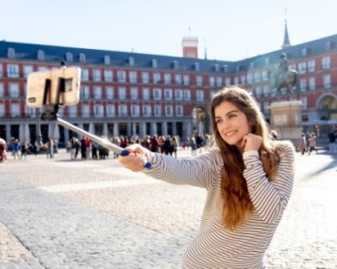
Carol: Hi, Emily!
Emily: Hello, sis! Where ¹ ____________________ (you / call) from?
Carol: I ² ____________________ (be) in Madrid at the moment.
Emily: ³ ____________________ (you / enjoy) yourself?
Carol: Yes, I ⁴ _______________________ (love) it here.
Emily: When ⁵ ____________________ (you / come) home?
Carol: Next Monday and I ⁶ _________________________ (need) you to do me a favour.
I ⁷ _________ (want) you to pick me up at the airport.
Emily: Oh! Does that mean you ⁸ ________________ (ask) me for another favour? I ⁹ ____________ (get) tired of doing you favours all the time!
Carol: I know! I’m sorry! It’s the last time, I promise!
Emily: All right. What time ¹⁰ ____________________ (your plane / arrive) in London?
Carol: It ¹¹ ____________ (leave) Rome at 11 o’clock and ¹² __________ (land) in London at 2 o’clock.

E. Fill in the gaps using the past simple or the past continuous of the verbs in brackets.

We ¹___________ (bake) a cake and then
we ²___________ (take) a selfie.
We ³_______________ (not bake) the carrot cake as planned, since while we ⁴___________ (do) it,
we ⁵_______________ (realise)
we ⁶___________ (not have) any carrots!

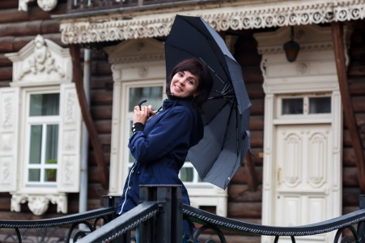



It ¹¹ _______________ (rain)
when she ¹² _______________ (go) out.
They ⁹___________ (hear) the news when they
¹⁰ _____________ (watch) TV.
She ⁷____________ (get) the idea while she ⁸______________ (read) a book.

III – Writing (15 minutes)
´
Write a blog post about:
Summer holidays 2021: Did you pack your bags or did you stay put?

Write 50-90 words about what you did last summer. Follow the guidelines below:
- refer to what you usually do in your summer holidays;
- say if you did the same or not in the summer of 2021 and explain why;
- say where you went in the summer of 2021; with whom; what you did.

_______________________________________________________________________________________________________________________________________________________________________________________________________________________________________
_______________________________________________________________________________________________________________________________________________________________________________________________________________________________________
_____________________________________________________________________________
_____________________________________________________________________________
_____________________________________________________________________________


Good work!
Your teacher

Year 8 – Progress Test 1A

Answer key

I – Reading
A. (8 x 1 = 8%)

1. Luke | 2. Natasha | 3. Carlos | 4. Emilia | 5. Luke | 6. Natasha | 7. Emilia | 8. Carlos

B. (4 x 2 = 8%)
1. a) | 2. b) | 3. a) | 4. c)

C. (4 x 4 = 16%)
1. Luke usually goes to Spain on holiday because he has relatives there. | 2. He was frustrated about the situation we’re living and because he couldn’t enjoy summer as usual. | 3. Natasha was planning to go to Thailand in the summer of 2021. | 4. She went to the beach in the first two weeks of August.

II – Language
A. (8 x 1 = 8%)

1. parties | 2. going/hanging…friends | 3. football | 4. concert | 5. surfing…net | 6. walk | 7. riding…bike | 8. reading

B. (10 x 1 = 10%)

1. b) | 2. a) | 3. c) | 4. d) | 5. a) | 6. b) | 7. d) | 8. c) | 9. b) | 10. d)

C. (6 x 1 = 6%)

1. I… its | 2. you…. theirs | 3. our… us

D. (12 x 1 = 12%)
1. are you calling | 2. am | 3. Are you enjoying | 4. love | 5. are you coming | 6. need | 7. want | 8. are asking | 9. am getting | 10. does your plane arrive | 11. leaves | 12. lands

E. (12 x 1 = 12%)

1. baked | 2. took | 3. didn’t bake | 4. were doing | 5. realised | 6. didn’t have | 7. got | 8. was reading | 9. heard |
10. were watching | 11. was raining | 12. went out

III – Writing
20%
Personal answer.

Alternative marking scheme

Per skill

I – Reading (100%)
A – 8 x 3 = 24%
B – 4 x 9 = 36%
C – 4 x 10 = 40%

II – Language (100%)
A – 8 x 2.5 = 20%
B – 10 x 2 = 20%
C – 6 x 2 = 12%
D – 12 x 1.5 = 18%
E – 12 x 2.5 = 30%

III – Writing (100%)
100%

