Name: ___________________________ Class: ______ No.: _____ Date: _____________________________
Teacher: _______________ Mark: ____________________ Enc. Educação: ___________________

Progress Test 1B – Year 8

I – Reading (20 minutes)

Read the blog posts below.
Summer holidays 2021: Did you pack your bags or did you stay put?
I was going on an interrail in Europe with my friends in the summer of 2020, but the pandemic situation didn’t allow it, so we decided to save money and do it in 2021. However, this summer we also had a “stay-cation”! There are so many nice places to visit in England. To be honest, my friends and I didn’t go on the interrail this year either because there is so much to discover around town. |  | We normally go on holidays to countries like Greece, Italy or Spain, but not this year. My family booked a holiday to Turkey and I had school trips to France and Spain, but they didn’t happen. I was so annoyed! But now I’m over it! I prefer to wait until it’s safer, so I spent summer with my cousins in the pool!
Carlos, 17 |  | Emilia, 14
I usually go to Spain on holiday with my family because we have relatives there. This summer we didn’t go due to the pandemic. I felt so frustrated about this situation and that we couldn’t enjoy summer as usual… But we have to make the best of every situation even when it seems impossible, so I took advantage of it to spend quality time with my family and instead of going abroad we travelled in the UK. |  | My family had plans to travel to Thailand in the summer of 2020, but there was absolutely no chance of doing that as we were stuck at home and there were strict restrictions. We thought we were going to do it in 2021, but we didn’t! In fact, this summer I didn’t do much! I just went to the beach in the first two weeks of August and saw my friends and family.
Luke, 12 |  | Natasha, 13

A. Choose the name that matches each picture.
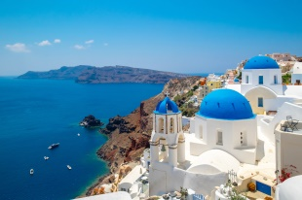
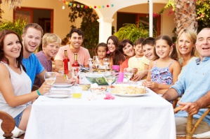
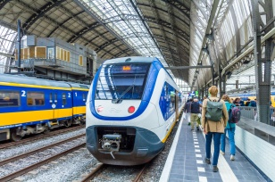

Summer plans before the pandemic…

1. Natasha / Luke | 2. Carlos / Natasha | 3. Emilia / Carlos | 4. Emilia / Luke

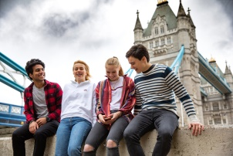
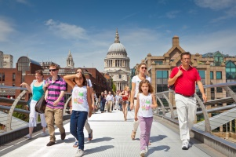
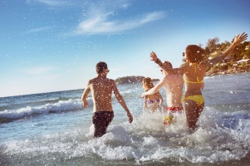
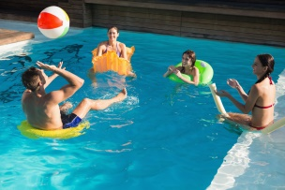
Summer holidays in 2021

5. Luke / Carlos | 6. Natasha / Emilia | 7. Emilia / Carlos | 8. Carlos / Luke
B. Tick () the correct option to complete the sentences about Carlos and Emilia.
1. Carlos and his friends didn’t go on an interrail in 2020, …
a) but they didn’t quit the idea and they wanted to do it the following year.
b) but they intended to do it later that year, as soon as the situation got better.
2. They decided to stay in their country, since…
a) they were afraid of the restrictions.
b) they realised their country has many places to see.
3. Emilia’s school trips…
a) didn’t occur due to the pandemic.
b) were fantastic and the pandemic didn’t affect them.
4. She feels…
a) very annoyed now, because she finds the restrictions exaggerated.
b) better now because being safe is what matters to her.

C. Complete the answers to the questions about Luke and Natasha’s posts.
1. Why does Luke usually go to Spain on holiday?
Luke usually goes on holiday to Spain because he has __________________________________.
2. What was he frustrated about?
He was frustrated about the situation we’re living and that we _______________________________.
3. Where was Natasha planning to go in the summer of 2021?
Natasha was planning to go to ___________________________________ in the summer of 2021.
4. When did she go to the beach?
She went to the beach in ___________________________________________________________.

II – Language (15 minutes)
A. Looking for safe activities to do during a pandemic? Choose the correct words to label the pictures.





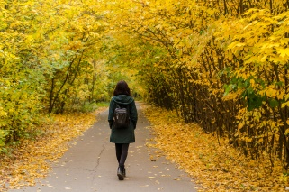

1. going to parties / the beach | 2. hanging out / surfing  with friends | 5. surfing / chatting  the net | 6. going for a  sightseeing / walk



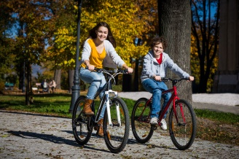


3. playing basketball / football | 4. going to a concert / cinema | 7. running / riding a bike | 8. listening / reading a book

B. Decide which answer – a) or b) – best fits each space.

Holidays
Most people enjoy going ¹ _________ for their holidays and having the opportunity to ² _________ time in an interesting city or appreciate different and astonishing scenery in the ³ _____________. You can ⁴_________ beautiful photos, go ⁵ ___________ and buy ⁶ ___________ to take home! Others prefer ⁷___________ holidays, where they can swim in the sea and get a ⁸ ___________. They go camping or stay at a holiday ⁹ ___________ with a ¹⁰ ___________ holiday.
And then there are others that…well, there are others that simply prefer to stay at home and relax!

1. | a) trip | b) abroad
2. | a) spend | b) stay
3. | a) city | b) countryside
4. | a) have | b) take
5. | a) sightseeing | b) surfing
6. | a) ice creams | b) souvenirs
7. | a) beach | b) backpacking
8. | a) sunbathing | b) tan
9. | a) journey | b) resort
10. | a) package | b) vacation

C. Choose the correct pronoun or determiner to complete the sentences.
- “Do you know much about football?”
“Actually I / me am watching a documentary about its / his history at the moment.”
- “My grandparents live on the same street as you / your.”
“Really? Is the house with the lovely garden their / theirs?”
- My sister and I love it when our / ours mum makes pancakes for us / our.

D. Choose the correct present simple or present continuous form of the verbs.
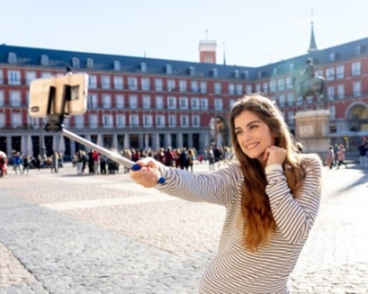
Carol: Hi, Emily!
Emily: Hello, sis! Where ¹ are you calling / do you call from?
Carol: I ² am / am being in Madrid at the moment.
Emily: ³ Do you enjoy/ Are you enjoying yourself?
Carol: Yes, I ⁴ love / loving it here.
Emily: When ⁵ do you come / are you coming home?
Carol: Next Monday and I ⁶ am needing / need you to do me a favour.
I ⁷ am wanting / want you to pick me up at the airport.
Emily: Oh! Oh! Does that mean you ⁸ are asking / ask me for another favour? I ⁹ get / am getting tired of doing you favours all the time!
Carol: I know! I’m sorry! It’s the last time, I promise!
Emily: All right. What time ¹⁰ your plane arrives / does your plane arrive in London?
Carol: It ¹¹ is leaving / leaves Rome at 11 o’clock and ¹² lands / is landing in London at 2 o’clock.

E. Choose the correct past simple or past continuous form of the verbs.
We ¹ baked / bake a cake and then we
² took / were taking a selfie.
We ³ weren’t baking / didn’t bake the carrot cake as planned, since while we ⁴ did / were doing it, we ⁵ realised / were realising we ⁶ didn’t have / weren’t having any carrots!
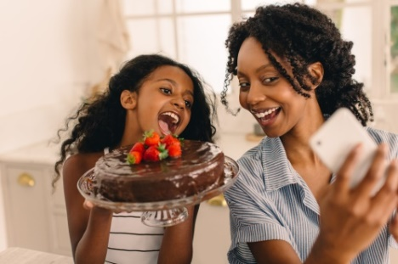


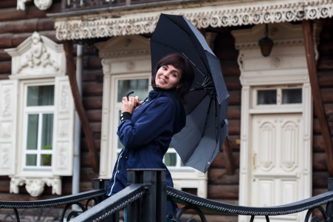


She ⁷ got/ was getting the idea while she ⁸ was reading / read a book.
It ¹¹ rained / was raining when she ¹² went / was going out.
They ⁹ were hearing / heard
the news when they
¹⁰ watched / were watching TV.

III – Writing (15 minutes)

Complete a blog post about:
Summer holidays 2021: Did you pack your bags or did you stay put?
Write 50-90 words about what you did last summer. The guidelines in brackets will help you.

In my summer holidays I usually ______________________________________________________ (refer to what you usually do in your summer holidays).
This year I __________________________________________________________________________
__________________________________________________________________________________ (say if you did the same or not in the summer of 2021 and explain why).
In the summer of 2021 I went to ______________________________________________ (say where you went in the summer of 2021) with ______________________________ (with whom).
I _________________________________________________________________ (what you did).


Good work!
Your teacher

Year 8 – Progress Test 1B

Answer key

I – Reading
A. (8 x 1 = 8%)

1. Luke | 2. Natasha | 3. Carlos | 4. Emilia | 5. Luke | 6. Natasha | 7. Emilia | 8. Carlos

B. (4 x 2 = 8%)
1. a) | 2. b) | 3. a) | 4. b)

C. (4 x 4 = 16%)
1. relatives there. | 2. we couldn’t enjoy summer as usual. | 3. Thailand | 4. the first two weeks of August.

II – Language
A. (8 x 1 = 8%)

1. parties | 2. hanging out | 3. football | 4. concert | 5. surfing | 6. walk | 7. riding | 8. reading

B. (10 x 1 = 10%)

1. b) | 2. a) | 3. b) | 4. b) | 5. a) | 6. b) | 7. a) | 8. b) | 9. b) | 10. a)

C. (6 x 1 = 6%)

1. I… its | 2. you… theirs | 3. our… us

D. (12 x 1 = 12%)

1. are you calling | 2. am | 3. Are you enjoying | 4. love | 5. are you coming | 6. need | 7. want | 8. are asking | 9. am getting | 10. does your plane arrive | 11. leaves | 12. lands

E. (12 x 1 = 12%)

1. baked | 2. took | 3. didn’t bake | 4. were doing | 5. realised | 6. didn’t have | 7. got | 8. was reading | 9. heard |
10. were watching | 11. was raining | 12. went

III – Writing
20%
Personal answer.

Alternative marking scheme

Per skill

I – Reading (100%)
A – 8 x 3 = 24%
B – 4 x 9 = 36%
C – 4 x 10 = 40%

II – Language (100%)
A – 8 x 2.5 = 20%
B – 10 x 2 = 20%
C – 6 x 2 = 12%
D – 12 x 1.5 = 18%
E – 12 x 2.5 = 30%

III – Writing (100%)
100%

