Name: ___________________________ Class: ______ No.: ___ Date: __________________________________________
Teacher: _______________ Mark: ____________________ Enc. Educação: _____________________________

Progress Test 2A – Year 8

I – Reading (20 minutes)

Read the magazine article below.

Should the government tell you what to eat?
First schools banned chocolate and fizzy drinks. Now they’re banning burgers, chips and chicken nuggets, too. School lunches will be healthier from now on.
1.

Too much junk food, like chips and chicken nuggets, and too little exercise causes obesity. One in three children under 16 in the UK is either overweight or obese. The government wants to change the nation’s eating habits.
2.

“Schools must provide more fruit and vegetables, and food with less fat, salt and sugar. We must reduce obesity and protect our children’s health. Children can learn to like healthy food,” they say.
3.

The cooks say the new rules are too strict. They say school meals will cost more and students will stop buying them. “Students will just go out to fast food shops at lunch time,” they say.
4.

YES, maybe…
Chloe: “It will depend on how the food looks. When I see the food in our canteen, I just want to go out a search for the nearest sandwich. But if you have better option, I think it may work.”
Clare: “I think people need better education about what they eat. People just eat pasta and rice the whole time, even when they’re not doing anything. They must learn about calories.”
NO:
Finn: “People will say they will go to the town to buy lunch. I’m not spending my money in the canteen.”
Lauren: “The idea of boiled fish with mashed potatoes will make students run away from the canteen.”
Oliver: “I think I prefer to eat a snack for lunch and then have a great dinner at home to eating spinach and broccoli for lunch.”
Team, Mary Glasgow (abridged and adapted, accessed in September 2021)

A. Write the questions below in the correct place in the article above.

What does the government say?
What do the students say?
Why is this happening?
Who doesn’t like it?

B. Tick () the wrong ending.
1. With the changes made in school menus, the government wants to…
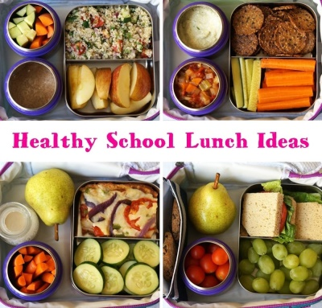
a) encourage students to eat more often in the canteen.
b) provide the students with healthier diet options.
c) prevent students from eating junk food.
2. The school menu must…
a) include more nutritional food such as vegetables and fruit.
b) reduce the amount of salt, fat and sugar.
c) have food with no salt, fat and sugar at all.
3. According to the cooks, …
a) the government’s rules may be a bit exaggerated.
b) the new rules will reduce the cost of a meal as well as its quality.
c) the meals will be more expensive.

C. Complete the sentences according to the article.
1. The causes of obesity are __________________________________________________________.
2. As for the cooks, students __________________________________________________________.

D. Answer the questions. Write complete answers.
- According to Chloe, which aspect is essential to make you want to eat in the canteen?
_____________________________________________________________________________
- In Clare’s opinion, what do people need to know when it comes to their diets?
_____________________________________________________________________________
- Where does Finn think people will have lunch?
_____________________________________________________________________________
- What kind of menu do students hate, according to Lauren?
_____________________________________________________________________________

II – Language (15 minutes)
A. What’s on and off the menu? Label the food and drink. The first letter is given.
OFF THE MENU
ON THE MENU
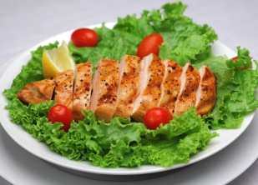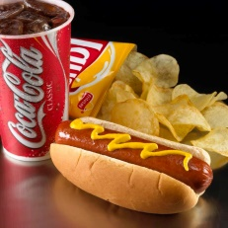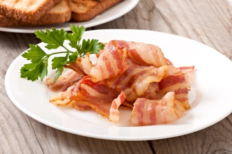

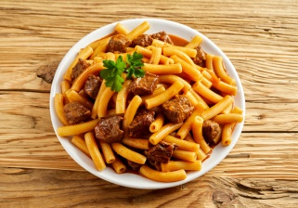1. c_________ and s_________ 5. h____ d____, c______ and f_____ drinks

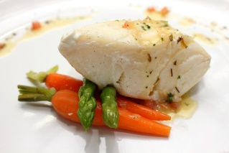2. m_____________ with p_________ 6. b ________

3. f______ with c__________ 7. i_______ c________
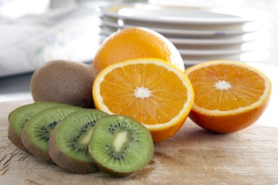
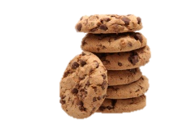
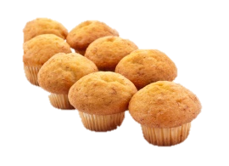

4. Fruit: o__________and k______ 8. b ________ and m___________

B. Look at these pictures. Choose the correct food-related adjectives to make correct phrases.
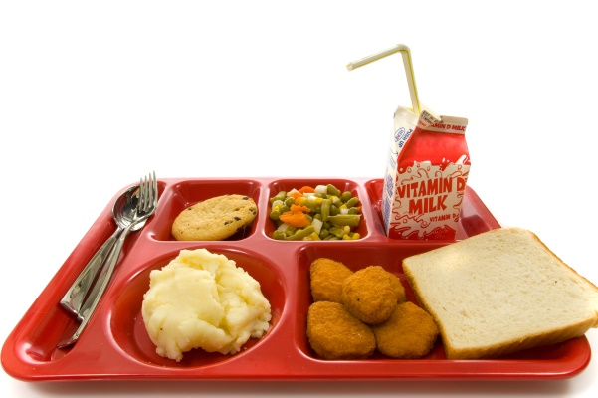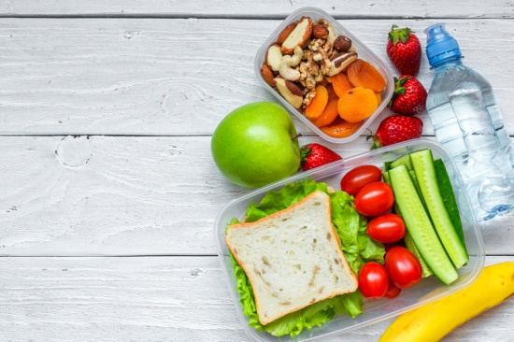
1. sweet / bitter / burnt cookie
2. healthy / fattening / greasy veggies
3. fried / mashed / boiled potatoes
4. fatty / sweet / raw nuggets
8. smoky / frozen / fresh tomatoes
5. salty / juicy / frozen apple
7. tasty / oily / hot sandwich
6. acid / full / dry fruits

C. Complete the sentences with the correct form of used to and a verb from the box.
drink eat follow do bring
- Oscar __________________ pizza and lasagna at school, but not anymore.
- When I was young, I __________________ a packed lunch to school.
- My parents __________________ (not) a strict diet, but now they are very healthy.
- _______ you __________________ cola or juice for lunch at school?
- We __________________ (not) any exercise, but now we go to the gym twice a week.

D. Choose the correct quantifier to complete the sentences.
- How many / How any / How much / pasta have we got?
- I put any / many / some chocolate somewhere, but where is it?
- I’m afraid we haven’t got much / many / a little time.
- You bought too much / many / some pizzas.
- There are any / a few / a little eggs in the fridge. Can you bring them?

E. Complete the sentences by choosing the correct expression of quantity.
- When you go shopping, don’t forget to buy a _____ of bread. (cup / dozen / loaf)
- I like to have a _____ of coffee for breakfast. (cup / box / bag)
- I’m thirsty! I need a ______ of water! (slice / bunch / bottle)
- Please put the _____ of milk in the fridge! (can / dozen / carton)
- Could we have another ____ of rice, please? (bowl / slice / piece)

F. Look at the picture. Fill in the gaps with should / shouldn’t.
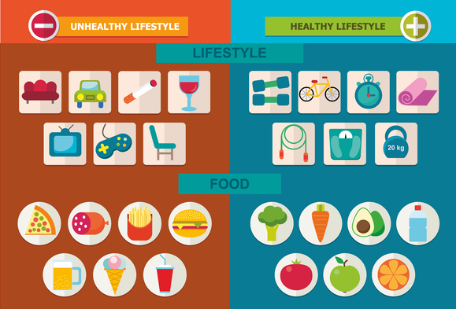
1. You ____________ sit on the sofa all day.
2. You ____________ smoke or drink alcohol.
3. You ____________ drink more water.
4. You ____________ play video games for too long. You ____________ do exercise instead.
5. You ____________ eat vegetables, but you __________ eat pizza or burgers all the time.
6. You ____________ sleep well.

G. Choose the correct modal verbs to make correct sentences.
- Schools would / could / mustn’t offer cooking lessons to parents and their children after school.
- Mum, must / may / would I go to the gym class with Jackie today?
- To be healthy you may / might / must eat well, but you couldn’t / mustn’t / might not forget physical exercise.
- Would / May / Could you like something for dessert, sir?
- When I was your age, I could / can / should run and climb trees, but now I’m not able to!

III – Writing (15 minutes)

Write an article (50-90 words) for a teen magazine with the title:
Should the government tell me what to eat?
Follow the guidelines below:
  - start with your opinion about school lunches in your country and the influence the government has on them;
  - say if you agree with the government’s choices for your school’s menu;
  - say where you have lunch and why;
  - give your opinion about lunch in your own school’s canteen (what’s the best and the worst food/drink on the menu).

_______________________________________________________________________________________________________________________________________________________________________________________________________________________________________
_______________________________________________________________________________________________________________________________________________________________________________________________________________________________________
_____________________________________________________________________________
_____________________________________________________________________________
_____________________________________________________________________________
__________________________________________________________________________________________________________________________________________________________

Good work!
Your teacher

Year 8 – Progress test 2A
Answer key

I – Reading
A. (4 x 1 = 4%)

1. Why is this happening? | 2. What does the government say? | 3. Who doesn’t like it? | 4. What do the students say?
B. (3 x 2 = 6%)
1. a) | 2. c) | 3. b)
C. (2 x 1 = 2%)
1. too much junk food and too little exercise. | 2. won’t buy school meals.
D. (4 x 4 = 16%)
1. According to Chloe, the look of the food is essential to make you want to eat in the canteen. | 2. In Clare’s opinion, people must learn about what they eat and about calories. | 3. Finn thinks people will buy lunch in town. | 4. Students hate boiled fish with mashed potatoes, according to Lauren.

II – Language
A. (15 x 1 = 15%)

1. chicken… salad | 2. meatballs... pasta | 3. fish… carrots | 4. orange(s)… kiwi(s) | 5. hot dog… crisps; fizzy |
6. bacon | 7. ice cream | 8. biscuits… muffins

B. (8 x 1 = 8%)

1. sweet | 2. healthy | 3. mashed | 4. fatty | 5. juicy | 6. dry | 7. tasty | 8. fresh
C. (5 x 1 = 5%)

1. used to eat | 2. used to bring | 3. didn’t use to follow | 4. Did …use to drink | 5. didn’t use to do
D. (5 x 1 = 5%)

1. much | 2. some | 3. much | 4. many | 5. a few
E. (5 x 1 = 5%)

1. loaf | 2. cup | 3. bottle | 4. carton | 5. bowl

F. (8 x 1 = 8%)

1. shouldn’t | 2. shouldn’t | 3. should | 4. shouldn’t… should | 5. should… shouldn’t | 6. should
G. (6 x 1 = 6%)

1. could | 2. may | 3. must / mustn’t | 4. Would | 5. could

III – Writing
20%
Personal answer.

Alternative marking scheme

Per skill
I – Reading (100%)
A – 4 x 5 = 20%
B – 3 x 5 = 15%
C – 2 x 10 = 20%
D – 5 x 9 = 45%

II – Language (100%)
A – 15 x 1 = 15%
B – 8 x 2 = 16%
C – 5 x 2.5 = 12.5%
D – 5 x 2.5 = 12.5%
E – 5 x 2 = 10%
F – 8 x 2 = 16%
G – 6 x 3 = 18%

III – Writing (100%)
100%

