Name: ___________________________ Class: ______ No.: ____ Date: __________________________________________
Teacher: _______________ Mark: ____________________ Enc. Educação: ____________________________

Progress Test 2B – Year 8

I – Reading (20 minutes)

Read the magazine article below.

Should the government tell you what to eat?
First schools banned chocolate and fizzy drinks. Now they’re banning burgers, chips and chicken nuggets, too. School lunches will be healthier from now on.
1.

Too much junk food, like chips and chicken nuggets, and too little exercise causes obesity. One in three children under 16 in the UK is either overweight or obese. The government wants to change the nation’s eating habits.
2.

“Schools must provide more fruit and vegetables, and food with less fat, salt and sugar. We must reduce obesity and protect our children’s health. Children can learn to like healthy food,” they say.
3.

The cooks say the new rules are too strict. They say school meals will cost more and students will stop buying them. “Students will just go out to fast food shops at lunch time,” they say.
4.

YES, maybe…
Chloe: “It will depend on how the food looks. When I see the food in our canteen, I just want to go out a search for the nearest sandwich. But if you have better option, I think it may work.”
Clare: “I think people need better education about what they eat. People just eat pasta and rice the whole time, even when they’re not doing anything. They must learn about calories.”
NO:
Finn: “People will say they will go to the town to buy lunch. I’m not spending my money in the canteen.”
Lauren: “The idea of boiled fish with mashed potatoes will make students run away from the canteen.”
Oliver: “I think I prefer to eat a snack for lunch and then have a great dinner at home to eating spinach and broccoli for lunch.”
Team magazine, Mary Glasgow (abridged and adapted, accessed in September 2021)

A. Match the questions with the blank spaces in the article above. Choose.
2
1
3
2

a) What does the government say?
3
2
1
4
b) What do the students say?
c) Why is this happening?
d) Who doesn’t like it?

B. Tick () the wrong ending.
1. With the changes made in school menus, the government wants to…
a) encourage students to eat more often in the canteen.
b) provide the students with healthier diet options.

2. The school menu must…
a) include more nutritional food such as vegetables and fruit.
b) have food with no salt, fat and sugar at all.

3. According to the cooks, …
a) the government’s rules may be a bit exaggerated.
b) the new rules will reduce the cost of a meal as well as its quality.

C. Complete the following sentences according to the article. Use two words.
1. The causes of obesity are too much _________________ and too little exercise.
2. As for the cooks, students won’t buy _________________________________.

D. Match the questions (1-4) with the answers (a-d).
- According to Chloe, which aspect is essential to make you want to eat in the canteen?  - In Clare’s opinion, what do people need to know when it comes to their diets?  - Where does Finn think people will have lunch?  - What kind of menu do students hate, according to Lauren? |  | - He thinks people will buy lunch in town.  - The look of the food is essential to make you want to eat in the canteen.  - People must learn about what they eat and about calories.  - Students hate boiled fish with mashed potatoes.
1

2

3

4

A. What’s on and off the menu? Label the food and drink. The vowels are given.

II – Language (15 minutes)
ON THE MENU
OFF THE MENU
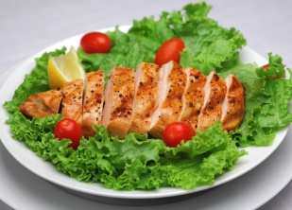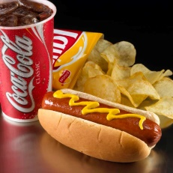

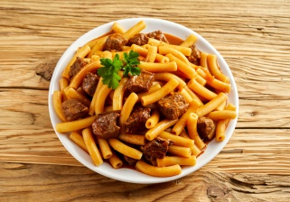1. _ _ i_ _ e_ and _a_a_ 5. _o _ _ o _ , _ _ i _ _ _and _ i _ _ _ drinks
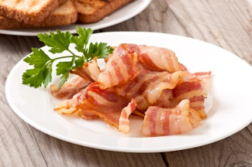

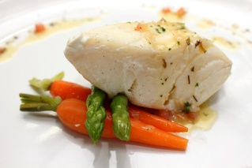2. _ ea _ _ a a _ _ _ with _ a _ a 6. _ a _ o _


3. _ i _ _ with _a _ _ o _ _ 7. i _ e _ _ ea_
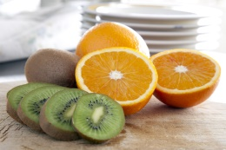
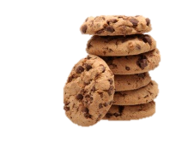
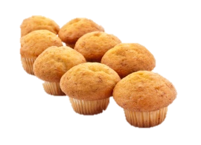

4. Fruit: o _a_ _ e _ and _ i _ i _ 8. _ i _ _ u i _ _ and _ u _ _ i _ _

B. Look at these pictures. Choose the correct food-related adjectives to make correct phrases.
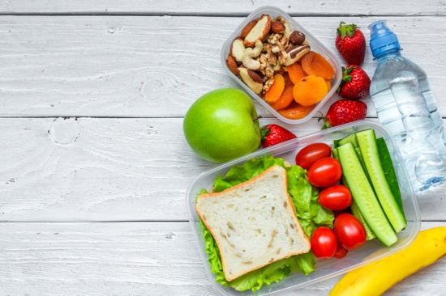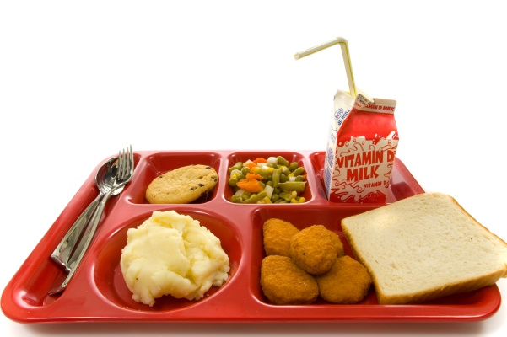
8. frozen / fresh tomatoes
5. salty / juicy apple
7. tasty / oily sandwich
6. acid / dry fruits
1. sweet / bitter / cookie
2. healthy / greasy veggies
3. fried / mashed potatoes
4. fatty / sweet nuggets

C. Complete the sentences with the correct form of used to and the verbs in brackets.
- Oscar ___________________ (eat) pizza and lasagna at school, but not anymore.
- When I was young, I ___________________ (bring) a packed lunch to school.
- My parents ___________________ (not follow) a strict diet, but now they are very healthy.
- _______ you __________________ (drink) cola or juice for lunch at school?
- We ___________________ (not do) any exercise, but now we go to the gym twice a week.

D. Choose the correct quantifier to complete the sentences.
- How much / many pasta have we got?
- I put many / some chocolate somewhere, but where is it?
- I’m afraid we haven’t got many / much time.
- You bought too many / much pizzas.
- There are a little / a few eggs in the fridge. Can you bring them?

E. Complete the sentences by choosing the correct expression of quantity.
- When you go shopping, don’t forget to buy a ________ of bread. (dozen / loaf)
- I like to have a ________ of coffee for breakfast. (cup / box)
- I’m thirsty! I need a ________ of water! (slice / bottle)
- Please put the ________ of milk in the fridge! (can / carton)
- Could we have another ________ of rice, please? (bowl / piece)

F. Look at the picture. Fill in the gaps with should/shouldn’t.
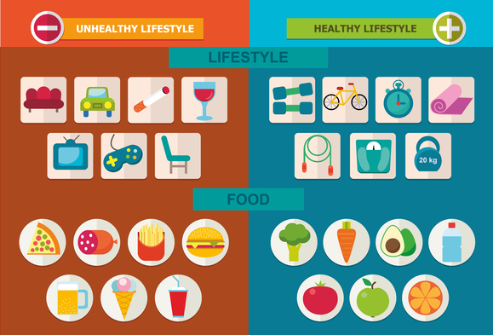
1. You _________ sit on the sofa all day.
2. You __________ smoke or drink alcohol.
3. You __________ drink more water.
4. You _________ play video games for too long. You ____________ do exercise instead.
5. You ___________ eat vegetables,
but you __________ eat pizza or burgers.
6. You ____________ sleep well.


G. Choose the correct modal verbs to make correct sentences.
- Schools would / could offer cooking lessons to parents and their children after school.
- Mum, may / would I go to the gym class with Jackie today?
- To be healthy you must / may eat well, but you couldn’t / mustn’t forget physical exercise.
- Could / Would you like something for dessert, sir?
- When I was your age, I could / should run and climb trees, but now I’m not able to!
Complete an article (50-90 words) for a teen magazine with the title:

III – Writing (15 minutes)

Should the government tell me what to eat?

In my country, the government chooses / doesn’t choose* what we eat in the school canteen.
I agree / don’t agree* with this because ________________________________________________
(say why you agree or don’t agree).
I usually have lunch _____________________________________ (place where you have lunch).
My school’s lunch is _________________________________________ (your opinion). The best food they serve there is _________________________________ and the worst is ______________________.

*(cross out what isn’t true)

Good work!
Your teacher

Year 8 – Progress test 2B

Answer key

I – Reading
A. (4 x 1 = 4%)

a. 2 | b. 4 | c. 1| d. 3
B. (3 x 2 = 6%)
1. a) | 2. b) | 3. b)
C. (2 x 1 = 2%)
1. junk food | 2. school meals/lunch.
D. (4 x 4 = 16%)
1. b) | 2. c) | 3. a) | 4. d)

II – Language
A. (15 x 1 = 15%)

1. chicken… salad | 2. meatballs… pasta | 3. fish… carrots | 4. oranges… kiwis | 5. hot dog… crisps… fizzy | 6. bacon |
7. ice cream | 8. biscuits… muffins
B. (8 x 1 = 8%)
1. sweet | 2. healthy | 3. mashed | 4. fatty | 5. juicy | 6. dry | 7. tasty | 8. fresh
C. (5 x 1 = 5%)
1. used to eat | 2. used to bring | 3. didn’t use to follow | 4. Did …use to drink | 5. didn’t use to do
D. (5 x 1 = 5%)
1. much | 2. some | 3. much | 4. many | 5. a few
E. (5 x 1 = 5%)
1. loaf | 2. cup | 3. bottle | 4. carton | 5. bowl
F. (8 x 1 = 8%)
1. shouldn’t | 2. shouldn’t | 3. should | 4. shouldn’t… should | 5. should… shouldn’t | 6. should
G. (6 x 1 = 6%)
1. could | 2. may | 3. must / mustn’t | 4. Would | 5. could

III – Writing
20%
Personal answer.

Alternative marking scheme

Per skill
I – Reading (100%)
A – 4 x 5 = 20%
B – 3 x 5 = 15%
C – 2 x 10 = 20%
D – 5 x 9 = 45%

II – Language (100%)
A – 15 x 1 = 15%
B – 8 x 2 = 16%
C – 5 x 2.5 = 12.5%
D – 5 x 2.5 = 12.5%
E – 5 x 2 = 10%
F – 8 x 2 = 16%
G – 6 x 3 = 18%

III – Writing (100%)
100%

