Name: ___________________________ Class: ______ No.: ___ Date: __________________________________________
Teacher: _______________ Mark: ____________________ Enc. Educação: _____________________________

Progress Test 4B – Year 8

I – Reading (20 minutes)

Read the online article below.

More than 1 in 3 teens say Snapchat is their favourite social media app, only 2% mention Facebook

BREAKING | Oct. 14, 2021,12:48pm EDT | 3823 views

Tommy Beer

The survey
Snapchat is the favourite social media platform among teenagers in the United States and is still growing in popularity, while Facebook's usage is minimal among them, according to a new 2021 survey. This research included 10,000 young Americans, across forty-four states, who are 15.8 years old on average.
5

10

15

20

The facts
Previous surveys, especially one from 2018, show that 90% of teens aged 13-17 have used social media mainly to socialize, even if they don’t know their virtual friends. 75% reported having at least one active social media profile, and 51% admitted visiting a social media site at least daily. Two-thirds of teens said they had their own mobile devices with internet connection. This changed completely in the last two to three years.

In the 2021 survey, around 35% of the teenagers said Snapchat is their favourite app (up from 31% in a previous survey last spring), followed by TikTok (30%) and Instagram (22%). Facebook and Twitter only gathered 2% of the total count. These teens also confirmed they spend approximately 4.2 hours per day on social media and Snapchat users check the app 30 times daily on average. However, Instagram had the highest engagement rate, with 81% of teens saying they used the app at least once over the past month, compared to 77% for Snapchat.
Shopping online
According to the survey, shopping online increased in the past two years. 28% of teens said they have purchased at least one item directly from a social media site. More than half (52%) of teens said Amazon is their favourite e-commerce site. It is more reliable than others, they stated. However, Amazon's popularity dropped a bit compared to the previous survey.
This means that teens and their families are using social media not only to socialize, as they did before, but also to purchase online.
in https://www.forbes.com/sites/tommybeer (adapted, accessed in January 2022)

A. Circle the correct option to fill in the table according to the article.

1. year of the new survey | 2018 / 2019 / 2021
2. number of teens involved in the survey | 15,000 / 10,000 / 2,000
3. number of states participants are from | 48 / 50 / 44
4. average age of the participants in the new survey | 13 / 15.8 / 17
5. percentage of teens having at least one active profile according to a 2018 survey | 75% / 70% / 28%

B. Tick () the correct option to complete the sentences about the text.

- American teens’ favourite _____________________________ is Snapchat.
a) social media platform b) website c) online app

- According to a previous survey, _________________ of teens state they visit social media every day.

- 75% b) 31% c) 51%

- Only ________________ of teens state they use Facebook and Twitter.
- 22% b) 2% c) 30%

- Teens and their families are using social media platforms to _________________________ and to buy online, these days.

a) socialize b) exchange money c) study

D. Read the questions and complete the answers, according to the text.

- Which are the most popular social media platforms among American teens?
_________________________, ______________________ and _________________________ are the most popular social media platforms among American teens.

- How many times do these teens check their Snapchat profile per day, on average?
They check their Snapchat profile _______________________________________ on average.

- What happened to Instagram between September and October 2021?
Instagram _________________________________________ between September and October 2021.

- Why is Amazon teens’ favourite e-commerce site?
Amazon is teens’ favourite e-commerce site because, according to them, ______________________________________________________________________________.

II – Language (15 minutes)
A. Label the pictures with the words in the box.
radio website newspaper magazine talk show weather forecast


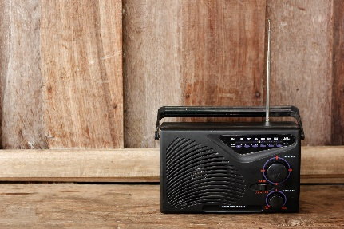
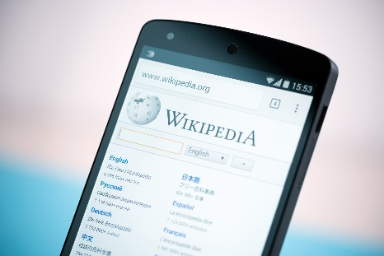

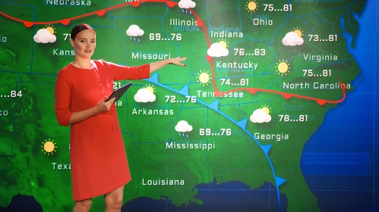


1. ________________ 2. ________________ 3. ________________

4. ________________ 5. _________________ 6. ________________

B. Make sentences with the -ing form of the verbs where necessary. There is one example.
- we / hate / use / Twitter
We hate using Twitter._________________________________________________________

- she / check her Instagram / before go to school
_____________________________________________________________________________
- we / went shop / on Saturday
_____________________________________________________________________________
- watch / YouTube videos is my brother’s favourite activity
_____________________________________________________________________________
- they / love / post / photos on Snapchat
_____________________________________________________________________________

C. Circle the correct phrasal verbs to complete the sentences.
- Helen, can you turn off / turn down the TV? It’s too loud! I can’t concentrate.
- Our favourite talk show is about to start. Let’s turn over / turn off to its channel.
- Can you turn down / turn up the sound of the radio, please? That song is so beautiful!
- When I’m not in the study, I usually turn off / turn over the computer to save some energy.

D. Circle the correct option to complete the sentences.
- Jim is good at take / taking photos to make his Insta stories.
- You shouldn’t spending / spend so much time on social media. It’s not healthy.
- I promise see / to see the new Spider-Man film with you next Sunday.
- I’m sorry! I forgot buy / to buy you a present.

E. Tick () the correct relative pronoun to fill in the gaps.
- Charli D’Amelio is a teenager ________________ has over 100,000 followers on TikTok.
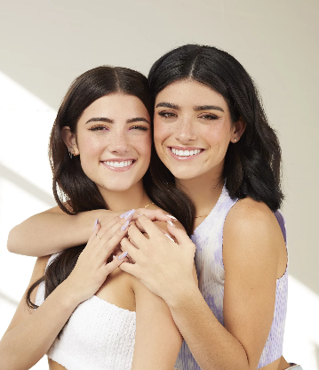
a) who b) which
- This is the story __________________ her sister published yesterday.
a) whose b) which
- The girl _____________________ stories are so famous is Dixie, Charli’s sister.
a) who b) whose
- The profile ___________________ I follow every day has lots of fun videos.
a) which b) who

F. Are the underlined words in the following sentences Right (R) or Wrong (W)?
- The girl who has millions of followers on TikTok closed her Reddit account.
- This is the last post whose has one million viewers.
- She is a famous TikToker which videos are a huge success.
- These are the two sisters who have a TV show.

G. Circle the correct option to complete the sentences.
- Charli must / doesn’t have to use TikTok every day, but every week for sure!
- If she has problems online, she must / mustn’t ask for help.
- She don’t have to / mustn’t give her personal details to strangers. It’s very dangerous!
- It’s not allowed to use the mobile phone in class, so you mustn’t / must use it.

III – Writing (15 minutes)

Considering what you’ve studied in class, answer the following questions and write a short text (40-70 words) about yourself and social media.
- Do you use social media platforms?
- Which social media platform do you prefer?
- How much time do you spend on social media?
- Is social media important in your life? Why?
- What are the positive and negative aspects of social media? (say at least one)

Good work!
Your teacher

Year 8 – Progress test 4B
Answer key

I – Reading
A. 5 x 2% = 10%
1. 2021 | 2. 10,000 | 3. 44 | 4. 15.8 | 5. 75%
B. 4 x 3% = 12%
1. a) | 2. c) | 3. b) | 4. a)
C. 4 x 5% = 20%
1. Snapchat, TikTok… Instagram | 2. thirty times | 3. had the highest engagement rate | 4. it is more reliable than others

II – Language
A. 6 x 1% = 6%
1. newspaper | 2. website | 3. talk show | 4. radio | 5. weather forecast | 6. magazine
B. 4 x 2% = 8%
1. She checks her Instagram before going to school. | 2. We went shopping on Saturday. | 3. Watching YouTube videos is my brother’s favourite activity. | 4. They love posting photos on Snapchat.
C. 4 x 1% = 4%
1. turn down | 2. turn over | 3. turn up | 4. turn off
D. 4 x 1% = 4%
1. taking | 2. spend | 3. to see | 4. to buy
E. 4 x 1% = 4%
1. a) | 2. b) | 3. b) | 4. a)
F. 4 x 2% = 8%
1. R | 2. W | 3. W | 4. R
G. 4 x 1% = 4%
1. doesn’t have to | 2. must | 3. mustn’t | 4. mustn’t

III – Writing
5 x 4% = 20%
Personal answer.

Alternative marking scheme

Per skill
I – Reading (100%)
A – 5 x 6% = 30%
B – 4 x 5% = 20%
C – 4 x 12.5% = 50%

II – Language (100%)
A – 6 x 4% = 24%
B – 4 x 4% = 16%
C – 4 x 3% = 12%
D – 4 x 3% = 12%
E – 4 x 3% = 12%
F – 4 x 3% = 12%
G – 4 x 3% = 12%

III – Writing (100%)
5 x 20%

