Show & Tell
Presentation Worksheet 2

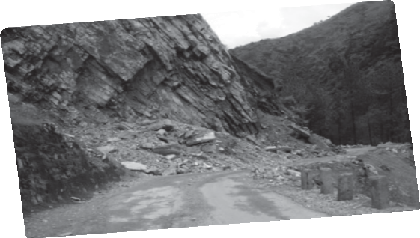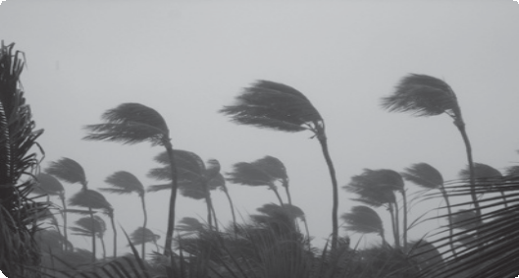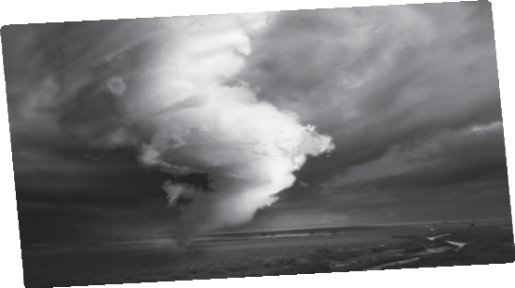Materials
What do I need to bring to class?
(magazine picture, object…)

Presentation
What do I say to begin?

Words to help me…
write your ideas
hurricane • drought • typhoon • flood

Useful phrases to remember

More notes:

