New Wave Revolution · 8.˚ ano Show & Tell

Show & Tell
Presentation Worksheet 3

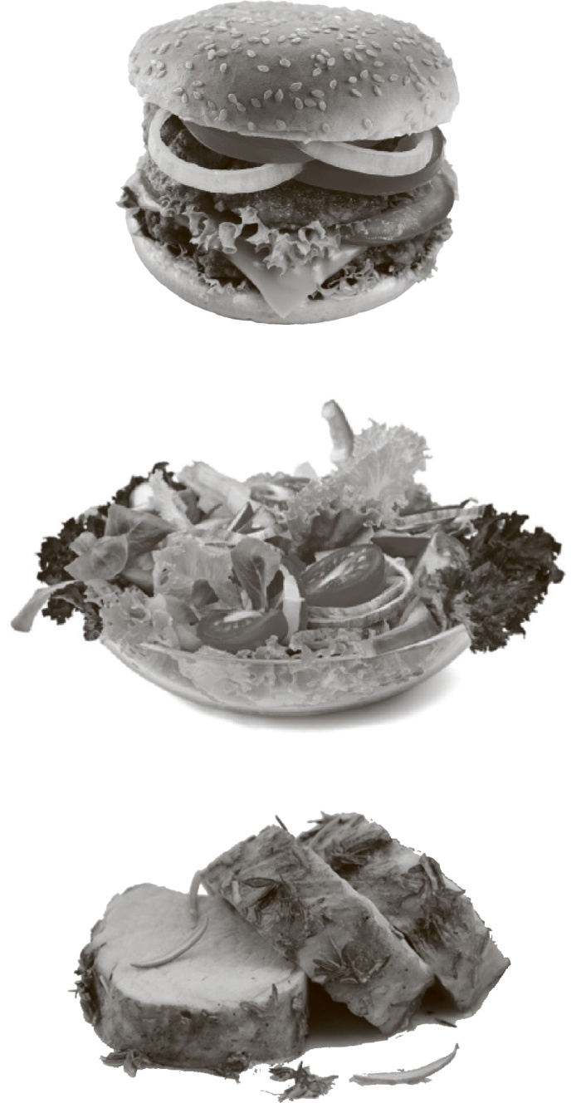

Materials
What do I need to bring to class?
(magazine picture, object…)

Presentation
What do I say to begin?

Words to help me…
write your ideas
allergic • eating disorder • fattening healthy • bulimia

Useful phrases to remember
NWR8TR © Porto Editora

More notes:



