Show & Tell
Presentation Worksheet 4

Preparation instructions
What problems do you or your friends have?

How do you help each other solve your problems?

Why are friends important?

What materials do I need?
What do I need to bring to class?
(magazine picture, object…)
Presentation
What do I say to begin?

Words to help me…
write your ideas
worry • depressed • friendship problem • feeling down • comfort
My note…
Useful phrases
… will always be there
… can help each other with…

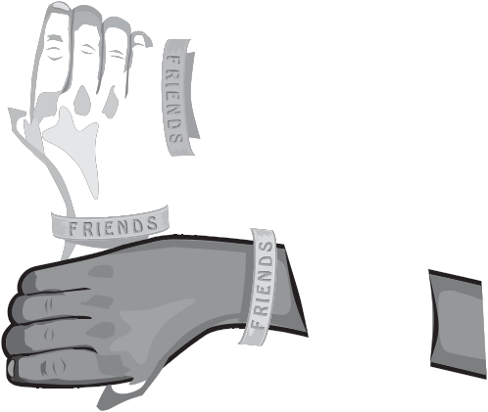

?

More notes:

