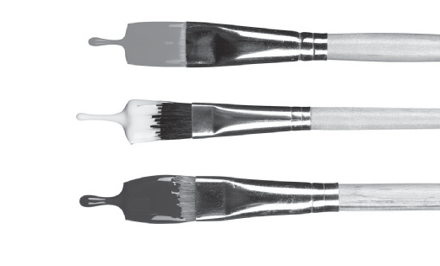New Wave Revolution · 8.˚ ano Show & Tell

Show & Tell
Presentation Worksheet 5

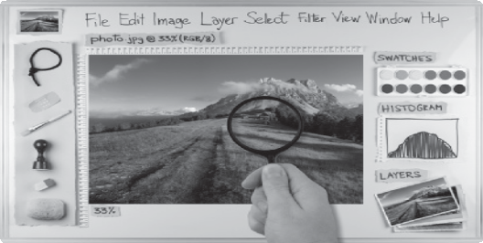Materials
What do I need to bring to class?
(magazine picture, object…)

Presentation
What do I say to begin?

Words to help me…
write your ideas
copy & paste • alter images • artificial photoshopping • real beauty

Useful phrases to remember Magazines should be careful about the images they use in their magazines
I don’t agree with… I think that…

More notes:

Editora

Porto
©

NWR8TR

