Show & Tell
Presentation Worksheet 6

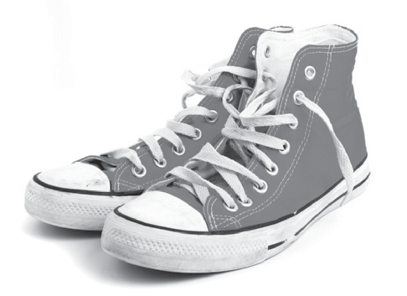You are going to talk about fashion and clothes. These are some things you can talk about.

1. Introduction
• Smile, look at your colleagues, say your name and what your topic will be…

2. Ideas
Say what you are going to talk about:
• Your new tennis shoes
• Your new hoodie
• Things you like to wear
• Your personal style
• Some crazy fashions you don’t like

3. Fashion – why you like it / don’t like it
• How often do you buy new clothes?
• Do clothes make you a better person?
• What’s more important than fashion?

4. Who is your favourite fashion model.

5. What is your favourite brand of clothing?

Make some notes:

