Show & Tell
Presentation Worksheet 10

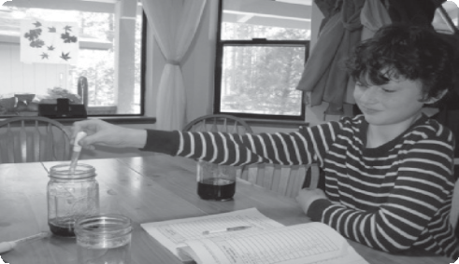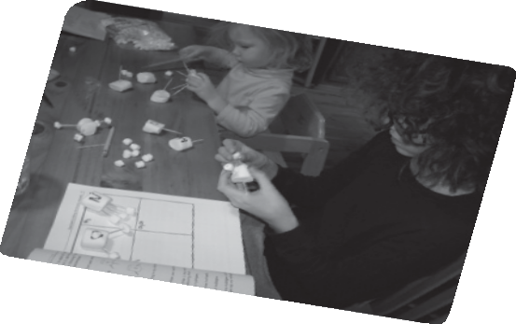You are going to talk about school stuff.

These are some things you can talk about.

1. Ideas
• Homeschooling
• Old fashioned Amish style schooling
• Future school
• What do you like best?
• What would your ideal school be like?
• What do you think about Amish education?
• What do you think about homeschooling?

2. Words and phrases
• I’d like to go to school at home…
• I like school the way it is…
• School in the past was better…
• School in the future will be more
fun…
• I think…
• I don’t like…
• I really love…

Make some notes:

