Vocabulary
Worksheet 1
New Wave Revolution · 8.˚ ano iCAN Worksheets

Environment

Name No. Class

Date / / Evaluation Teacher

A Find the words in the word search puzzle.

S E A R T H R T A W H T L A E H E C O N O S E R E S O U E A N S C C L I M A T E R E A L R N V E
I O P I M V A S N A E T H E I L M W O A M E S U W A H R E T R V A R L L Y G O L O C E Y C U O I T E L A R E R P K E C O O O N R
A T U R N T A A R A L G L I M O N A T U R A L R E S O U R C E S M W I R A T N K O R E S T R N M I N O N N I T U W M N A R U T R
L M N M E O X Y G E N S E A U N

C E R A I N F O R E S T E L R T

oxygen ecology rainforest vegetation water
tree pollution

natural resources park
health earth climate
environment

B Join the words on the left with the ones on the right to make a compound word.

es

ng

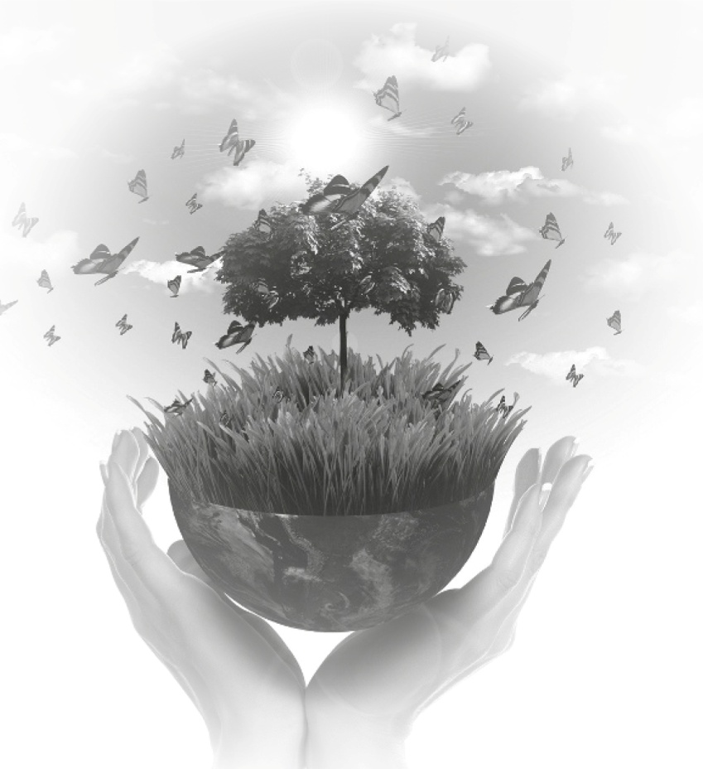
1. acid a) speci

2. animal b) issues

3. carbon c) rain

4. solar d) warmi

5. forest e) dioxide

6. global f) energy

7. protected g) fires

8. green h) rights

CASA DA AULA – Centro de Explicações – www.casadaaula.com – mail@casadaaula.com – 262 099 270

