Worksheet 2

Extreme nature

Name No. Class

Date / / Evaluation Teacher

A Label the pictures with the words in the boxes.

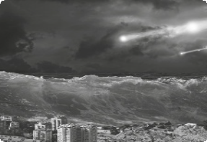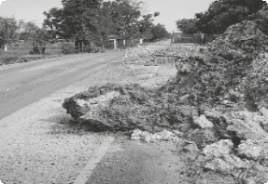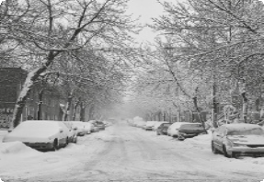drought

landslide

blizzard

hurricane thunderstorm
forest fire

1.

2.

3.

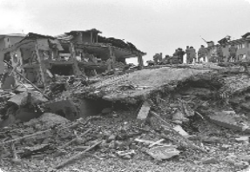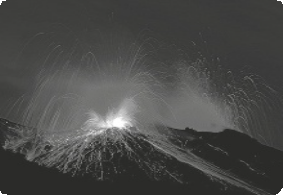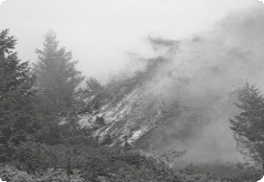volcano

tsunami

typhoon

earthquake

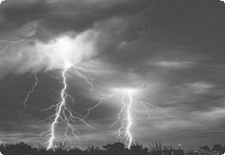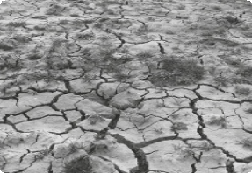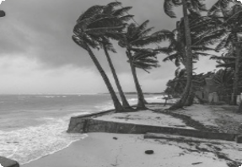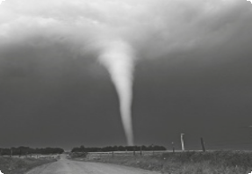4.

5.

6.

7.
8.
9.
10.

B Complete with some of the words above.

1. Organise prevention and firefighting teams.

2. I’m sure that it’s a because I saw the lightning and I heard a very loud noise.

3. I went out and there was a snow and everything iced up.

4. On a distant horizon we could see the erupting .

5. All the land was very dry because of the . There were no plants.

