Worksheet 3
New Wave Revolution · 8.˚ ano iCAN Worksheets

Save the ocean

Name No. Class

Date / / Evaluation Teacher

Label the pictures with the words in the boxes.

1. beach
4. industrial waste
7. waves
10. boat

2. plastic
5. surf board
8. sand
11. marine life

3. chemicals
6. garbage
9. clean beaches
12. oil spill

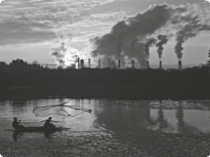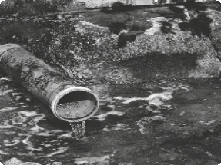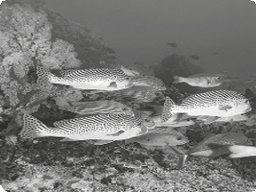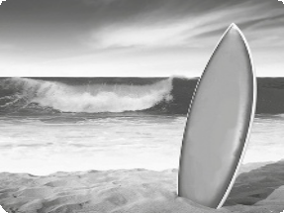a.
b. c. d.

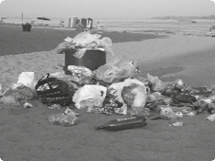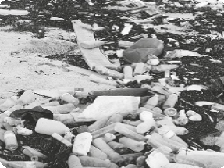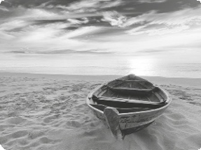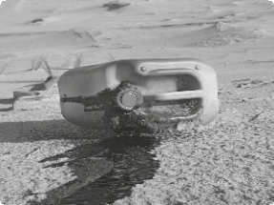e.
f. g. h.

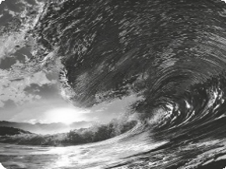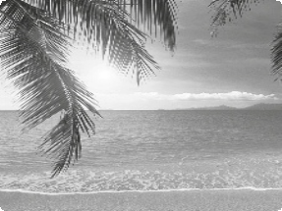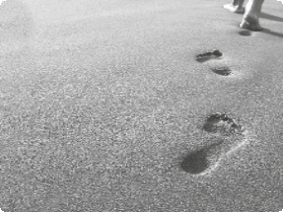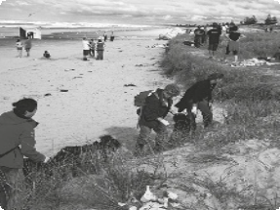i.
j. k. l.

CASA DA AULA – Centro de Explicações – www.casadaaula.com – mail@casadaaula.com – 262 099 270

