Worksheet 6

The right food

Name No. Class

Date / / Evaluation Teacher

A Complete the text with the words in the boxes.

good health

fats

nutrients (2x)

salt

oils and sugar

growth
health

omega
consume

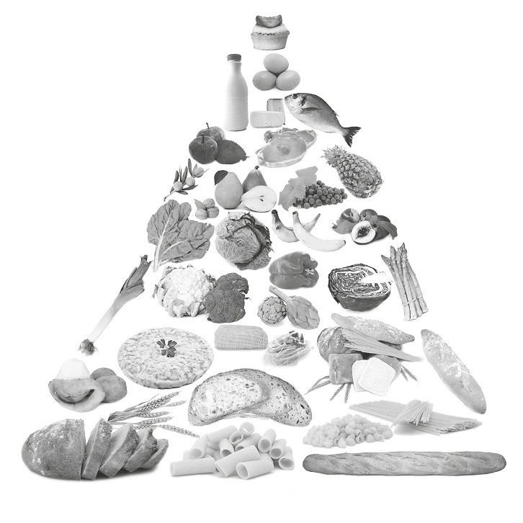

Eat in Small Amounts

Sugars and 1 are in this layer. These foods should be limited because they haven’t got the 2 needed for your 3
good 4 and quick energy, while small amounts of fats,
5 are acceptable.
When choosing fats and oils it is better to choose the ones that have low levels of saturated fat and higher levels of 6 (like salmon fish).
7 should not be added to foods.
Choosing a wide variety of foods helps us to 8 all the
9 and other food that are needed for 10 .

