Worksheet 8

Song – Hungry, hungry

Name No. Class

Date / / Evaluation Teacher

A Listen to the song and fill in the gaps with the words in the boxes.

I’m hungry yeah
I said I’m starving yeah
I want some pizza coke and 1
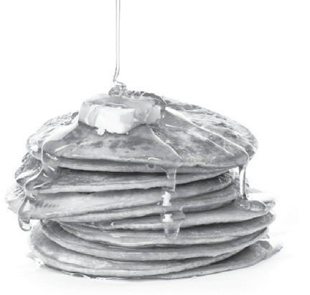2 cotton 3
Marshmallows 4 and peanuts would be so great
5 chips candy apples
Twinkies Frosted Flakes
6 French fries
and some 7 with mustard
Cookies avocados 8 pineapple juice
Whipped cream on some raw 9
That’s not all I could eat… I’m hungry
I want some food for my tum…
I want some 10 roasted walnuts pepperoni slices

11 and burritos different kinds of rice
Cherries dipped in chocolate cottage 12
and 13
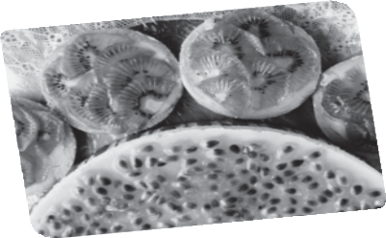Colonel Sander’s 14 still won’t fill my belly Broccoli sticky 15
churros dipped in sauce
Drippy sloppy joes then I’m full at last
Oh oh oh oh oh oh I’m full at last
And I’m full at I’m really really full

Gwen Stefani, A little something refreshing (shortened)

syrup ice cream jelly candy
pop corn pies doughnuts pasta milkshake meat chocolate pancakes cheese honey chicken

