
Worksheet 11
New Wave Revolution · 8.˚ ano iCAN Worksheets
Teen Quiz
New Wave Revolution · 8.˚ ano iCAN Worksheets

Name No. Class

Date / / Evaluation Teacher

Teen Quiz

True (T) or False (F)?

1. If you exercise you can eat what you want.

2. When you are a teen you are a lot more stressed out, which makes you sweat more.

3. Eating disorders only happen with girls.

4. Only skinny people can get eating disorders.

5. Exercising increases your self-esteem.

6. The loss of appetite is good for your health.

7. Both boys and girls gain the same amount of weight during puberty.

8. When you don’t sleep enough, you can’t concentrate.

9. Insomnia and loss of memory are common symptoms of an eating disorder.

10. When you feel down no one can help you.

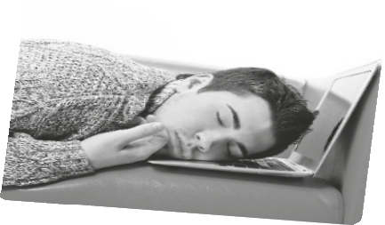

11. When you’re down you tend to overreact to situations and that’s normal.

12. Getting easily irritated with your friends is the wrong attitude.

13. You can cure your stress by talking with friends and participating in extracurricular activities.

