Worksheet 13
New Wave Revolution · 8.˚ ano iCAN Worksheets

Fashion brands

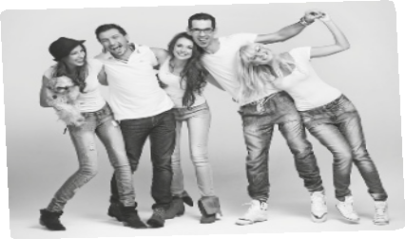

Name No. Class

Date / / Evaluation Teacher

A Listen and complete the text.

Teens find 1 as something that make them look 2 as many teens say today at school. When people associate themselves with a particular brand or 3 , they immediately assume a new identity. They classify themselves through the brands they 4 and it makes them feel like they fit in. There is always that new 5

.
or those 6 or just some new
7 that happens to begin. Teens may feel like if they don’t have the 8 , they aren’t worthy or not able to fit in and be themselves.
9 are a big impact on teen 10
Ashton Pittman says that often, 11 for teenagers is the result of the
12 to be like a celebrity. But most of the time they end up giving the
13 to their friends and people around them.
Have you ever tried 14 some way so that others accept you? A lot of teens don’t realize that this is an issue on their everyday life because they are so worried with trying to fit in. Just because other teens have the latest brand and you don’t,
doesn’t mean that you aren’t 15 .

http://teenink.com (adapted)

B Match the words with their meaning.

1. classy a) belong to/be accepted

2. assume b) having a strong effect on someone/something

3. fit in c) good and deserving respect

4. worthy d) understand

5. impact e) important subject

6. realize f) think something is true without having proof

7. issue g) special and attractive

