Worksheet 14

Fashion

Name No. Class

Date / / Evaluation Teacher

A Label the pictures with words from the boxes.

fashion designer
hairdresser
models photographer make-up catwalk

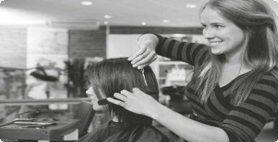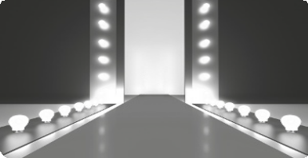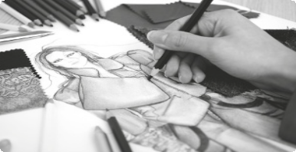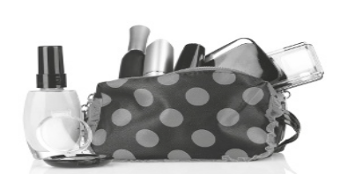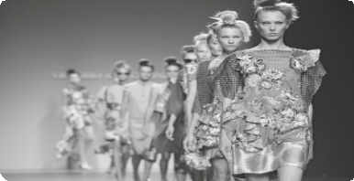1.
2.
3.

4.
5.
6.

B Find the words in the word search.

style fashionable up-to-date magazine accessories cool
chic collection
casual
basics unfashionable appearance brand
label trend
window shop

R N I W I N D O W S H O P P F N T A M A G A Z I N E G A Z I A N R B C O L L E C T I O N H E S S E A C C E U S S I R I E L S H A N S H O P P I N G O D Y C T I C D C I O L T R L N S T N H Y O F C I C C O O L E C S N O A L N D B S L A B D E B L E T R I E A B A A P P E A R A N C E L C L B R S B R A N T E L L C A S U A L A C M A C C E S S O R I E S L E N
A U N F A S H I O N A B L E S D

