Worksheet 16

Internet piracy

Name No. Class

Date / / Evaluation Teacher

A Complete the crossword puzzle and find the mystery word.
The words in the picture will help you.

2

4 M O P

5

6

7 O R

8 R
1 C R T F M
3 O S S

Y

B A D C L
G N L

G
R

I E S I N

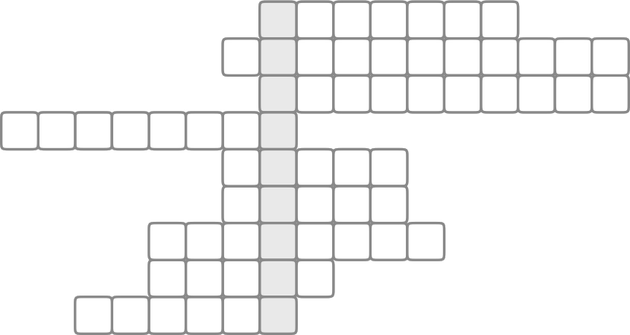
9 P N T

B Match the words with their meaning.

1. software a) to buy something by paying money for it.

2. purchase b) pay in advance to receive something regulary.

3. illegally c) programs on a computer.

4. customer d) to publicize a product to sell it.

5. property e) to have or use something with others.

6. share f) not allowed by the law.

7. download g) something protected by a trademark or brand.

8. advertise h) someone who buys things in a shop.

9. subscribe i) something that belongs to someone.

10. patent j) copy or move from a computer or device to another one.

