Worksheet 19
New Wave Revolution · 8.˚ ano iCAN Worksheets

Song – E.T.

Name No. Class

Date / / Evaluation Teacher

A Listen to the song and fill in with the words/expressions below.

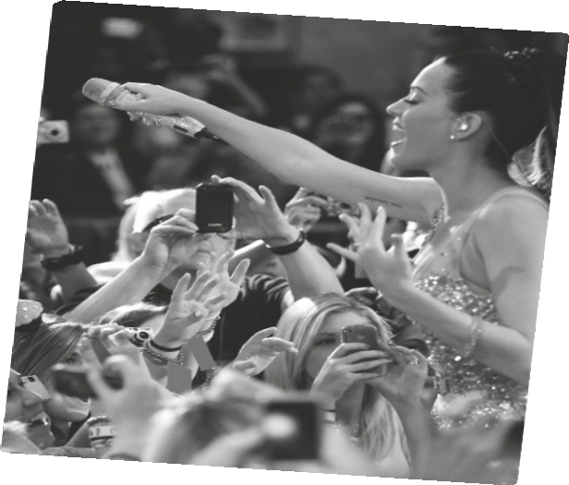You’re so hypnotizing Could you be the devil? Could you be an angel?

Your touch 1
Feels like I am 2
Leaves my body 3

They say, be afraid
You’re not like the others
4 lover
Different DNA
They don’t understand you

You’re from a whole 5
A different 6
You open my eyes And I’m ready to go Lead me 7

Kiss me, ki-ki-kiss me
Infect me with your love and
Fill me with your poison
Take me, Ta-Ta-Take me
Wanna be your victim, ready for abduction

Boy, you’re an 8
Your touch so foreign
It’s 9
10

You’re so 11
Wanna feel your 12
Stun me with your 13
Your kiss is 14
Every move is magic

Katy Perry, E.T. (shortened)

floating cosmic magnetizing lasers extraterrestrial supersonic powers

glowing futuristic supernatural alien
another world dimension into the light

B Listen to the song again and check your work.

