Worksheet 2

Past Simple

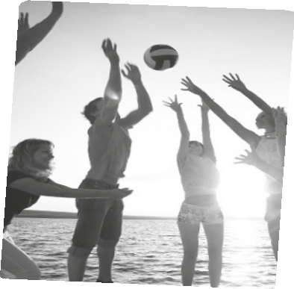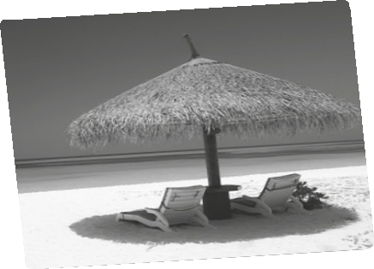

Name No. Class

Date / / Evaluation Teacher

A Fill in the gaps using the Past Simple.

1. Last year I (spend) my holidays in the Algarve.

2. We (visit) a lot of interesting places there.

3. I (have) a great time.

4. It (be) a great opportunity to practice surfing.

5. My friends (play) beach volleyball.

6. I (enjoy) the weather conditions and the sea.

B Use the verbs in bold to complete the questions.

1. Where ?

I stayed in a hotel near the beach.

2. What ?

I visited a lot of interesting places.

3. Who with in your summer holidays?

I slept with my younger brother, Simon.

4. when you a kid?

I lived near the sea when I was a kid.

5. When ?

Our school meeting started at 9.30 p.m.

C Fill in the gaps with the verbs given.

1. My friends and I (not / cook) every day.

2. Last week I (not / see) my grandparents.

3. Mariana (not / go) to London last month.

4. I (not / buy) many postcards because
I (not / have) enough money.

5. Maria and Joana (not / get) a good mark in the English test.

CASA DA AULA – www.casadaaula.com

