Worksheet 4

Used to

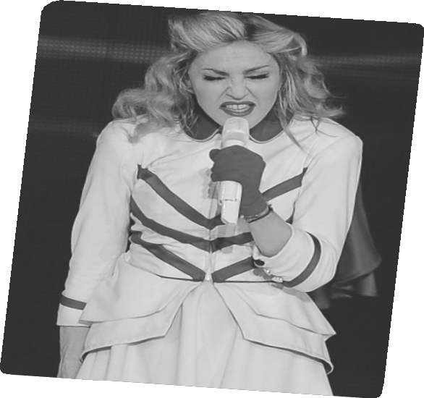

Name No. Class

Date / / Evaluation Teacher

A Listen to the song and fill in the gaps using used to and the Past Simple of the verbs in brackets.

This 1 my playground
This 2 my childhood dream
This 3 the place I 4 (run) to
Whenever I 5 (be) in need
Of a friend
Why 6 it (have) to end
And why do they always say
(…)

Live and learn
Well the years they 7 (fly) And we never 8 (know) We 9 (be) foolish then
We would never tire
And that little fire
Is still alive in me
It will never go away
Can’t say goodbye to yesterday (can’t say goodbye)
(Chorus)

No regrets
But I wish that you
10 (be) here with me
Well then there’s hope yet
I can see your face
In our secret place
You’re not just a memory
Say goodbye to yesterday (the dream)
Those are words I’ll never say (I’ll never say)

Madonna, This used to be my playground (shortened)

B Rewrite the sentences as asked.

1. This used to be my playground. (negative)

2. We used to be foolish. (interrogative)

