Worksheet 7
New Wave Revolution · 8.˚ ano iCAN Worksheets

So + adjective + quantifiers

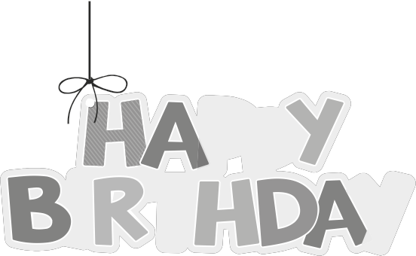

Name No. Class

Date / / Evaluation Teacher

A Use so in the right place.

1. I’m glad that you could come to my birthday party.

2. It was hot during this summer holidays!

3. I’m tired. I need to have some rest.

4. Why are you laughing? What’s funny about this?

5. You don’t need to go fast! You’d better slow down.

6. I’m pleased to meet you! You’re a very nice person.

B Fill in with so + many / much / little / few.

1. I had rest during the day, that I fell asleep in the cinema.

2. There is noise in this bar! I can’t hear you.

3. I can’t eat this steak. There is salt in it.

4. There were people in the ticket queue. I had to wait for hours.

5. He is not a nice person and that’s why he has friends.

6. Why do you spend time in front of the TV?

C Right or wrong? Correct the wrong ones.

1. I have already told you many so times that you should study hard.

2. Yesterday I ran for two hours and I’ve lost so few calories.

3. I’ve got so much people to interview and I feel exhausted.

4. I spent little so time with my best friend that now I miss her.

5. The film was so awful! I couldn’t watch it until the end.

6. They have little so food. We must help them.

7. There so are few restaurants in the area that I have to go to the nearest town.

8. The meal was so good! It was worth the money.

