Worksheet 8

Present Perfect

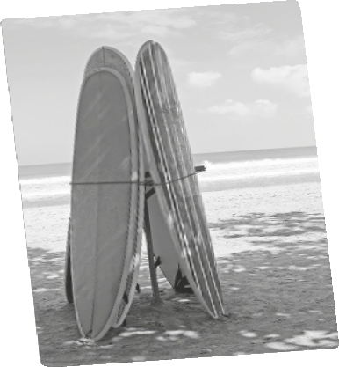

Name No. Class

Date / / Evaluation Teacher

A Use the Present Perfect of the verbs in brackets to complete the sentences.

1. John and Catherine (not / water) the plants.

2. Mary (do) her homework on the computer.

3. you (receive) the email I sent you?

4. Filipa (not / finish) her project work.

5. you ever (be) to Lisbon?

6. We (not / plan) our holidays yet.

7. My teacher (write) six letters.

8. Louise and Anthony (watch) a film on TV.

9. Bob (read) all the computer magazines.

10. they (go) to the shopping centre?

11. I (not / be) on holiday for two years.

12. Bruce already (prepare) his birthday party.

B Fill in the gaps using for or since.

1. My parents have lived in Madeira ten years.

2. I haven’t seen Mariana she was twelve years old.

3. I have known her I was a child.

4. What have they done they left school?

5. I have been teaching English a long time.

6. Where have you been the last four hours?

7. I have surfed every day the last two years.

8. when have you been here?

9. How long have you known her? I was ten years old.

10. She has not seen her friends seven months and she misses them.

