Worksheet 13
New Wave Revolution · 8.˚ ano iCAN Worksheets

Order of adjectives

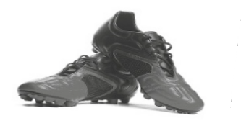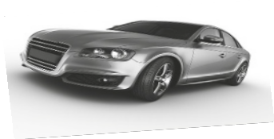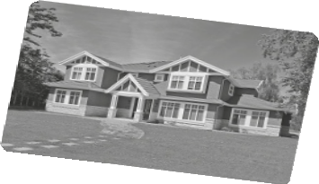

Name No. Class

Date / / Evaluation Teacher

A Describe the pictures using the words given and the right order of adjectives.

1. tennis shoes / red and white / nice / small / Italian

2. dress / red / short /nice / cotton / new / a

3. car / red / big / modern / English / a

4. house / big / wonderful / expensive / white / an

5. jacket / leather / black / short / nice / a

B Use the information to write a single sentence.

1. These shorts are modern. They are black. They are medium size.

2. This is a belt. It is old. It’s leather. The colour is brown.

3. This film is American. It is good. It’s very long.

4. She is a woman. She is intelligent. She is nice. She is very young.

5. I’ve got an enormous umbrella. It is brown and Portuguese.

