Worksheet 14

Modal verbs

Name No. Class

Date / / Evaluation Teacher

A Label the pictures using the right modal verb (must / mustn’t) and the verbs in the boxes.

attention litter cross obey walk smoke

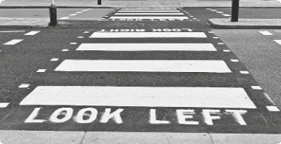1.
2.
3.

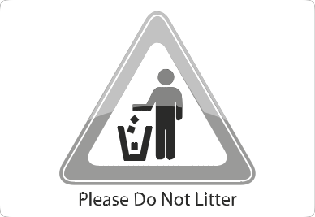4.
5.
6.

B Write sentences using the right modal verb: must / mustn’t / have to.

1. You / wait / in line / like everyone.

2. You / take / pictures in the museum.

3. You / stay / until the end of the race?

4. You / talk / during your teacher’s presentation.

