Worksheet 19
New Wave Revolution · 8.˚ ano iCAN Worksheets

Future tense (will/won’t)

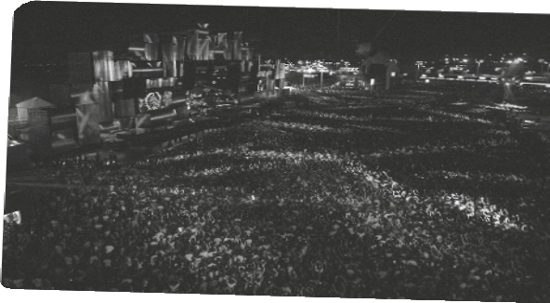

Name No. Class

Date / / Evaluation Teacher

A Listen to the song and fill in with the missing verbs. Use the Future will/won’t.

I can’t win, I can’t reign
I 1 (never win) this game
Without you, without you
I am lost, I am vain,
I 2 (never be) the same
Without you, without you

I 3 , I won’t fly (not run)
I 4 (never make) it by
Without you, without you
I can’t rest, I can’t fight All I need is you and I, Without you, without you

Can’t erase, so I 5 (take) blame
But I can’t accept that we’re estranged
Without you, without you
I can’t quit now, this can’t be right
I can’t take one more sleepless night
Without you, without you

I 6 , I won’t climb (not / soar) If you’re not here, I’m paralyzed
Without you, without you
I can’t look, I’m so blind
I lost my heart, I lost my mind
Without you, without you

David Guetta, Without you (shortened)

B Rewrite the sentences as asked in brackets.

1. I will never win this game. (negative)

2. I will take the blame. (interrogative)

3. I won’t soar and I won’t climb. (positive)

