Worksheet 22

Conditional: type 0 / type 1

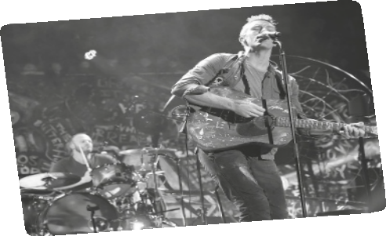
Name No. Class
Date / / Evaluation Teacher

A Listen to the song and fill in the gaps.

When you try your best but you 1 (not / succeed)
When you 2 (get) what you want but not what you need
When you feel so tired but you can’t sleep
Stuck in reverse

And the tears come streaming down your face
When you 3 (lose) something you 4 (not / can) replace When you 5 (love) someone but it 6 (go) to waste
Could it be worse?

Lights 7 (guide) you home
And ignite your bones
And I 8 (try) to fix you (chorus)

And high up above or down below
When you 9 (be) too in love to let it go
But if you never try you 10 never 11 (know) Just what you’re worth
(chorus)

Tears stream down your face
When you 12 (lose) something you 13 (not / can) replace
Tears stream down your face
And I 14 (try) to fix you.

Tears stream down your face
I promise you I 15 (learn) from my mistakes
Tears stream down your face
And I 16 (try) to fix you.

Lights 17 (guide) you home
And ignite your bones
And I 18 (try) to fix you

Coldplay, Fix you (shortened)

B Give the song a different title.

