Matriz do teste de Compreensão Oral
Objetivos | Conteúdos | Estrutura | Cotações | Critérios de classificação
Compreender o texto. | Texto e vocabulário relacionados com os tópicos da unidade | A. Ordenar eventos de acordo com o texto. | 4 x 5 = 20 p | Resposta correta: 5 pontos; Resposta incorreta: 0 pontos.
Compreender o texto. | Texto e vocabulário relacionados com os tópicos da unidade | B. Distinguir frases verdadeiras das falsas. | 8 x 10 = 80 p | Resposta correta: 10 pontos; Resposta incorreta: 0 pontos.
 |  |  | 100%

Matriz do Teste 1A
Objetivos | Conteúdos | Estrutura | Cotações | Critérios de classificação
Compreender o texto.  Expressar informação de forma clara e estruturalmente correta. | Texto e vocabulário relacionados com os tópicos da unidade | A. Identificar sinónimos no texto. | 4 x 1,5 = 6 p | Resposta correta: 1,5 pontos; Resposta incorreta: 0 pontos.
 | Texto e vocabulário relacionados com os tópicos da unidade | B. Distinguir frases verdadeiras de falsas e corrigir as falsas. | 5 x 1,5 = 7,5 p  3 x 1,5 = 4,5 p | Resposta correta:1,5 pontos; Resposta incorreta: 0 pontos; Correção da frase falsa: 1,5 pontos.
 | Texto e vocabulário relacionados com os tópicos da unidade | C. Responder a perguntas sobre o texto. | 4 x 5 = 20 p | Resposta correta: 4 pontos; Resposta incorreta: 0 pontos;  Conteúdo parcialmente correto: 2 pontos; Desconto máximo para incorreções: 2 pontos.
Aplicar o vocabulário tratado na unidade. | Vocabulário relacionado com os tópicos da unidade | D. Identificar problemas e soluções ambientais. | 6 x 2 = 12 p | Resposta correta: 2 pontos; Resposta incorreta: 0 pontos.
Aplicar os itens gramaticais tratados. | Present Simple  Adverbs of frequency | E. Construir frases. | 4 x 2,5 = 10 p | Resposta correta: 2,5 pontos; Resposta incorreta: 0 pontos.
Aplicar os itens gramaticais tratados. | Past Simple  (Regular and irregular verbs and the verb to be) | F. Completar espaços. | 7 x 2 = 14 p | Resposta correta: 2 pontos; Resposta incorreta: 0 pontos.
Aplicar os itens gramaticais tratados. | Used to / Didn’t use to | G. Corrigir os erros nas frases. | 3 x 2 = 6 p | Resposta correta: 2 pontos; Resposta incorreta: 0 pontos.
Produzir um enunciado escrito. | Ambiente | H. Escrever um email propondo ações para proteger o ambiente. | 20 p | 16-20 pontos – o texto respeita o tema, tem uma estrutura coerente e não apresenta erros ortográficos relevantes.  10-15 pontos – o texto respeita o tema, mas revela alguns erros de estrutura e de ortografia.  1-9 pontos – o texto não respeita integralmente o tema, tem erros de estrutura graves e apresenta erros ortográficos que dificultam a comunicação.  0 pontos – o texto não respeita o tema proposto ou tem erros de estrutura graves e apresenta erros ortográficos que inviabilizam a sua compreensão.
 |  |  | 100%

Matriz do Teste 1B
Objetivos | Conteúdos | Estrutura | Cotações | Critérios de classificação
Compreender o texto.  Expressar informação de forma clara e estruturalmente correta. | Texto e vocabulário relacionados com os tópicos da unidade | A. Fazer correspondência entre sinónimos. | 4 x 1,5 = 6 p | Resposta correta: 1,5 pontos; Resposta incorreta: 0 pontos.
 | Texto e vocabulário relacionados com os tópicos da unidade | B. Distinguir frases verdadeiras de falsas. | 5 x 2 = 10 p | Resposta correta: 1,5 pontos; Resposta incorreta: 0 pontos.
 | Texto e vocabulário relacionados com os tópicos da unidade | C. Responder a perguntas sobre o texto. | 4 x 5,5 = 22 p | Resposta correta: 5,5 pontos; Resposta incorreta: 0 pontos;  Conteúdo parcialmente correto: 2 pontos; Desconto máximo para incorreções: 4 pontos.

New Wave Revolution · 8.˚ ano Evaluation Tests

N

Objetivos | Conteúdos | Estrutura | Cotações | Critérios de classificação
Aplicar o vocabulário tratado na unidade. | Vocabulário relacionado com os tópicos da unidade | D. Identificar problemas e soluções ambientais. | 6 x 2 = 12 p | Resposta correta: 2 pontos; Resposta incorreta: 0 pontos.
Aplicar os itens gramaticais tratados. | Present Simple  Adverbs of frequency | E. Escolher a frase correta. | 4 x 2,5 = 10 p | Resposta correta: 2,5 pontos; Resposta incorreta: 0 pontos.
Aplicar os itens gramaticais tratados. | Past Simple | F. Escolher a forma correta. | 7 x 2 = 14 p | Resposta correta: 2 pontos; Resposta incorreta: 0 pontos.
Aplicar os itens gramaticais tratados. | Used to / Didn’t use to | G. Corrigir os erros nas frases. | 3 x 2 = 6 p | Resposta correta: 2 pontos; Resposta incorreta: 0 pontos.
Produzir um enunciado escrito. | Ambiente | H. Escrever um email propondo ações para proteger o ambiente. | 20 p | 16-20 pontos – o texto respeita o tema, tem uma estrutura coerente e não apresenta erros ortográficos relevantes.  10-15 pontos – o texto respeita o tema, mas revela alguns erros de estrutura e de ortografia.  1-9 pontos – o texto não respeita integralmente o tema, tem erros de estrutura graves e apresenta erros ortográficos que dificultam a comunicação.  0 pontos – o texto não respeita o tema proposto ou tem erros de estrutura graves e apresenta erros ortográficos que inviabilizam a sua compreensão.
 |  |  | 100%

Matriz do teste 1C
Objetivos | Conteúdos | Estrutura | Cotações | Critérios de classificação
Compreender o texto.  Expressar informação de forma clara e estruturalmente correta. | Texto e vocabulário relacionados com os tópicos da unidade | A. Fazer correspondência entre sinónimos. | 4 x 1,5 = 6 p | Resposta correta: 1,5 pontos; Resposta incorreta: 0 pontos.
 | Texto e vocabulário relacionados com os tópicos da unidade | B. Distinguir frases verdadeiras de falsas e corrigir as falsas. | 5 x 1,5 = 7,5 p  3 x 1,5 = 4,5 p | Resposta correta: 1,5 pontos; Resposta incorreta: 0 pontos; Correção da frase falsa: 1,5 pontos.
 | Texto e vocabulário relacionados com os tópicos da unidade | C. Responder a perguntas sobre o texto. | 4 x 5 = 20 p | Resposta correta: 5 pontos; Resposta incorreta: 0 pontos;  Conteúdo parcialmente correto: 2 pontos; Desconto máximo para incorreções: 4 pontos.
Aplicar o vocabulário tratado na unidade. | Vocabulário relacionado com os tópicos da unidade | D. Identificar problemas e soluções ambientais. | 6 x 2 = 12 p | Resposta correta: 2 pontos; Resposta incorreta: 0 pontos.
Aplicar os itens gramaticais tratados. | Present Simple  Adverbs of frequency | E. Construir frases | 5 x 2 = 10 p | Resposta correta: 2 pontos; Resposta incorreta: 0 pontos.
Aplicar os itens gramaticais tratados. | Past Simple | F. Completar espaços. | 7 x 2 = 14 p | Resposta correta: 2 pontos; Resposta incorreta: 0 pontos.
Aplicar os itens gramaticais tratados. | Used to / Didn’t use to | G. Corrigir os erros nas frases. | 3 x 2 = 6 p | Resposta correta: 2 pontos; Resposta incorreta: 0 pontos.
Produzir um enunciado escrito. | Ambiente | H. Escrever um texto propondo ações para proteger o ambiente. | 20 p | 16-20 pontos – o texto respeita o tema, tem uma estrutura coerente e não apresenta erros ortográficos relevantes.  10-15 pontos – o texto respeita o tema, mas revela alguns erros de estrutura e de ortografia.  1-9 pontos – o texto não respeita integralmente o tema, tem erros de estrutura graves e apresenta erros ortográficos que dificultam a sua comunicação.  0 pontos – o texto não respeita o tema proposto ou tem erros de estrutura graves e apresenta erros ortográficos que inviabilizam a sua compreensão.
 |  |  | 100%

Correction Table Listening Test 1 / Test 1A

Unit Class Date / /

No. | Name | Listening Test 1 |  | Total | Test 1A |  |  |  |  |  |  |  |  | Total | Final  Mark
No. | Name | A | B | Total | A | B |  | C | D | E | F | G | H | Total | Final  Mark
No. | Name | 4 x 5 | 8 x 10 | 100 | 4 x 1,5 | 5 x 1,5 | 3 x 1,5 | 4 x 5 | 6 x 2 | 4 x 2,5 | 7 x 2 | 3 x 2 | 20 | 100 | Final  Mark
1.
2.
3.
4.
5.
6.
7.
8.
9.
10.
11.
12.
13.
14.
15.
16.
17.
18.
19.
20.
21.
22.
23.
24.
25.
26.
27.
28.
29.
30.

Correction Table Tests 1B-C

Unit Class Date / /

New Wave Revolution · 8.˚ ano Evaluation Tests

No. | Name | Test 1B |  |  |  |  |  |  |  | Test 1C |  |  |  |  |  |  |  |  | Total | Final  Mark
No. | Name | A | B | C | D | E | F | G | H | A | B |  | C | D | E | F | G | H | Total | Final  Mark
No. | Name | 4 x 1,5 | 5 x 2 | 4 x 5,5 | 6 x 2 | 4 x 2,5 | 7 x 2 | 3 x 2 | 20 | 4 x 1,5 | 5 x 1,5 | 3 x 1,5 | 4 x 5 | 6 x 2 | 5 x 2 | 7 x 2 | 3 x 2 | 20 | 100 | Final  Mark
1.
2.
3.
4.
5.
6.
7.
8.
9.
10.
11.
12.
13.
14.
15.
16.
17.
18.
19.
20.
21.
22.
23.
24.
25.
26.
27.
28.
29.
30.

Listening Test 1
Wild side
Unit 1

Name No. Class

Date / / Evaluation Teacher

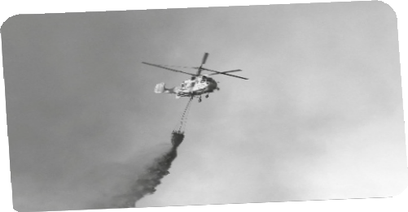A Order the following events according to the text.

1. Water bombing by helicopters to extinguish the fire.

2. Let the animals go.

3. Pack the essential things.

4. Drive through walls of flames.

B Listen to the text and mark the sentences True (T) or False (F).

1. It’s spring in Australia.

2. Sydney is Australia’s largest city.

3. Michael Silver lost his car.

4. They didn’t know what they were going to find ahead.

5. They live in a war zone.

6. They expected these fires.

7. Life is more important than property.

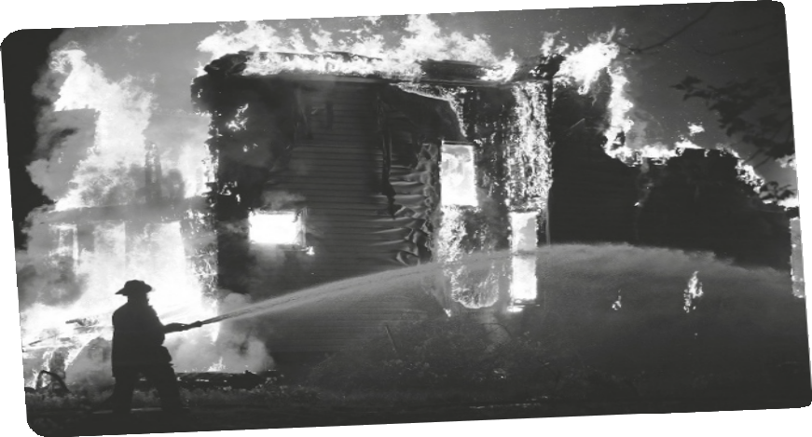8. He misses his TV

Unit 1 Wild side
New Wave Revolution · 8.˚ ano Evaluation Tests
Test 1A

Name No. Class

Date / / Evaluation Teacher

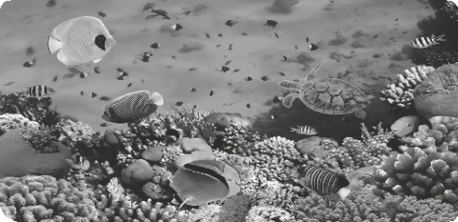
The Great Barrier Reef is the largest coral reef system in the world. You can see it from space and it is the world’s biggest single structure made by living organisms. It has got a lot of types of marine life and became a World Heritage Site in 1981.

Reefs can develop in diameter and vertically. Because they need sunlight, they appear only about 150 metres under the water, but they cannot grow on the surface.

The Great Barrier Reef supports many life forms, including many vulnerable or endangered species: more than thirty species of whales; dolphins; more than 1,500 fish species, including the clownfish; seventeen species of sea snake; and six species of sea turtles that come to the reef to breed, for example.

Climate change, pollution and fishing are big problems for the health of reef systems.

The rise of the ocean temperatures damages the reefs and endangers the life of the coral reef. Some fish and the sea turtle population are affected, too. They can’t live in such warm water and seek a new habitat.

Another very big problem for the Great Barrier Reef is pollution and bad water quality. The rivers of North
Eastern Australia bring the pollution from farms during tropical floods.

Fishing also affects the reef because of water pollution from boats, catching unwanted species, like dolphins and turtles, and habitat destruction from anchors and nets.
Source: Wikipedia

A Find words in the text that mean the same as…

1. easy to hurt

2. reproduce

3. increase

4. look for

B Say whether the sentences are True (T) or False (F) according to the text.
Then correct the false ones.

1. We can see the Great Barrier Reef outside the Earth’s atmosphere.

2. It is the biggest structure of living beings on Earth.

3. The Great Barrier Reef has got little variety of life.

4. Reefs can’t grow.

5. Reefs don’t need the sun to live.

C Answer the questions about the text.

1. When did the Great Barrier Reef become a World Heritage Site?

2. What vulnerable species can we find in the Great Barrier Reef?

3. What are the worse dangers to the reef system?

4. Why does fishing have a negative impact on the reef system?

D Label the pictures.

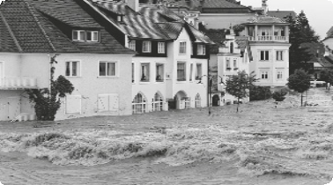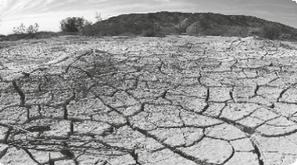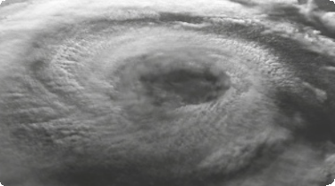1.
2.
3.

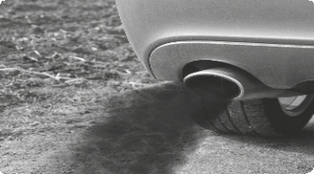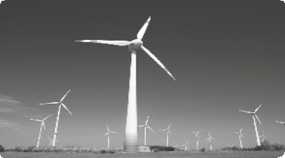4.
5.
6.

New Wave Revolution · 8.˚ ano Evaluation Tests

E Build sentences using the Present Simple and the adverbs of frequency in the right order.

1. nature / always / be / beautiful

2. aerosol / cans/ she / never / buy

3. I / bags/ plastic / reuse / often

4. sometimes / he / to / go / the / bottle / bank

F Complete the sentences using the Past Simple of the verbs in brackets.

1. When I (be) younger I (not / understand) these questions about the environment.

2. (you / talk) about this with your friends?

3. Peter (go) camping this weekend.

4. I (read) some information about it and (understand)
the importance of them.

5. Our class (visit) a recycling centre.

G Find the mistakes in the sentences and correct them.

1. I use to ask for plastic bags at the supermarket.

2. Did you used to recycle?

3. I didn’t used to care about environmental problems.

H A friend of yours sent you an e-mail saying he/she was going to camp with some friends. Write an e-mail giving him/her some advice about the things he/she can do to protect nature.

Unit 1 Wild side

Test 1B

Name No. Class

Date / / Evaluation Teacher

The Great Barrier Reef is the largest coral reef system in the world. You can see it from space and it is the world’s biggest single structure made by living organisms. It has got a lot of types of marine life and became a World Heritage Site in 1981.

Reefs can develop in diameter and vertically. Because they need sunlight, they appear only about 150 metres under the water, but they cannot grow on the surface.

The Great Barrier Reef supports many life forms, including many vulnerable or endangered species: more than thirty species of whales; dolphins; more than 1,500 fish species, including the clownfish; seventeen species of sea snake; and six species of sea turtles that come to the reef to breed, for example.

Climate change, pollution and fishing are big problems for the health of reef systems.

The rise of the ocean temperatures damages the reefs and endangers the life of the coral reef. Some fish and the sea turtle population are affected, too. They can’t live in such warm water and seek a new habitat.

Another very big problem for the Great Barrier Reef is pollution and bad water quality. The rivers of north eastern Australia bring the pollution from farms during tropical floods.

Fishing also affects the reef because of water pollution from boats, catching unwanted species, like dolphins and turtles, and habitat destruction from anchors and nets.

Source: Wikipedia

A Match the words from the text to their synonyms.

1. vulnerable a) look for

2. breed b) easy to hurt

3. rise c) reproduce

4. seek d) increase

B Say whether the sentences are True (T) or False (F) according to the text.

1. We can see the Great Barrier Reef outside the Earth’s atmosphere.

2. It is the biggest structure of living beings on Earth.

3. The Great Barrier Reef has got little variety of life.

4. Reefs can’t grow.

5. Reefs don’t need the sun to live.

New Wave Revolution · 8.˚ ano Evaluation Tests

C Answer the questions about the text.

1. When did the Great Barrier Reef become a World Heritage Site?

2. What vulnerable species can we find in the Great Barrier Reef?

3. What are the worse dangers to the reef system?

4. Why does fishing have a negative impact on the reef system?

D Label the pictures. Use the words from the boxes.

hurricane flood
exhaust fumes

wind power drought endangered species

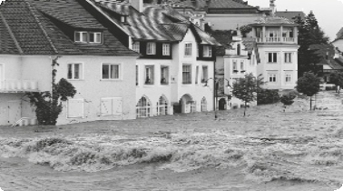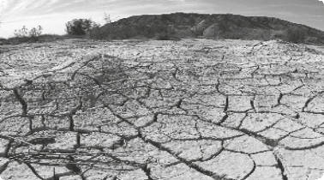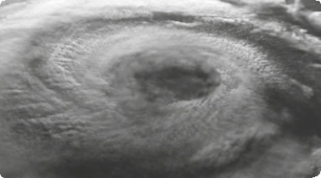1.
2.
3.

4.
5.
6.

E Look at the following sentences and choose the best option.

1. a) Nature is always beautiful. b) Nature always is beautiful.

2. a) She don’t buy always aerosol cans. b) She doesn’t always buy aerosol cans.

3. a) I often reuse plastic bags. b) I reuse often plastic bags.

4. a) He go sometimes to the bottle bank. b) He sometimes goes to the bottle bank.

F Choose the correct form of the Past Simple of the verbs.

1. When I was/were younger I didn’t understand/didn’t understood these questions about the environment.

2. Did you talk/Did you talked about this with your friends?

3. Peter goed/went camping this weekend.

4. I read/readed some information about it and understanded/understood the importance of them.

5. Our class visited/visit a recycling centre.

G Find the mistakes in the sentences and correct them.

1. I use to ask for plastic bags at the supermarket.

2. Did you used to recycle?

3. I didn’t used to care about environmental problems.

H A friend of yours sent you an e-mail saying he/she was going to camp with some friends. Write an e-mail giving him/her some advice about the things he/she can do to protect nature.

Unit 1 Wild side
New Wave Revolution · 8.˚ ano Evaluation Tests

Test 1C

Name No. Class

Date / / Evaluation Teacher

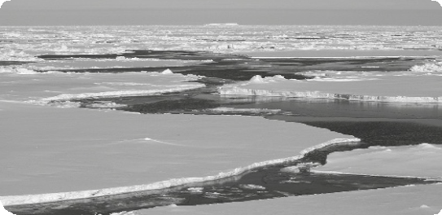The layer of ice covering the Arctic Ocean is thinner than usual. In future summers the ice could completely disappear. The area of ice this year was over four million km2, which is a lot less than last year.

Experts said that the past record would not happen again. However, conditions have changed quickly. The ice cover is now just so thin and weak in the springtime that large parts of it can’t survive the melt season.

Sea ice in the Arctic Ocean grows in winter and partly melts in summer. More sea ice melts in the summer now than in the past decades. Environmentalists say this is because of global warming. The six lowest periods of sea-ice cover happened in the last six years.

More melting means there is less ice to reflect the sun’s heat; and this means the ocean gets warmer. This year’s ice cover was equivalent to last year’s levels until July, after that it started disappearing faster. Meteorologists say a strong storm that hit the Arctic in early August made the thinner ice weaker, making it melt much faster.

Source: www.breakingnewsenglish.com

A Match the words from the text to their meanings.

1. layer a) become liquid

2. record b) send back

3. melt c) sheet

4. reflect d) write down facts or events

B Say whether the sentences are True (T) or False (F) according to the text.
Correct the false ones.

1. According to the article there may be no Arctic ice in future winters.

2. According to the article the area of ice is shorter than before.

3. Experts said that the past record would not repeat again.

4. All the ice melts in the summer.

5. The last six years were the highest periods in Arctic ice cover.

C Answer the questions about the text.

1. What was the area of ice recorded this year?

2. Why is sea ice in the Artic Ocean melting more than before?

3. What are the consequences of more ice melting?

4. What made the ice melt faster this year?

D Label the pictures with the words from the boxes.

deforestation
drought
air pollution
solar power
water pollution
recycle

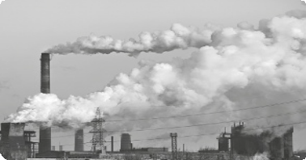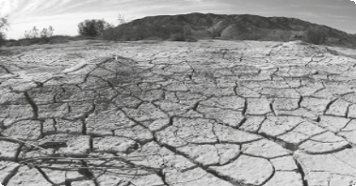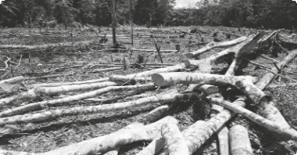1.
2.
3.

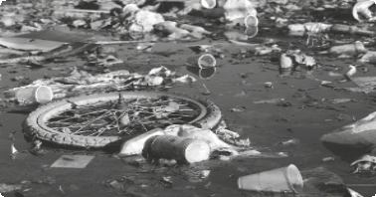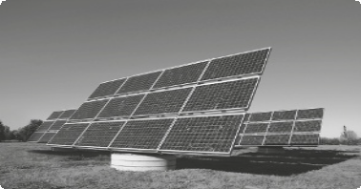4.
5.
6.

New Wave Revolution · 8.˚ ano Evaluation Tests

E Build sentences using the Present Simple and the adverbs of frequency in the right order.

1. aerosol / sometimes / cans / she / buy

2. floods / usually / be / dangerous / very

3. he / trees / never / cut

4. I / about / documentaries / watch / often / endangered / species

5. always / she / environment / the / protect

F Complete the sentences using the Past Simple of the verbs in brackets.

1. When we (be) at Mary’s house, we (watch) a BBC
programme about the Arctic.

2. (you / know) the sea level is rising?

3. China (not / have) a typhoon last week.

4. John (read) a newspaper article about environmental problems.

5. My mother (call) the weather centre because she (see)
a tornado.

G Find the mistakes in the sentences and correct them.

1. We use to buy a tree for Christmas.

2. Did you used to go to the bottle bank?

3. I didn’t used to care about the environment.

H What can you do to protect the environment?
Write a small text about it.

Answer Key

Unit 1 Wild side

Listening Test 1

Script
Even though it’s springtime there are already bush fires in Australia.
We spoke to Michael Silver, who lost his home. He lived near Sydney, Australia’s largest city.

What did you feel when your house was surrounded by flames?
I didn’t think much at all. My wife packed the essential things while I was letting our animals go, hoping that they would survive. And we just drove away through walls of flames on both sides of the road. We didn’t know what we were going to find on the other side, but we had to continue, trying to escape.

What were the conditions like?
They were horrendous. It was like a war zone, I imagine: too much smoke, noise, helicopters flying over, the water bombing to extinguish the fire… It was hell! It’s not even summer, yet! It’s Spring! People weren’t expecting fires this month.

What did you lose?
I’m very sad because I lost my house, but life is more important than property. But I lost personal things I can never replace such as my family photos. It’s the photos I miss most of all.

A. 4, 2, 1, 3

B. 1. T. 2. T. 3. F. 4. T. 5. F. 6. F. 7. T. 8. F.
Test 1A

A. 1. vulnerable; 2. breed; 3. rise; 4. seek

B. 1. T.; 2. T.; 3. F. It has got a large diversity of life.;
4. F. Reefs can develop in diameter and vertically.;
5. F. They need sunlight.

C. 1. The Great Barrier Reef became a World Heritage
Site in 1981.
2. We can find whales, dolphins, more than 1,500 fish species, including the clownfish, sea snakes and sea turtles.
3. The main dangers are climate change, pollution and fishing.
4. Because of water pollution from boats, the catching of forbidden species like dolphins and turtles, and the habitat destruction from anchors and nets.

D. 1. flood; 2. drought; 3. hurricane; 4. endangered species (panda); 5. exhaust fumes; 6. wind power

E. 1. Nature is always beautiful.
2. She never buys aerosol cans.
3. I often reuse plastic bags.
4. He sometimes goes to the bottle bank.

F. 1. was; didn’t understand; 2. Did you talk; 3. went;
4. read; understood; 5. visited

G. 1. I used to…; 2. Did you use to…; 3. I didn’t use to…

H. Personal answer.

New Wave Revolution · 8.˚ ano Answer Key

Test 1B

A. 1. b); 2. c); 3. d); 4. a)

B. 1. T.; 2. T.; 3. F. It has got a large diversity of life.;
4. F. Reefs can develop in diameter and vertically.;
5. F. They need sunlight.

C. 1. The Great Barrier Reef became a World Heritage
Site in 1981.
2. We can find whales, dolphins, more than 1,500 fish species, including the clownfish, sea snakes and sea turtles.
3. The main dangers are climate change, pollution and fishing.
4. Because of water pollution from boats, the catching of forbidden species, like dolphins and turtles, and the habitat destruction from anchors and nets.

D. 1. flood; 2. drought; 3. hurricane; 4. endangered species (panda); 5. exhaust fumes; 6. wind power

E. 1. a); 2. b); 3. a); 4. b).

F. 1. was; didn’t understand; 2. Did you talk;
3. went; 4. read; understood; 5. visited

G. 1. I used to…; 2. Did you use to…; 3. I didn’t use to…

H. Personal answer.
Test 1C

A. 1. c); 2. d); 3. a); 4. b).

B. 1. F. According to the article there may be no Arctic ice in the future summers.; 2. T.; 3. T.; 4. F. Part of the Arctic ice melts in the summer.; 5. F. The last
six years were the lowest periods in Arctic ice cover.

C. 1. The area of ice recorded was over four million km2.
2. Environmentalists say this is due to global warming.
3. More ice melting means there is less ice to reflect the sun’s heat and the ocean gets warmer.
4. A strong storm in early August.

D. 1. factory smoke emissions; 2. drought;
3. deforestation; 4. water pollution; 5. recycle;
6. solar power.

E. 1. She sometimes buys aerosol cans.
2. Floods are usually very dangerous.
3. He never cuts trees.
4. I often watch documentaries about endangered species.
5. She always protects the environment.

F. 1. were; watched; 2. Did you know; 3. didn’t have;
4. read; 5. called; saw

G. 1. We used to…; 2. Did you use to…; 3. I didn’t use to…

H. Personal answer.

