Matriz do Teste 2B
Objetivos | Conteúdos | Estrutura | Cotações | Critérios de classificação
Compreender o texto.  Expressar informação de forma clara e estruturalmente correta. | Texto e vocabulário relacionados com os tópicos da unidade | A. Identificar sinónimos no texto. | 4 x 1,5 = 6 p | Resposta correta: 1,5 pontos; Resposta incorreta: 0 pontos.
 | Texto e vocabulário relacionados com os tópicos da unidade | B. Distinguir frases verdadeiras e falsas. | 5 x 2 = 10 p | Resposta correta: 2 pontos; Resposta incorreta: 0 pontos. Correção da frase falsa: 2 pontos.
 | Texto e vocabulário relacionados com os tópicos da unidade | C. Responder a perguntas sobre o texto. | 4 x 5,5 = 22 p

Matriz do teste de Compreensão Oral
Objetivos | Conteúdos | Estrutura | Cotações | Critérios de classificação
Compreender o texto. | Texto e vocabulário relacionados com os tópicos da unidade | A. Distinguir frases verdadeiras e falsas. | 6 x 10 = 60 p | Resposta correta: 10 pontos; Resposta incorreta: 0 pontos.
Compreender o texto. | Texto e vocabulário relacionados com os tópicos da unidade | B. Completar espaços. | 5 x 8 = 40 p | Resposta correta: 8 pontos; Resposta incorreta: 0 pontos.
 |  |  | 100%

Matriz do Teste 2A
Objetivos | Conteúdos | Estrutura | Cotações | Critérios de classificação
Compreender o texto.  Expressar informação de forma clara e estruturalmente correta. | Texto e vocabulário relacionados com os tópicos da unidade | A. Identificar sinónimos no texto. | 4 x 1,5 = 6 p | Resposta correta: 1,5 pontos; Resposta incorreta: 0 pontos.
 | Texto e vocabulário relacionados com os tópicos da unidade | B. Distinguir frases verdadeiras de falsas e corrigir as falsas. | 5 x 1,5 = 7,5 p  3 x 1,5 = 4,5 p | Resposta correta: 1,5 pontos; Resposta incorreta: 0 pontos. Correção da frase falsa: 1,5 pontos
 | Texto e vocabulário relacionados com os tópicos da unidade | C. Responder a perguntas sobre o texto. | 4 x 5,5 = 22 p | Resposta correta: 5,5 pontos; Resposta incorreta: 0 pontos;  Conteúdo parcialmente correto: 2 pontos; Desconto máximo para incorreções: 4 pontos.
Aplicar o vocabulário tratado na unidade. | Vocabulário relacionado com os tópicos da unidade | D. Identificar imagens. | 6 x 2,5 = 15 p | Resposta correta: 2,5 pontos; Resposta incorreta: 0 pontos.
Aplicar os itens gramaticais tratados. | Countable and uncountable nouns (much/many/a little/  a few/a lot of/lots of) | E. Completar espaços. | 10 x 1,5 = 15 p | Resposta correta: 1,5 pontos; Resposta incorreta: 0 pontos.
Aplicar os itens gramaticais tratados. | Grau dos Adjetivos | F. Preencher espaços com o adjetivo no grau correto. | 6 x 2 = 14 p | Resposta correta: 2 pontos; Resposta incorreta: 0 pontos.
Produzir um enunciado escrito. | Comida | G. Descrever um pequeno almoço equilibrado. | 20 p | 16-20 pontos – o texto respeita o tema, tem uma estrutura coerente e não apresenta erros ortográficos relevantes.  10-15 pontos – o texto respeita o tema, mas revela alguns erros de estrutura e de ortografia.  1-9 pontos – o texto não respeita integralmente o tema, tem erros de estrutura graves e apresenta erros ortográficos que dificultam a comunicação.  0 pontos – o texto não respeita o tema proposto ou tem erros de estrutura graves e apresenta erros ortográficos que inviabilizam a sua compreensão.
 |  |  | 100%

Resposta correta: 5,5 pontos; Resposta incorreta: 0 pontos;
Conteúdo parcialmente correto: 2 pontos; Desconto máximo para incorreções: 4 pontos.

New Wave Revolution · 8.˚ ano Evaluation Tests

ditora orto
©

WR8TR
N
P E

Objetivos | Conteúdos | Estrutura | Cotações | Critérios de classificação
Aplicar o vocabulário tratado na unidade. | Vocabulário relacionado com os tópicos da unidade | D. Identificar imagens. | 6 x 2,5 = 15 p | Resposta correta: 2,5 pontos; Resposta incorreta: 0 pontos.
Aplicar os itens gramaticais tratados. | Countable and uncountable nouns (much/many/a little/  a few/a lot of/lots of) | E. Escolher a opção correta. | 10 x 1,5 = 15 p | Resposta correta: 1,5 pontos; Resposta incorreta: 0 pontos.
Aplicar os itens gramaticais tratados. | Grau dos Adjetivos | F. Escolher a opção correta. | 6 x 2= 12 p | Resposta correta: 2 pontos; Resposta incorreta: 0 pontos.
Produzir um enunciado escrito. | Comida | G. Descrever um pequeno almoço equilibrado. | 20 p | 16-20 pontos – o texto respeita o tema, tem uma estrutura coerente e não apresenta erros ortográficos relevantes.  10-15 pontos – o texto respeita o tema, mas revela alguns erros de estrutura e de ortografia.  1-9 pontos – o texto não respeita integralmente o tema, tem erros de estrutura graves e apresenta erros ortográficos que dificultam a comunicação.  0 pontos – o texto não respeita o tema proposto ou tem erros de estrutura graves e apresenta erros ortográficos que inviabilizam a sua compreensão.
 |  |  | 100%

Matriz do Teste 2C
Objetivos | Conteúdos | Estrutura | Cotações | Critérios de classificação
Compreender o texto.  Expressar informação de forma clara e estruturalmente correta. | Texto e vocabulário relacionados com os tópicos da unidade | A. Correspondência de palavras do texto com sinónimos. | 4 x 1,5 = 6 p | Resposta correta: 1,5 pontos; Resposta incorreta: 0 pontos.
 | Texto e vocabulário relacionados com os tópicos da unidade | B. Distinguir frases verdadeiras e falsas e corrigir as falsas. | 5 x 1,5 = 7,5 p  3 x 1,5 = 4,5 p | Resposta correta: 1,5 pontos; Resposta incorreta: 0 pontos; Correção da frase falsa: 1,5 pontos.
 | Texto e vocabulário relacionados com os tópicos da unidade | C. Responder a perguntas sobre o texto. | 4 x 5,5 = 22 p | Resposta correta: 5,5 pontos; Resposta incorreta: 0 pontos;  Conteúdo parcialmente correto: 2 pontos; Desconto máximo para incorreções: 4 pontos.
Aplicar o vocabulário tratado na unidade. | Vocabulário relacionado com os tópicos da unidade | D. Identificar imagens. | 5 x 3 = 15 p | Resposta correta: 2,5 pontos; Resposta incorreta: 0 pontos.
Aplicar os itens gramaticais tratados. | Countable and uncountable nouns (much/many/a little/  a few/a lot of/ lots of) | E. Preencher espaços. | 10 x 1,5 = 15 p | Resposta correta: 1,5 pontos; Resposta incorreta: 0 pontos.
Aplicar os itens gramaticais tratados. | Grau dos Adjetivos | F. Escolher a opção correta. | 5 x 2 = 10 p | Resposta correta: 2 pontos; Resposta incorreta: 0 pontos.
Produzir um enunciado escrito. | Comida | G. Descrever a ceia de  Natal. ou  Comentar a ingestão de peixe e carne crus. | 20 p | 16-20 pontos – o texto respeita o tema, tem uma estrutura coerente e não apresenta erros ortográficos relevantes.  10-15 pontos – o texto respeita o tema, mas revela alguns erros de estrutura e de ortografia.  1-9 pontos – o texto não respeita integralmente o tema, tem erros de estrutura graves e apresenta erros ortográficos que dificultam a comunicação.  0 pontos – o texto não respeita o tema proposto ou tem erros de estrutura graves e apresenta erros ortográficos que inviabilizam a sua compreensão.
 |  |  | 100%

Correction Table Listening Test 2 / Test 2A

Unit Class Date / /

No. | Name | Listening Test 2 |  | Total | Test 2A |  |  |  |  |  |  |  | Total | Final  Mark
No. | Name | A | B | Total | A | B |  | C | D | E | F | G | Total | Final  Mark
No. | Name | 6 x 10 | 5 x 8 | 100 | 4 x 1,5 | 5 x 1,5 | 3 x 1,5 | 4 x 5,5 | 6 x 2,5 | 10 x 1,5 | 6 x 2 | 20 | 100 | Final  Mark
1.
2.
3.
4.
5.
6.
7.
8.
9.
10.
11.
12.
13.
14.
15.
16.
17.
18.
19.
20.
21.
22.
23.
24.
25.
26.
27.
28.
29.
30.

Correction Table Tests 2B-C

Unit Class Date / /

New Wave Revolution · 8.˚ ano Evaluation Tests

No. | Name | Test 2B |  |  |  |  |  |  | Test 2C |  |  |  |  |  |  |  | Total | Final  Mark
No. | Name | A | B | C | D | E | F | G | A | B |  | C | D | E | F | G | Total | Final  Mark
No. | Name | 4 x 1,5 | 5 x 2 | 4 x 5,5 | 6 x 2,5 | 10 x 1,5 | 6 x 2 | 20 | 4 x 1,5 | 5 x 1,5 | 3 x 1,5 | 4 x 5,5 | 5 x 3 | 10 x 1,5 | 5 x 2 | 20 | 100 | Final  Mark
1.
2.
3.
4.
5.
6.
7.
8.
9.
10.
11.
12.
13.
14.
15.
16.
17.
18.
19.
20.
21.
22.
23.
24.
25.
26.
27.
28.
29.
30.

Listening Test 2
Food, glorious food!
Unit 2

Name No Class

Date / / Evaluation Teacher

A Say whether the sentences are True (T) or False (F) according to the text.

1. A new computer menu downloads eating and exercise information.

2. A researcher says information about walking off calories is very useful.

3. The researcher said we do not really understand calories.

4. We all understand how much exercise we need to do to burn the calories we eat.

5. Researchers said that not everyone can fast walk.

6. A doctor said we have to order low-calorie food.

B Listen and write the missing words to complete the text.

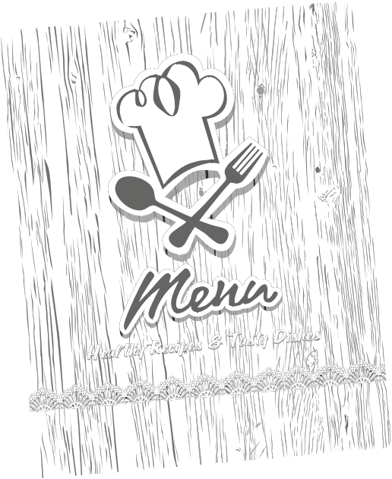
The researchers looked at the 1
orders made by different people. Some used a menu
2 calorie information; some had a menu with calorie information; and the rest had a menu with 3 about how many minutes of fast 4 would burn off the calories in the 5 . For example you
need to walk for two hours to burn off the calories in a 6 cheeseburger. The people who had the menus with the 7
information ordered food with the 8
calories.

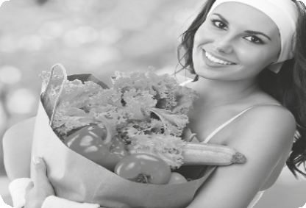

Unit 2 Food, glorious food!

Test 2A

Name No. Class

Date / / Evaluation Teacher

Deciding to become a vegetarian can be a big decision because it is difficult to stop eating meat. The first thing is to decide what kind of vegetarian you want to be: lacto-ovo, lacto-vegetarian, ovo-vegetarian or vegan.

Confused? Let me explain.
• A lacto-ovo vegetarian is someone who eats dairy products (like milk and cheese) as well as eggs and all plant-based foods (vegetables, grains, fruits, etc).
• A lacto-vegetarian is someone who eats dairy products (like milk and cheese) and plant-based foods
(vegetables, grains, fruits, etc.) but not eggs.
• An ovo-vegetarian is someone who eats eggs and plant-based foods but no dairy products.
• A vegan or pure vegetarian is someone who does not eat any dairy products or eggs and only eats plant- based foods.

The important thing for teens (vegetarian or not) is to get all the right nutrients. A common mistake that first-time vegetarians make is having a diet of mainly pasta and pizza. It is important to include alternatives like beans, tofu, lentils, nuts as well as vegetables.

Vegetarians must have a diet rich in iron because it can only be obtained from food. It is found in red meat, such as liver. Because vegetarians don’t eat meat they can find other good sources of iron in fish, eggs, beans and green vegetables, like spinach and lettuce. As long as you have all the vitamins and nutrients you need on a daily basis, you should be just fine.

Source: http://www.kidzworld.com

A Find words or phrases in the text that mean the same as…

1. type 3. get

2. error 4. origin

B Say whether the sentences are True (T) or False (F).
Correct the false ones.

1. There are different types of vegetarians.

2. All vegetarians eat plant-based foods and don’t eat meat.

3. Beans, tofu, lentils and nuts are meat alternatives for vegetarians.

4. Liver is rich in vitamin C.

5. Spinach isn’t a good source of iron.

C Answer the questions about the text.

1. What’s the difference between a lacto-vegetarian and an ovo-vegetarian?

2. What is usually the diet of “new” vegetarians?

3. Why must vegetarians have a diet rich in iron?

4. Where can vegetarians find good sources of iron?

D Label the pictures.

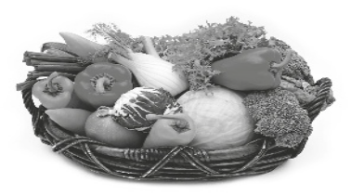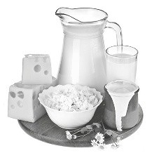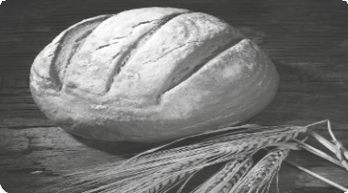1.
2.
3.

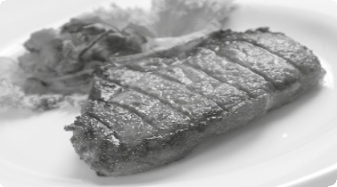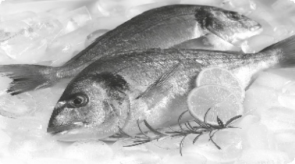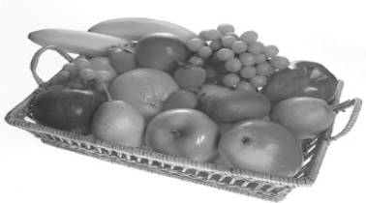4.
5.
6.

New Wave Revolution · 8.˚ ano Evaluation Tests

E Complete the text with the words from the boxes.

lots of
a few
some
many (2x)
much
a little any
so a lot of

Birthday parties are hard work. So 1 recipes but 2 delicious! Let me check if I’ve got all the ingredients. There’s 3 milk. I’ll buy more. I’ll need
4 oranges to make 5 orange juice. I’ll need 6 apples for the apple pie. There aren’t 7 . There’s not 8 chocolate powder left for the birthday cake and only 9 eggs. Ok. I’ll go to the supermarket to buy these
ingredients and 10 balloons.

F Fill in the spaces with the correct form of the adjectives in brackets.

1. Breakfast is (important) meal of the day.

2. Vegetables and fruit are (expensive) than fast food but are
(healthy).

3. Getting all the right nutrients should be our (big) concern.

4. Eating well and regular exercise will keep you (fit).

5. Your (good) treasure is your health.

G It’s your mother’s birthday. You want to surprise her with a healthy big breakfast. Describe what you would prepare and justify your choices.

Unit 2 Food, glorious food!

Test 2B

Name No. Class

Date / / Evaluation Teacher

Deciding to become a vegetarian can be a big decision because it is difficult to stop eating meat. The first thing is to decide what kind of vegetarian you want to be: lacto-ovo, lacto-vegetarian, ovo-vegetarian or vegan.

Confused? Let me explain.
• A lacto-ovo vegetarian is someone who eats dairy products (like milk and cheese) as well as eggs and all plant-based foods (vegetables, grains, fruits, etc).
• A lacto-vegetarian is someone who eats dairy products (like milk and cheese) and plant-based foods
(vegetables, grains, fruits, etc.) but not eggs.
• An ovo-vegetarian is someone who eats eggs and plant-based foods but no dairy products.
• A vegan or pure vegetarian is someone who does not eat any dairy products or eggs and only eats plant- based foods.

The important thing for teens (vegetarian or not) is to get all the right nutrients. A common mistake that first-time vegetarians make is having a diet of mainly pasta and pizza. It is important to include alternatives like beans, tofu, lentils, nuts as well as vegetables.

Vegetarians must have a diet rich in iron because it can only be obtained from food. It is found in red meat, such as liver. Because vegetarians don’t eat meat they can find other good sources of iron in fish, eggs, beans and green vegetables, like spinach and lettuce. As long as you have all the vitamins and nutrients you need on a daily basis, you should be just fine.

Source: http://www.kidzworld.com

A Match the words or expressions from the text to their synonyms.

1. kind a) origin

2. mistake b) type

3. obtain c) error

4. source d) get

B Say whether the sentences are True (T) or False (F).

1. There are different types of vegetarians.

2. All vegetarians eat plant-based foods and don’t eat meat.

3. Beans, tofu, lentils and nuts are meat alternatives for vegetarians.

New Wave Revolution · 8.˚ ano Evaluation Tests

4. Liver is rich in vitamin C.

5. Spinach isn’t a good source of iron.

C Answer the questions about the text.

1. What’s the difference between a lacto-vegetarian and an ovo-vegetarian?

2. What is usually the diet of “new” vegetarians?

3. Why must vegetarians have a diet rich in iron?

4. Where can vegetarians find good sources of iron?

D Label the pictures with words from the boxes.

dairy products bread fish meat fruit vegetables

1.
2.
3.

4.
5.
6.

E Choose the correct option.

Birthday parties are hard work. So 1many/much recipes but 2so/any delicious!
Let me check if I’ve got all the ingredients. There’s 3a lot of/a little milk. I’ll buy more. I’ll need 4any/many oranges to make 5a lot of/a little orange juice. I’ll need 6any/some apples for the apple pie. There aren’t 7any/some. There’s not 8many/much chocolate powder left for the birthday cake and only 9lots of/a few eggs. Ok. I’ll go to the supermarket to buy these ingredients and 10lots of/much balloons.

F Fill in the spaces with the correct form of the adjectives in brackets.

1. Breakfast is (important) meal of the day.

a) the most important b) more important

2. Vegetables and fruit are (expensive) than fast food but are
(healthy).

a) most expensive / more healthy b) more expensive / healthier

3. Getting all the nutrients is (big) concern of vegetarians.

a) bigger b) the biggest

4. Eating well and regular exercise will keep you (fit).

a) fitter b) more fit

5. Your (good) treasure is your health.

a) best b) better

G It’s your mother’s birthday. You want to surprise her with a healthy big breakfast. Describe what you would prepare and justify your choices.

Unit 2 Food, glorious food!
New Wave Revolution · 8.˚ ano Evaluation Tests

Test 2C

Name No. Class

Date / / Evaluation Teacher

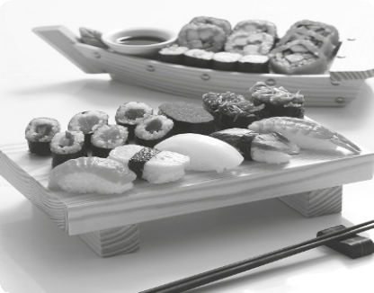The United Nations is going to put traditional Japanese food on the list of important world cuisines. It will be the fifth time for UNESCO to give a country’s or region’s food its cultural heritage status. French, Mediterranean, Mexican and Turkish food are already on the list.

Traditional Japanese food is called Washoku. It is very famous for its variety. It ranges from sushi (raw fish on rice) to ramen noodles, tempura and sukiyaki. Japan’s Agency for Cultural Affairs said it wants to put all of its food on the list, not just one or two famous dishes. Japanese food is special because of its artistic presentation. It also uses unique ingredients. Many dishes are important because they celebrate the four seasons.

Washoku is very healthy and has a good balance of minerals, vitamins, carbohydrates and protein. It is one of the reasons why Japanese people live for so long. It also helps to keep obesity levels low. The cuisine is also important as different meals throughout
the year help to bring families and communities together. Food plays an important role in many ceremonies that mark seasonal traditions. The menu for New Year’s celebrations, rice-planting events and harvest festivals are all very different. Japan’s government said food helps Japanese people keep a strong sense of culture. It also said Washoku is closely “associated with an essential spirit of respect for nature.”

Sources: www.breakingnewsenglish.com

A Match the words from the text to their synonyms.

1. throughout a) cooking

2. heritage b) special

3. unique c) all around

4. cuisine d) cultural background

B Say whether the sentences are True (T) or False (F) according to the text. Correct the false ones.

1. The United Nations will give modern Japanese food a special prize.

2. Japan doesn’t want only sushi and sukiyaki to be on the UNESCO list.

3. Japanese food isn’t presented in an artistic way.

4. The Japanese diet is not well balanced.

5. ‘Washoku’ is associated with a respect for nature.

C Answer the questions about the text.

1. How many other cuisines are already on the UNESCO list?

2. Why is Washoku considered healthy food?

3. Why is the cuisine more important than just eating?

4. Which celebrations have special dishes in Japan?

D Label the pictures.

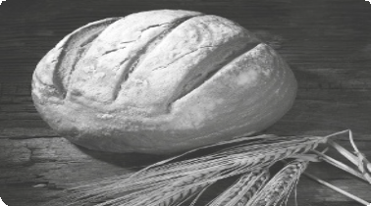1.
2.
3.

4.
5.
6.

New Wave Revolution · 8.˚ ano Evaluation Tests

E Complete the text with the words from the boxes.

so (2x) many (2x) so much (2x) some
any
a lot of
lots of

Why do Japanese live 1 long? Japanese cuisine is 2 rich in nutrients that it allows Japanese to live 3 years. There are so 4 shapes and
5 different flavours in it. This cuisine doesn’t use meat 6 but there is
7 . They prefer to eat 8 raw fish, rice and some vegetables. I don’t remember seeing 9 fruit in the dishes! But I can forget the way they look! There is 10 art in their presentations!

F Fill in the spaces with the correct form of the adjectives in brackets.

1. Breakfast is (important) meal of the day.

a) more important b) the most important

2. Japanese cuisine is (healthy) than fast food but
(expensive).

a) more healthy / expensiver b) healthier / more expensive

3. Getting all the right nutrients allows you to live (long).

a) longer b) the longest

4. Eating well and regular exercise will keep you (fit).

a) more fit b) fitter

5. Japanese cuisine is (artistic) cuisine in Asia.

a) the most artistic b) more artistic

G Choose one topic and write a short paragraph about it.

• What special food do you eat on Christmas Eve?
• What do you think of raw fish and raw meat?

Answer Key

Unit 2 Food, glorious food!

Listening Test 2

Script

Menu shows exercise needed to lose weight

A.
New research reveals that restaurant menus, showing how much exercise is needed to burn off calories, are better for losing weight. Telling people how many minutes they must fast walk to burn off the calories from a hamburger makes them think twice about eating it. People don’t really understand calories but do understand how long they have to fast walk. Walking fast is something everyone can do. A doctor said the menu could help people make healthier choices. She said ‘We need to encourage people to consume fewer calories.’
B.
The researchers looked at the restaurant orders made by different people. Some used a menu without calorie information; some had a menu with calorie information; and the rest had a menu with information about how many minutes of fast walking would burn
off the calories in the food. For example, you need to walk for two hours to burn off the calories in a double cheeseburger. The people who had the menus with the exercise information ordered food with the fewest calories.

Source: www.breakingnewsenglish.com

A. 1. T. 2. T. 3. T. 4. T. 5. F. 6. T.

B. 1. restaurant; 2. without; 3. information;
4. walking; 5. food; 6. double; 7. exercise;
8. fewest.
Test 2A

A. 1. kind; 2. mistake; 3. obtained; 4. sources.

B. 1. T. 2. T. 3. T. 4. F. Liver is rich in iron. 5. F.
Spinach is a good source of iron.

C. 1. A lacto-vegetarian is someone who eats dairy products and plant-based foods but not eggs.
An ovo-vegetarian is someone who eats eggs and plant-based foods but no dairy products.
2. First-time vegetarians usually have a diet of mainly pasta and pizza.
3. Iron can only be obtained from food. It’s usually found in red meat, but because vegetarians don’t eat meat they must find other good sources of iron.
4. Vegetarians can find good sources of iron in fish, eggs, beans and leafy green vegetables, like
spinach and lettuce.

D. 1. vegetables; 2. dairy products; 3. bread;
4. meat; 5. fish; 6. fruit.

E. 1. many / a lot of / lots of; 2. so; 3. a little;
4. many / a lot of / lots of; 5. a lot of;
6. some; 7. any; 8. much; 9. a few; 10. lots of

F. 1. the most important; 2. more expensive than;
healthier; 3. biggest; 4. fitter; 5. best.

G. Personal answer.

New Wave Revolution · 8.˚ ano Answer Key

Test 2B

A. 1. b; 2. c; 3. d; 4. a.

B. 1. T. 2. T. 3. T.; 4. F. 5. F.

C. 1. A lacto-vegetarian is someone who eats dairy products and plant-based foods but not eggs.
An ovo vegetarian is someone who eats eggs and plant-based foods but no dairy products.
2. First-time vegetarians usually have a diet of mainly pasta and pizza.
3. Iron can only be obtained from food. It’s usually found in red meat, but because vegetarians don’t
eat meat they must find other good sources of iron.;
4. Vegetarians can find good sources of iron in fish, eggs, beans and leafy green vegetables, like
spinach and lettuce.

D. 1. vegetables; 2. dairy products; 3. bread;
4. meat; 5. fish; 6. fruit.

E. 1. many; 2. so; 3. a little; 4. many; 5. a lot of;
6. some; 7. any; 8. much; 9. a few; 10. lots of

F. 1. a; 2. b; 3. b; 4. a; 5. a.

G. Personal answer.
Test 2C

A. 1. d); 2. c); 3. a); 4. b).

B. 1. F. The United Nations will give traditional Japanese food a special prize.; 2. T.; 3. F. A cultural agency said Japanese food is presented in an
artistic way.; 4. F. The Japanese diet is well balanced.; 5. T.

C. 1. Four other cuisines are already on the UNESCO
list: French, Mediterranean, Mexican and Turkish.;
2. ‘Washoku’ is healthy because it has a good balance of minerals, vitamins, carbohydrates and protein, which help to keep obesity levels low. That’s why Japanese people live for so long.;
3. Cuisine is also important because it helps to bring families and communities together.
4. The New Year’s celebrations, rice-planting events and harvest festivals.

D. 1. vegetables; 2. dairy products; 3. bread;
4. meat; 5. fish; 6. fruit.

E. 1. so; 2. so; 3. many / a lot of / lots of; 4. many;
5. a lot of / lots of; 6. so much; 7. some; 8. lots of; 9. any; 10. so much

F. 1. b); 2. b); 3. a); 4. b); 5. a)

G. Personal answer.

