Unit 6 Tomorrow and yesteryear

Matriz do teste de Compreensão Oral
Objetivos | Conteúdos | Estrutura | Cotações | Critérios de classificação
Compreender o texto. | Texto e vocabulário relacionados com os tópicos da unidade | A. Escolher a opção correta. | 7 x 10 = 70 p | Resposta correta: 10 pontos; Resposta incorreta: 0 pontos.
Compreender o texto. | Texto e vocabulário relacionados com os tópicos da unidade | B. Preencher espaços. | 6 x 5 = 30 p | Resposta correta: 5 pontos; Resposta incorreta: 0 pontos.
 |  |  | 100%

Matriz do Teste 6A
Objetivos | Conteúdos | Estrutura | Cotações | Critérios de classificação
Compreender o texto.  Expressar informação de forma clara e estruturalmente correta. | Texto e vocabulário relacionados com os tópicos da unidade | A. Identificar sinónimos no texto. | 4 x 1,5 = 6 p | Resposta correta: 1,5 pontos; Resposta incorreta: 0 pontos.
 | Texto e vocabulário relacionados com os tópicos da unidade | B. Distinguir frases verdadeiras e falsas e corrigir as falsas. | 5 x 1,5 = 7,5 p  3 x 1,5 = 4,5 p | Resposta correta: 1,5 pontos; Resposta incorreta: 0 pontos; Correção da frase falsa: 1,5 pontos.
 | Texto e vocabulário relacionados com os tópicos da unidade | C. Responder a perguntas sobre o texto. | 4 x 5 = 20 p | Resposta correta: 5 pontos; Resposta incorreta: 0 pontos;  Conteúdo parcialmente correto: 2 pontos; Desconto máximo para incorreções: 4 pontos.
Aplicar o vocabulário tratado na unidade. | Vocabulário relacionado com os tópicos da unidade | D. Fazer correspondência. | 10 x 1,5 = 15 p | Resposta correta: 1,5 pontos; Resposta incorreta: 0 pontos.
Aplicar os itens gramaticais tratados. | Modal verbs could/couldn’t would/wouldn’t | E. Preencher espaços. | 6 x 2,5 = 15 p | Resposta correta: 2,5 pontos; Resposta incorreta: 0 pontos.
Aplicar os itens gramaticais tratados. | Phrasal verbs | F. Preencher espaços. | 6 x 2 = 12 p | Resposta correta: 2 pontos; Resposta incorreta: 0 pontos.
Produzir um enunciado escrito. | Visões de futuro | G. Comentar uma afirmação. | 20 p | 16-20 pontos – o texto respeita o tema, tem uma estrutura coerente e não apresenta erros ortográficos relevantes.  10-15 pontos – o texto respeita o tema, mas revela alguns erros de estrutura e de ortografia.  1-9 pontos – o texto não respeita integralmente o tema, tem erros de estrutura graves e apresenta erros ortográficos que dificultam a comunicação.  0 pontos – o texto não respeita o tema proposto ou tem erros de estrutura graves e apresenta erros ortográficos que inviabilizam a sua compreensão.
 |  |  | 100%

Resposta correta: 5 pontos; Resposta incorreta: 0 pontos.

Matriz do Teste 6B
Objetivos | Conteúdos | Estrutura | Cotações | Critérios de classificação
Compreender o texto.  Expressar informação de forma clara e estruturalmente correta. | Texto e vocabulário relacionados com os tópicos da unidade | A. Fazer correspondência entre sinónimos. | 4 x 1,5 = 6 p | Resposta correta: 1,5 pontos; Resposta incorreta: 0 pontos.
 | Texto e vocabulário relacionados com os tópicos da unidade | B. Distinguir frases verdadeiras e falsas. | 5 x 2 = 10 p | Resposta correta: 2 pontos; Resposta incorreta: 0 pontos.
 | Texto e vocabulário relacionados com os tópicos da unidade | C. Escolher a opção correta. | 4 x 5 = 20 p

New Wave Revolution · 8.˚ ano Evaluation Tests

Objetivos | Conteúdos | Estrutura | Cotações | Critérios de classificação
Aplicar o vocabulário tratado na unidade. | Vocabulário relacionado com os tópicos da unidade | D. Fazer correspondência. | 10 x 1,5 = 15 p | Resposta correta: 1,5 pontos; Resposta incorreta: 0 pontos.
Aplicar os itens gramaticais tratados. | Modal verbs could/couldn’t would/wouldn’t | E. Preencher espaços. | 6 x 2,5 = 15 p | Resposta correta: 2,5 pontos; Resposta incorreta: 0 pontos.
Aplicar os itens gramaticais tratados. | Phrasal verbs (conversas telefónicas) | F. Preencher espaços. | 6 x 2 = 12 p | Resposta correta: 2 pontos; Resposta incorreta: 0 pontos.
Produzir um enunciado escrito. | Visões de futuro | G. Comentar uma afirmação. | 20 p | 16-20 pontos – o texto respeita o tema, tem uma estrutura coerente e não apresenta erros ortográficos relevantes.  10-15 pontos – o texto respeita o tema, mas revela alguns erros de estrutura e de ortografia.  1-9 pontos – o texto não respeita integralmente o tema, tem erros de estrutura graves e apresenta erros ortográficos que dificultam a comunicação.  0 pontos – o texto não respeita o tema proposto ou tem erros de estrutura graves e apresenta erros ortográficos que inviabilizam a sua compreensão.
 |  |  | 100%

Matriz do Teste 6C
Objetivos | Conteúdos | Estrutura | Cotações | Critérios de classificação
Compreender o texto.  Expressar informação de forma clara e estruturalmente correta. | Texto e vocabulário relacionados com os tópicos da unidade | A. Identificar sinónimos no texto. | 4 x 1,5 = 6 p | Resposta correta: 1,5 pontos; Resposta incorreta: 0 pontos.
 | Texto e vocabulário relacionados com os tópicos da unidade | B. Distinguir frases verdadeiras de falsas e corrigir as falsas. | 5 x 1,5 = 7,5 p  3 x 1,5 = 4,5 p | Resposta correta: 1,5 pontos; Resposta incorreta: 0 pontos. Correção da frase falsa: 1,5 pontos
 | Texto e vocabulário relacionados com os tópicos da unidade | C. Responder a perguntas sobre o texto. | 4 x 5 = 20 p | Resposta correta: 5 pontos; Resposta incorreta: 0 pontos;  Conteúdo parcialmente correto: 2 pontos; Desconto máximo para incorreções: 4 pontos.
Aplicar o vocabulário tratado na unidade. | Vocabulário relacionado com os tópicos da unidade | D. Fazer correspondência. | 10 x 1,5 = 15 p | Resposta correta: 1,5 pontos; Resposta incorreta: 0 pontos.
Aplicar os itens gramaticais tratados. | Modal verbs could/couldn’t would/wouldn’t | E. Preencher espaços. | 6 x 2,5 = 15 p | Resposta correta: 2,5 pontos; Resposta incorreta: 0 pontos.
Aplicar os itens gramaticais tratados. | Phrasal verbs | F. Preencher espaços. | 6 x 2 = 12 p | Resposta correta: 2 pontos; Resposta incorreta: 0 pontos.
Produzir um enunciado escrito. | Visões de futuro | G. Comentar uma afirmação. | 20 p | 16-20 pontos – o texto respeita o tema, tem uma estrutura coerente e não apresenta erros ortográficos relevantes.  10-15 pontos – o texto respeita o tema, mas revela alguns erros de estrutura e de ortografia.  1-9 pontos – o texto não respeita integralmente o tema, tem erros de estrutura graves e apresenta erros ortográficos que dificultam a comunicação.  0 pontos – o texto não respeita o tema proposto ou tem erros de estrutura graves e apresenta erros ortográficos que inviabilizam a sua compreensão.
 |  |  | 100%

ditora orto
©

WR8TR
N
P E

Correction Table Listening Test 6 / Test 6A

Unit Class Date / /

No. | Name | Listening Test 6 |  | Total | Test 6A |  |  |  |  |  |  |  | Total | Final  Mark
No. | Name | A | B | Total | A | B |  | C | D | E | F | G | Total | Final  Mark
No. | Name | 7 x 10 | 6 x 5 | 100 | 4 x 1,5 | 5 x 1,5 | 3 x 1,5 | 4 x 5 | 10 x 1,5 | 6 x 2,5 | 6 x 2 | 20 | 100 | Final  Mark
1.
2.
3.
4.
5.
6.
7.
8.
9.
10.
11.
12.
13.
14.
15.
16.
17.
18.
19.
20.
21.
22.
23.
24.
25.
26.
27.
28.
29.
30.

Correction Table Tests 6B-C

Unit Class Date / /

New Wave Revolution · 8.˚ ano Evaluation Tests

No. | Name | Test 6B |  |  |  |  |  |  | Test 6C |  |  |  |  |  |  |  | Total | Final  Mark
No. | Name | A | B | C | D | E | F | G | A | B |  | C | D | E | F | G | Total | Final  Mark
No. | Name | 4 x 1,5 | 5 x 2 | 4 x 5 | 10 x 1,5 | 6 x 2,5 | 6 x 2 | 20 | 4 x 1,5 | 5 x 1,5 | 3 x 1,5 | 4 x 5 | 10 x 1,5 | 6 x 2,5 | 6 x 2 | 20 | 100 | Final  Mark
1.
2.
3.
4.
5.
6.
7.
8.
9.
10.
11.
12.
13.
14.
15.
16.
17.
18.
19.
20.
21.
22.
23.
24.
25.
26.
27.
28.
29.
30.

Unit 6 Tomorrow and yesteryear
Listening
Test 6

Name No. Class

Date / / Evaluation Teacher

A Listen to the text and circle the right option.

1. The Dalai Lama was born in .

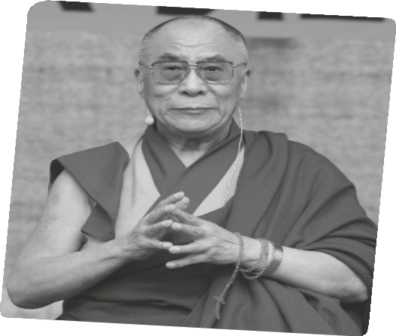a) Tibet. b) Taiwan.

2. His name is Tenzin Gyatso.

a) religious b) real

3. He is a monk.

a) activist b) Buddhist

4. Dalai Lama campaigns for Tibet’s
. a) independence and world’s peace. b) freedom and world’s security.

5. He became Dalai Lama when he was just
.

a) two years old. b) ten years old.

6. He had to escape from Tibet to .

a) Indiana. b) India.

7. After his escape, he .

a) never went back to Tibet. b) returned to Tibet.

B Listen and fill in the gaps.

He travelled to the West – to 1 and America. Thousands of people
2 him. He has helped to spread 3 and harmony around the world. He gives speeches wherever he goes and he has won many awards. He got the Nobel Peace Prize in 1989.
The Dalai Lama has been one of the best-loved and most well-4 world
leaders for many decades. He continues to ask China to give his Tibetan people more control over 5 land. One day he might meet Chinese leaders and talk about a better and 6 future.

New Wave Revolution · 8.˚ ano Evaluation Tests

Unit 6 Tomorrow and yesteryear

Test 6A

Name No. Class

Date / / Evaluation Teacher

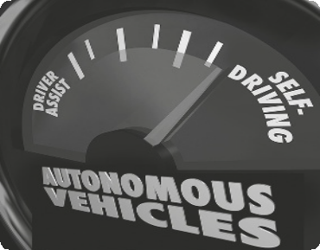Toyota has shown a new driverless car at an electronics show in Las Vegas. The car is full of special “intelligent” safety features to make sure it doesn’t crash. It uses radars and video cameras to understand where other cars are. It can also “see” people and slow down to avoid hitting them. The car can also communicate with other cars that have the same technology.

A Toyota spokesperson said: “We’re looking at a car that would stop accidents. Zero-crashes is our ultimate goal.” He said that the car would usually have a driver, but it can also drive itself. This would be useful if the driver wants to use his or her laptop, or if he or she falls asleep.

Toyota is not the first car maker to attract attention to selfdriving cars. In May 2012, the Swedish company Volvo tested a self-drive group of cars on a Spanish highway. The search engine Google has also invested a lot of money in the technology for these cars. The German auto manufacturers Audi and Mercedes are also developing similar cars.

These cars will reduce traffic jams in the future. They will receive information from computers that monitor traffic and then the cars will take a different route.

Source: www.breakingnewsenglish.com

A Find words or phrases in the text that mean the same as…

1. put an end to

2. final

3. producer

4. keep an eye on

B Say whether the sentences are True (T) or False (F) according to the text.
Correct the false ones.

1. Toyota has shown a car that needs no driver.

2. The car has technology that makes it communicate with any other car.

3. Toyota’s aim is to eliminate car accidents by 50 per cent.

4. Toyota isn’t the first car maker to make cars that do not need a driver.

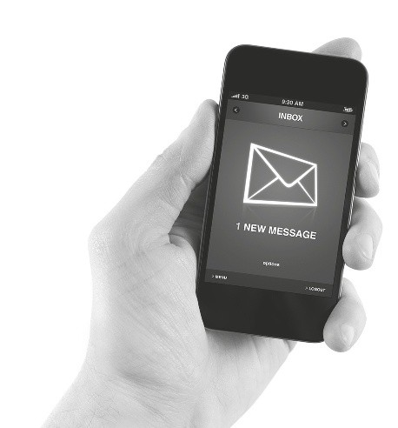5. The new driverless cars will create problems on the roads.

C Answer the questions about the text.

1. How can the car “detect” the obstacles in his way?

2. Why would a driverless car be useful?

3. Where have driverless cars been tested?

4. What will be the effect of these cars on traffic?

D Text messages use informal language. Here are some examples. Match them to their meanings.

1. WAN2 go cnma 2nite? a) Great to see you

2. 2G2BT b) I have a question for you

3. KIT c) Bye bye for now

4. GR8 2 CU d) Do you want to go to the cinema tonight?

5. BBFN e) Friendship, love

6. CU L8R f) See you later

7. <3 g) Tomorrow

8. ?4U h) Forever and ever

9. 2MOR i) Keep in touch

10. 4EAE j) Too good to be true

New Wave Revolution · 8.˚ ano Evaluation Tests

E Complete the sentences using could, couldn’t, would, wouldn’t.

1. you imagine how easy it be getting to school?

There be any traffic jams!

2. you like to come to the auto show with us?

3. I refuse that invitation.

4. I use your mobile to call my mum?

F Complete these parts of formal telephone conversations with the phrasal verbs from the boxes.

A: I’d like to speak to Mr Smith, please.

B: 1 , please. (…) Sorry, he has just

2 .

A: Can I 3 later?

B: Yes, of course.

A: Can you 4 your Delivery Department, please?

B: Just a minute, please.

A: Good morning. Could you 5 to Mrs Smith, please.
B: Sorry, this is no longer her number. Would you like her new phone number?
A: Yes, please. Let me just get a notebook to 6 .

a. gone out b. connect me with c. put me through
d. write it down e. hold on
f. call him back

G Write an e-mail to a friend about your father’s new car.

Unit 6 Tomorrow and yesteryear

Test 6B

Name No. Class

Date / / Evaluation Teacher

Toyota has shown a new driverless car at an electronics show in Las Vegas. The car is full of special “intelligent” safety features to make sure it doesn’t crash. It uses radars and video cameras to understand where other cars are. It can also “see” people and slow down to avoid hitting them. The car can also communicate with other cars that have the same technology.

A Toyota spokesperson said: “We’re looking at a car that would stop accidents. Zero-crashes is our ultimate goal.” He said that the car would usually have a driver, but it can also drive itself. This would be useful if the driver wants to use his or her laptop, or if he or she falls asleep.

Toyota is not the first car maker to attract attention to selfdriving cars. In May 2012, the Swedish company Volvo tested a self-drive group of cars on a Spanish highway. The search engine Google has also invested a lot of money in the technology for these cars. The German auto manufacturers Audi and Mercedes are also developing similar cars.

These cars will reduce traffic jams in the future. They will receive information from computers that monitor traffic and then the cars will take a different route.

Source: www.breakingnewsenglish.com

A Match the words from the text to their synonyms.

1. stop a) producer

2. ultimate b) keep an eye on

3. manufacturer c) put an end to

4. monitor d) final

B Say whether the sentences are True (T) or False (F) according to the text.

1. Toyota has shown a car that needs no driver.

2. The car has technology that means it can communicate with any other car.

3. Toyota’s aim is to eliminate car accidents by 50 per cent.

4. Toyota isn’t the first car maker to make cars that do not need a driver.

5. The new driverless cars will create problems on the roads.

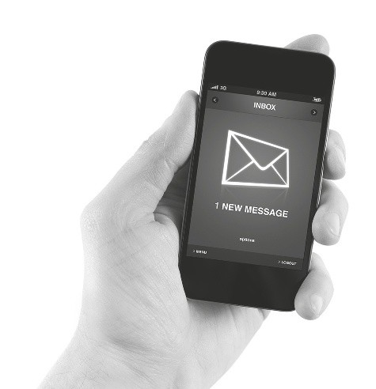New Wave Revolution · 8.˚ ano Evaluation Tests

C Choose the correct answer to the questions about the text.

1. How can the car “detect” the obstacles in his way?

a) It uses radars and video cameras.

b) It communicates with other cars.

2. Why would a driverless car be useful?

a) If the driver uses a hand-free phone kit or falls asleep.

b) If the driver wants to use a computer or falls asleep.

3. Where have driverless cars been tested?

a) In Spain.

b) In Las Vegas

4. What will be the effect of these cars on traffic?

a) Slow down and “talk” to other cars.

b) Cut traffic jams and avoid collisions.

D Text messages use informal language. Here are some examples. Match them to their meanings.

1. WAN2 go cnma 2nite? a) Great to see you

2. 2G2BT b) I have a question for you

3. KIT c) Bye bye for now

4. GR8 2 CU d) Do you want to go to the cinema tonight?

5. BBFN e) Friendship, love

6. CU L8R f) See you later

7. <3 g) Tomorrow

8. ?4U h) Forever and ever

9. 2MOR i) Keep in touch

10. 4EAE j) Too good to be true

E Complete the sentences using could, couldn’t, would, wouldn’t.

1. you imagine how easy it be getting to school?

There be any traffic jams!

2. you like to come to the auto show with us?

3. I refuse that invitation.

4. I use your mobile to call my mum?

F Complete these parts of formal telephone conversations with the phrasal verbs from the boxes.

A: I’d like to speak to Mr Smith, please.

B: 1 , please. (…) Sorry, he has just

2 .

A: Can I 3 later?

B: Yes, of course.

A: Can you 4 your Delivery Department, please?

B: Just a minute, please.

A: Good morning. Could you 5 to Mrs Smith, please.
B: Sorry, this is no longer her number. Would you like her new phone number?
A: Yes, please. Let me just get a notebook to 6 .

a. gone out b. connect me with c. put me through
d. write it down e. hold on
f. call him back

G Write an e-mail to a friend about your father’s new car.

New Wave Revolution · 8.˚ ano Evaluation Tests

Unit 6 Tomorrow and yesteryear Test 6C

Name No. Class

Date / / Evaluation Teacher

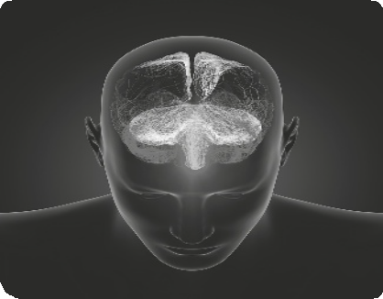Scientists from the Massachusetts Institute of Technology (MIT) have found the gene that could help people forget traumatic experiences. The scientists found the memory gene in mice.

The head researcher, Li-Huei Tsai, did many tests to make mice forget their fear. After some experiments, positive feelings replaced their stress and fear. The scientists looked at the brain activity when the mice were afraid and when they were not afraid. They were surprised to find the gene that replaced old memories with new ones. They will now try to find this gene in humans.

They hope that one day they can erase painful memories in humans. They think they can replace upsetting memories with
more positive thoughts and feelings. They say that this could benefit people with very painful memories: soldiers, crime victims and people who survived natural disasters. Many of these people suffer from very bad stress because of their memories. It is an illness called post-traumatic stress disorder (PTSD).

Source: www. breakingnewsenglish.com

A Find words or phrases in the text that mean the same as…

1. shocking

2. delete

3. bad

4. help

B Say whether the sentences are True (T) or False (F) according to the text.
Correct the false ones.

1. Scientists have found the gene in human brains that erases memories.

2. The mice never lost their fear.

3. Scientists will never find the gene in human brains.

4. Many people suffer from PTSD.

5. Post-traumatic stress disorder (PTSD) is an illness.

NWR8TR-TESTS-13

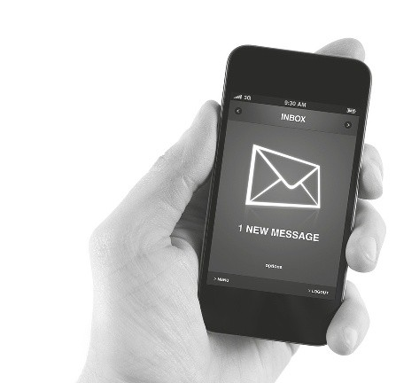

C Answer the questions about the text.

1. Who made this scientific discovery?

2. Who was responsible for this research?

3. What did they find in the mice brain?

4. Who could benefit from this research?

D Text messages use informal language. Here are some examples. Match them to their meanings.

1. 4EAE a) Great to see you

2. 2G2BT b) I have a question for you

3. 10x c) Parents are watching

4. GR8 2 CU d) Do you want to go to the cinema tonight?

5. PAW e) Friendship, love

6. CU L8R f) See you later

7. <3 g) Tomorrow

8. ?4U h) Forever and ever

9. 2MOR i) Thanks

10. WAN2 go cnma 2nite? j) Too good to be true

New Wave Revolution · 8.˚ ano Evaluation Tests

E Complete the sentences using could, couldn’t, would, wouldn’t.

1. you imagine how easy it be getting to school?

There be any traffic jams!

2. you like to come to the auto show with us?

3. I refuse that invitation.

4. I use your mobile to call my mum?

F Complete these parts of formal telephone conversations with the phrasal verbs from the boxes.

A: I’d like to speak to Mr Smith, please.

B: 1 , please. (…) Sorry, he has just

2 .

A: Can I 3 later?

B: Yes, of course.

A: Can you 4 your Delivery Department, please?

B: Just a minute, please.

A: Good morning. Could you 5 to Mrs Smith, please.
B: Sorry, this no longer her number. Would you like her new phone number?
A: Yes, please. Let me just get a notebook to 6 .

a. gone out b. connect me with c. put me through
d. write it down e. hold on
f. call him back

G Write a text expressing your opinion on whether is a good/bad idea to erase painful memories in humans.

Answer Key

Unit 6 Tomorrow and yesteryear

Listening Test 6

Script

A.
The Dalai Lama was born in Tibet on the 6th of July
1935. His real name is Tenzin Gyatso. He is the leader of Tibet’s Buddhists but he lives in India, where thousands of his followers visit him. He is the world’s most famous Buddhist monk. He campaigns for freedom in Tibet and peace in the world.

Tenzin became Dalai Lama when he was just two years old. He became Tibet’s leader in November 1950, when he was fifteen. This was just one month after China
took over Tibet. His first big job was to try and save his country from Chinese rule. He tried for nine years, but then had to escape to India. He has never returned.

B.
He travelled to the West – to Europe and America. Thousands of people welcomed him. He has helped to spread love and harmony around the world. He gives speeches wherever he goes and he has won many awards. He got the Nobel Peace Prize in 1989.

The Dalai Lama has been one of the best-loved and most well-known world leaders for many decades. He continues to ask China to give his Tibetan people more control over their land. One day he might meet
Chinese leaders and talk about a better and brighter future.

www.famouspeoplelessons.com

A. 1. a); 2. b); 3. b); 4. a); 5. a); 6. b); 7. a)

B. 1. Europe; 2. welcomed; 3. love; 4. known;
5. their; 6. brighter

Test 6A

A. 1. stop; 2. ultimate; 3. manufacturer; 4. monitor

B. 1. T.; 2. F. The car can communicate with other cars that have the same technology.; 3. F. Toyota’s aim is to eliminate all accidents.; 4. T.; 5. F. The new driverless cars will reduce traffic jams.
C. 1. It uses radars and video cameras. 2. It would be useful to stop accidents and to work or sleep during the trip. 3. Volvo tested a self-drive group of cars
on a Spanish highway. 4. These cars could cut traffic jams and avoid accidents.
D. 1. d); 2. j); 3. i); 4. a); 5. c); 6. f); 7. e); 8. b);
9. g); 10. h)

E. 1. Could; would; wouldn’t; 2. Would; 3. couldn’t;
4. Could.

F. 1. Hold on; 2. gone out; 3. call him back;
4. connect me with; 5. put me through;
6. write it down.

G. Personal answer.

Test 6B

A. 1. c); 2. d); 3. a); 4. b). B. 1. T. 2. F. 3. F. 4. T. 5. F. C. 1. a; 2. b; 3. a; 4. b.
D. 1. d); 2. j); 3. i); 4. a); 5. c); 6. f); 7. e); 8. b);
9. g); 10. h)

E. 1. Could; would; wouldn’t; 2. Would; 3. couldn’t;
4. Could.

F. 1. Hold on; 2. gone out; 3. call him back;
4. connect me with; 5. put me through;
6. write it down.

G. Personal answer.

Test 6C

A. 1. traumatic; 2. erase; 3. upsetting; 4. benefit.

B. 1. F. Scientists have found the gene in mice brains to erase memories. 2. F. The mice lost their fear.;
3. F. They will try to find this gene in humans. 4. T.;
5. T.

C. 1. Scientists from the Massachusetts Institute of Technology. 2. The head researcher was Li-Huei Tsai. 3. They found the gene that replaced old memories with new ones. 4. People with painful memories: soldiers, crime victims and people who survived natural disasters.
D. 1. h); 2. j); 3. i); 4. a); 5. c); 6. f); 7. e); 8. b);
9. g); 10. d)

E. 1. Could; would; wouldn’t; 2. Would; 3. couldn’t;
4. Could.

F. 1. Hold on; 2. gone out; 3. call him back; 4. connect me with; 5. put me through; 6. write it down.

G. Personal answer.

