10 MINUTES



PART 1

Each student interacts with the teacher answering some personal questions.

PART 2

Students interact with each other. Students ask and answer questions using the prompt material.

STUDENT A

Here is some information about a computer game. Look at this information and answer your partner’s questions.

My World

a fantastic new computer game

rmarkets

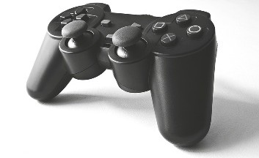Build a city in space

ON SALE

from next week

in computer shops and supermarkets

for 2 – 6 players
Only 45€

STUDENT A

You don’t know anything about this magazine. So ask student B some questions about it. Use these words to help you.



TEENAGE MAGAZINE

• name / magazine?

• website?

• what / read about?

• cost / €?

• when / buy?

(Adapted from: Cambridge Tests)

Swoosh · 8.˚ ano Evaluation tests




10 MINUTES

PART 1

Each student interacts with the teacher answering some personal questions.

PART 2

Students interact with each other. Students ask and answer questions using the prompt material.

STUDENT B

You don’t know anything about this computer game. So ask student A some questions about it. Use these words to help you.

COMPUTER GAME

• what / called?

• expensive?

• how many players?

• where / buy?

• buy / now?

STUDENT B

Here is some information about a teenage magazine. Look at this information and answer your partner’s questions.

a or
Edit o
ort
P
©

SW8TF


TeenWorld

the new magazine for teenagers

1€

interesting stories and pages of music, films and celebrities

on sale every week go to www.teenworld.com
NOW

(Adapted from: Cambridge Tests)

