Unit 2



Fashion and body image
Test A

School: Name: Class: No.:
Date: / / Mark:
Enc. Educação: Teacher:

15 Minutes


A. You will hear a teen talking about body image. For items 1 to 5, fill in the missing information.

MY BODY IMAGE
Name | Matt Scott
Age | 1.
Definition of body image | Your body image is how you see your body based on:  – what you see  – what 2. tell you
Pressures | 3.
Boys should be | 4.
Girls should be | 5.

B. You will hear a phone conversation between two friends discussing what to wear to a party. Choose the correct option.


1. Kate is worried about what to wear .

(a) to school (b) on a date (c) to a party

2. Jane is going to wear .

(a) black jeans (b) skinny jeans (c) a short dress

3. Jane suggests Kate should wear .

(a) jeans and a top (b) a short skirt (c) a pink dress

4. Kate rejects the suggestion because she doesn’t have .

(a) shoes (b) a belt (c) a bag

5. Jane will speak to and call Kate back with the news.

(a) Tom (b) her mum (c) her friend



SW

© P
ort
o
Edi
or a

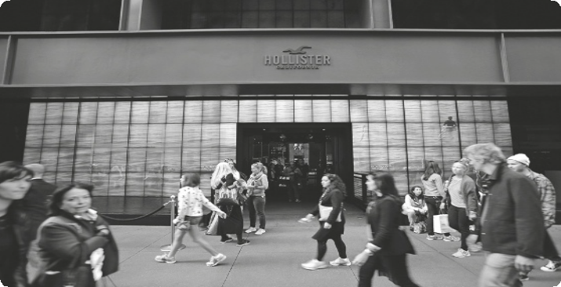

Read the text carefully.

HOLLISTER – THE PERFECT
STORE FOR TEENS

Hollister is one of the most popular fashion stores for teens of all ages all over the world. People say that when you go to Hollister, you buy more than a brand or the clothes that you choose. In fact, what you are really buying is a cool image that will get you into the toughest teen groups around. But what exactly is Hollister?
5 J.M. Hollister made a clothing company for teenagers in 1922. He wanted to give them something that was comfortable yet fashionable to wear. He also wanted to make sure that his clothing line was more or less affordable. The first thing that he did was find inspiration for his store and clothing line. He followed surfer slang and decided to call girls Bettys and boys Dudes. This means that if you go to Hollister, you can shop at the Bettys or Dudes
10 section depending on who or what you are shopping for. He named his store after a place in
California, mostly after the South Californian beaches.
But the brand Hollister really became popular in 2000 when the makers of Abercrombie
& Fitch decided to adopt it. They decided to do this because they felt that their Abercrombie
store was failing with younger costumers. They needed a brand which was just as cool as
15 the Abercrombie brand but slightly cheaper and thus more accessible for younger consumers. However, Hollister was intended to be the “summer” store and Abercrombie more the “winter” store but they both sell summer and winter clothes. Hollister still leans more to the summer clothing line and Abercrombie more towards winter. Since then, Hollister has become famous for its trendy clothes, especially its hoodies, T-shirts and jeans which every teen
20 dreams of having. You can find a Hollister store in most major cities around the world. Alternatively, you can also shop online. Check it out!

Adapted from: https://sites.google.com/site/walkerhollister/home

A. Match the parts of the sentences according to the text. Some expressions are not necessary.

1. Hollister is a store for (a) American teens.

2. Hollister sells (b) teens all over the world.

3. Hollister is famous for (c) its hoodies.

4. Hollister was initially (d) aimed at a winter line.

(e) casual and affordable clothes.

(f) aimed at a summer line.

B. Read the text again and find words that mean the following:

1. In paragraph 1 a word that means “label”.

2. In paragraph 2 a word that means “not too expensive”.

3. In paragraph 3 a word that means “not succeeding”.

4. In paragraph 3 a word that means “fashionable”.

C. Give details about.

1. When the brand was first created –

2. What girls are called –

3. When Hollister became popular –

4. A brand it competes with –

D. Label the following images with the words in the box. Not all the words are needed.



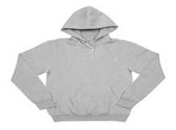





1.

a or
Edit o
ort
P
©
2.
3.
4.



A. Write the adjectives in the correct order.

1. She bought a bag. (Italian / black / trendy)

2. We live in a flat. (modern / small / cozy)

3. He has got some trainers. (white / new / expensive)

4. I ate a hamburger. (medium / tasty / French)

5. He’s got a jacket. (blue / cotton / fashionable)

6. They bought a car. (American / old / yellow)

B. Add the correct suffix to the word in bold.

1. I bought a colour sweater on the sales.

2. It was an unforget concert!

3. He was very thought to warn us about the strike.

4. I’ll never convince mum to let me go. It’s use .

5. I hate the taste of broccoli. It’s horror .

6. I really like comfort clothes.

C. Join the sentences using a relative pronoun: who, which or whose.

1. I am going to a shop. It is not very expensive.

2. We saw a girl. Her clothes were really trendy.

3. Anna wanted to buy some new jeans. They were really gorgeous.

4. I met the model. We saw him at the fashion show.

5. John likes girls. They are not very tall.

6. Mary made an ad. It was for Hollister.

35 Minutes


A. Imagine that you want to go shopping with a friend. Write a short message inviting her along. Use the information below to help you.


B. Write a biography (50-80 words) about the supermodel Gemma Ward. Use the information below to help you.
Nationality + Job: Australian model
Date of birth: November 3, 1987
Place of birth: Perth, Australia
Eyes + Hair: Green, blonde
Modeling Career: First modeling job: 16 years old
Cover: American Vogue, Teen Vogue
Accomplishments: Appeared in a John Mayer video;
Named the 10th in the top 15 supermodels by Forbes


