Unit 2

Fashion and body image
Test B


School: Name: Class: No.:
Date: / / Mark:
Enc. Educação: Teacher:

15 Minutes


A. You will hear a teen talking about body image. For items 1 to 5, circle the correct information.

MY BODY IMAGE
Name | Matt Scott / Tom Scott
Age | 1. 14 / 15 years old
Definition of body image | Your body is how you see your body based on:  * what you see  * what 2. your friends / others tell you
Pressures | 3. school / the media
Boys should be | 4. tall / well built
Girls should be | 5. skinny / slim

B. You will hear a conversation between two friends discussing what to wear to a party.


Choose the correct option.

1. Kate is worried about what to wear .

(a) to school (b) on a date (c) to a party

2. Jane is going to wear .

(a) black jeans (b) skinny jeans (c) a short dress

3. Jane suggests Kate should wear .

(a) jeans and a top (b) a short skirt (c) a pink dress

4. Kate rejects the suggestion because she doesn’t have .

(a) shoes (b) a belt (c) a bag

5. Jane will speak to and call Kate back with the news.

(a) Tom (b) her mum (c) her friend



Read the text carefully.

HOLLISTER – THE PERFECT
STORE FOR TEENS

Hollister is one of the most popular fashion stores for teens of all ages all over the world. People say that when you go to Hollister, you buy more than a brand or the clothes that you choose. In fact, what you are really buying is a cool image that will get you into the toughest teen groups around. But what exactly is Hollister?
5 J.M. Hollister made a clothing company for teenagers in 1922. He wanted to give them something that was comfortable yet fashionable to wear. He also wanted to make sure that his clothing line was more or less affordable. The first thing that he did was find inspiration for his store and clothing line. He followed surfer slang and decided to call girls Bettys and boys Dudes. This means that if you go to Hollister, you can shop at the Bettys or Dudes
10 section depending on who or what you are shopping for. He named his store after a place in
California, mostly after the South Californian beaches.
But the brand Hollister really became popular in 2000 when the makers of Abercrombie
& Fitch decided to adopt it. They decided to do this because they felt that their Abercrombie
store was failing with younger costumers. They needed a brand which was just as cool as
15 the Abercrombie brand but slightly cheaper and thus more accessible for younger consumers. However, Hollister was intended to be the “summer” store and Abercrombie more the “winter” store but they both sell summer and winter clothes. Hollister still leans more to the summer clothing line and Abercrombie more towards winter. Since then, Hollister has become famous for its trendy clothes, especially its hoodies, T-shirts and jeans which
20 every teen dreams of having. You can find a Hollister store in most major cities around the world. Alternatively, you can also shop online. Check it out!

Adapted from: https://sites.google.com/site/walkerhollister/home



A. Match the parts of the sentences according to the text. Some expressions are not necessary.

1. Hollister is a store for (a) American teens.

2. Hollister sells (b) teens all over the world.

3. Hollister is famous for (c) its hoodies.

4. Hollister was initially (d) aimed at a winter line.

(e) casual and affordable.

(f) aimed at a summer line.

B. Match the words from the text to the following meanings.

1. label (a) failing

2. not too expensive (b) trendy

3. not succeeding (c) affordable

4. fashionable (d) brand

C. Find and match details about.

1. When the brand was first created (a) 2000

2. What girls are called (b) Abercrombie & Fitch

3. When Hollister became popular (c) 1922

4. A brand it competes with (d) Bettys

D. Label the following images with the words in the box. Not all the words are needed.

1.




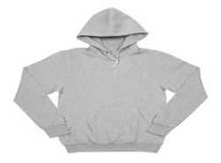



2.
3.
4.

A. Write the adjectives in the correct order.

1. She bought a bag. (Italian / black / trendy)

2. We live in a flat. (modern / small / cozy)

3. He has got some trainers. (white / new / expensive)

4. I ate a hamburger. (medium / tasty / French)

B. Circle the correct suffix for the word in bold.

1. I bought a colour ful / able sweater on the sales.

2. It was an unforget less / able concert!

3. He was very thought less / ful to warn us about the strike.

4. I’ll never convince mum to let me go. It’s use able / less.

C. Join the sentences using a relative pronoun: who, whose or which.

1. I am going to a shop is not very expensive.

2. We saw a girl clothes were really trendy.

3. Anna wanted to buy some new jeans were really gorgeous.

4. I met the model we saw at the fashion show.


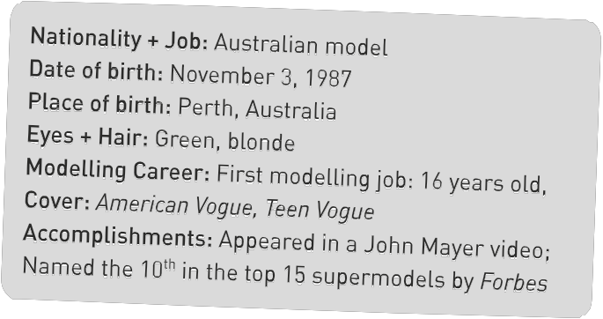

Nationality + Job: Australian model
Date of birth: November 3, 1987
Place of birth: Perth, Australia
Eyes + Hair: Green, blonde
Modeling Career: First modeling job: 16 years old
Cover: American Vogue, Teen Vogue
Accomplishments: Appeared in a John Mayer video;
Named the 10th in the top 15 supermodels by Forbes
Write a biography (50-80 words) about the supermodel Gemma Ward. Use the information given to help
you fill in the gaps.

35 Minutes



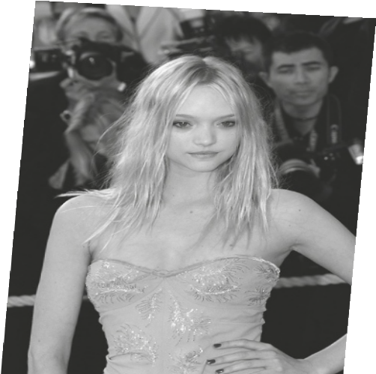

Gemma word is (1) who was born
(2) 3, 1987. (3)
are green and she has got (4) hair.

She started her career when she was (5)
and she was on the cover of American Vogue and Teen Vogue. She appeared in a John Mayer video and was named the 10th in the top 15 supermodels by Forbes.

