Unit 2

Fashion and body image

School: Name: Class: No.:
Date: / / Mark:
Enc. Educação: Teacher:

A. Write the words in the box below under the corresponding picture.
(Escreve as palavras da caixa por baixo da imagem correspondente.)

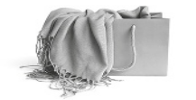



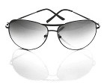

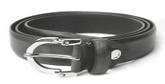

1.
2.
3.
4.

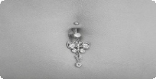

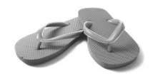

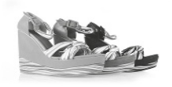

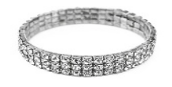

5.
6.
7.
8.

B. We can wear many different styles of clothing. Write the letters next to the corresponding words.
(Podemos utilizar muitos estilos de roupa diferentes. Escreve as letras ao lado das
palavras correspondentes.)
B


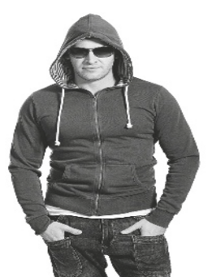

A
1. casual

2. conservative

3. extravagant

4. practical
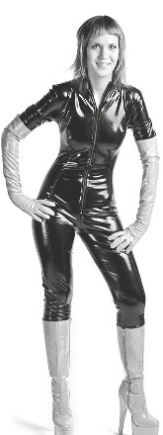

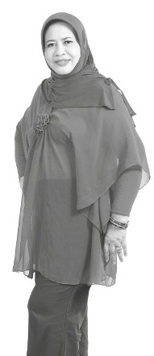

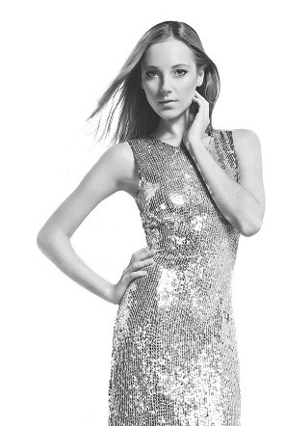

5. elegant

6. sophisticated
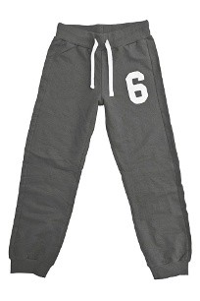

C D E F

Swoosh · 8.˚ ano Evaluation tests




C. Look at the pictures below and complete the crossword. Use the words in the box to help you.
(Observa a imagem e completa as palavras cruzadas. Utiliza as palavras da caixa
como ajuda.)
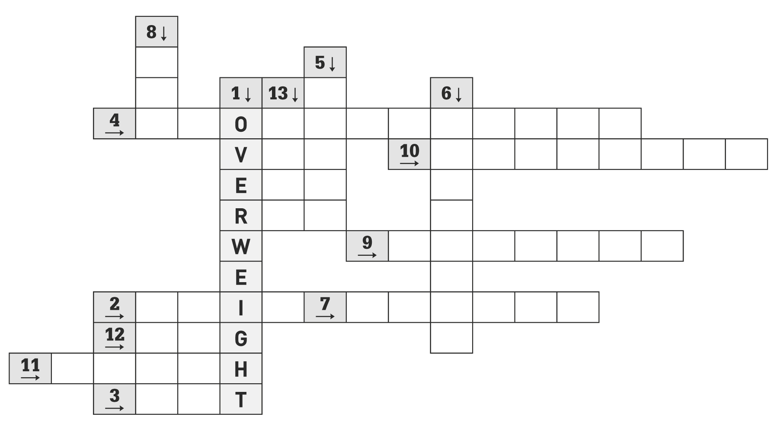
8 3

5 3

1 3 13 3 6 3
4
" O
10
V
"
E R
9
W
"
E
2 7
" I "
12
G
"
11
" H
" T
3

ACROSS
(Horizontal) DOWN
(Vertical)

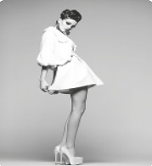

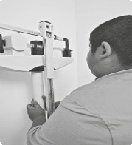

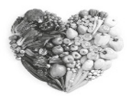





2 9 3
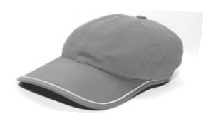

1 8 5
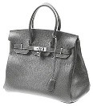

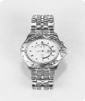

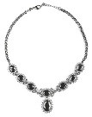

6 13
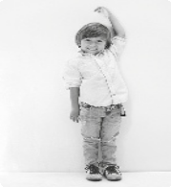

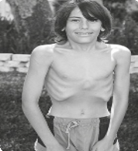

12 11 10





7 4

fat • model • overweight • cap • anorexic • necklace
healthy • skinny • bag • photographer • slim • tall • watch

