Unit 2



Fashion and body image
Key for Schools

School: Name: Class: No.:
Date: / / Mark:
Enc. Educação: Teacher:

15 Minutes


A. You will hear five short conversations. For each conversation, circle the appropriate picture (A-C).

1. What will the boy buy?

A B C
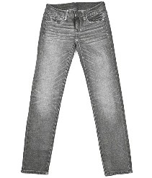

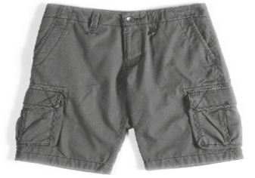

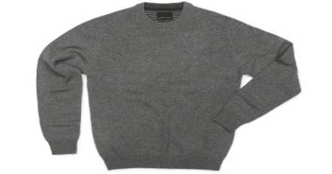

2. How much do the shoes cost?
39.99€
59.99€
15.99€

A B C

3. What does the girl want to buy?

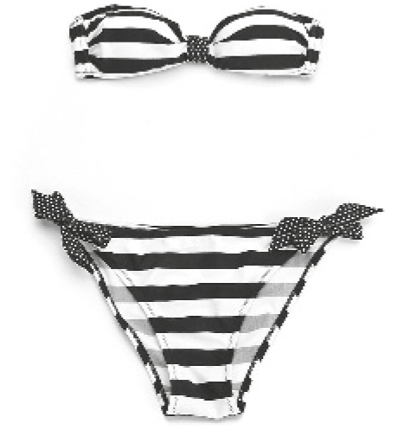

A B C
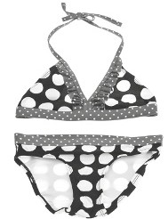

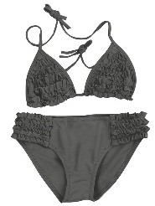

4. How big is the discount?

30%
33%
13%

A B C

5. Where does the boy buy his jeans?

Primark
C&A
ZARA

A B C

(Adapted from: Cambridge Tests)

B. You will hear a fashion designer talking about her summer collection. Listen and complete the table.

FASHION DESIGNER
Inspiration for the collection | glorious sixties
Main colour | 1.
Pattern | 2.
Favourite material | 3.
• Accessory 1 | 4.
• Accessory 2 | 5.

(Adapted from: Cambridge Tests)
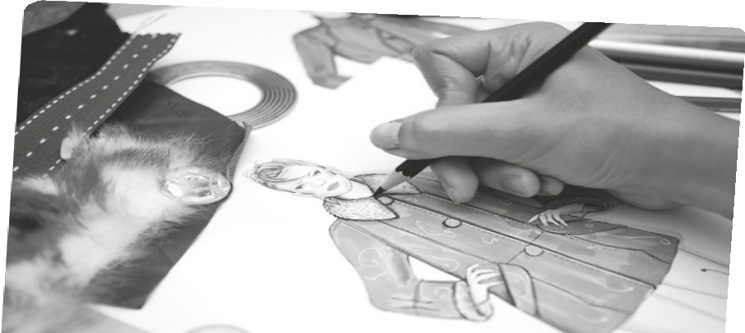

30 Minutes



A. Which notice (A-G) says the same as sentences 1-5? Write the correct letter in the corresponding place. Some are not necessary.

1. Don’t wash in the washing machine.
Wash in cold water only

2. Don’t use bleach.

3. You can only wash the item by hand.
A
4. Very fragile material.
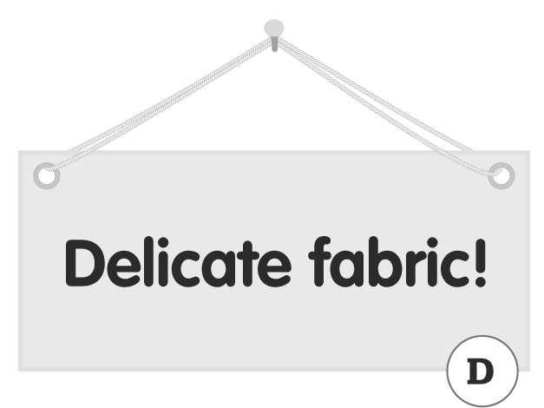
5. The item may dye other clothes.

Do not use aggressive cleaning
products!
B



C

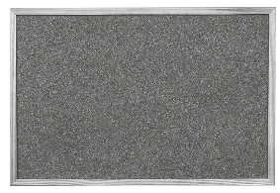

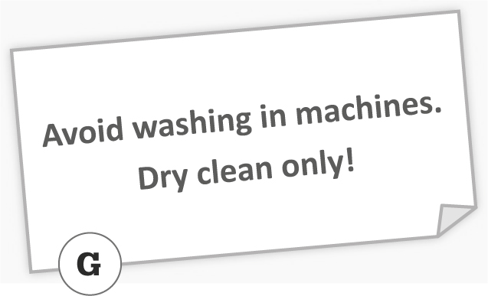

Resistant
material!
E
F

B. Choose the appropriate reply for each of the following conversations.

1. These jeans are too tight. | A. I’ll get a bigger size. B. I’ll get a smaller size. C. They’re perfect.
2. I don’t worry about my body image. | A. We all do.  B. Good for you.  C. So do I.
3. Jake put on some weight last month. | A. Is he overweight now?  B. He must be really skinny now.  C. He must be anorexic.
4. Are you a fashion victim? | A. You too!  B. Yes, I do.  C. Certainly not!
5. What style of clothes do you like? | A. Silky clothes.  B. Expensive clothes.  C. Casual and comfortable clothes.
(Adapted from: Cambridge Tests)

C. Read the sentences and choose the appropriate word for each space.

1. That dress is beautiful!

A so B such C many D a lot of

2. I went to the fashion show took place at the town hall.

A who B which C whose D where

3. The fashion show was really . There were lots of people there!

A success B successless C successfull D successful

4. I love that designer. He’s .

A wonderless B wonder C wonderful D wondering

5. Many teens are conscious their body image.

A of B about C with D over

6. Fashion dictates that women have to be nowadays.

A overweight B thin C chubby D fat

7. Jeans are an example of clothes.

A smart B sophisticated C conservative D casual

8. Did you ask the sales assistant, is very friendly, for a bigger size?

A who B whose C that D which

9. I really love clothes which are in fashion!

A trendy B outdated C old-fashioned D fashionible

10. I only buy clothes that are machine .

A wash B washable C washible D washy

D. Read this article about Body Image and choose the appropriate word.

Why are self-esteem and body image important?

Self-esteem is all about (1) how / very much you feel you are worth – and how much you feel (2) other / others people value you. Self-esteem is important because feeling good (3) of / about yourself can affect (4) your / yours mental health and how you behave.
People with (5) high / low self-esteem know themselves well and are happy with their (6) body / bodies. They’re realistic and find friends that like and appreciate them for who they (7) are / aren’t. People with a good self-esteem usually feel more in control of (8) his / their lives and know their own strengths and weaknesses. (9) In addition / However the same is not true of the people with a low self-esteem. (10) These / This people are very conscious of their bodies and are often depressed as well.
E. Read this article about Portuguese fashion.

Portugal has a long history as a textiles and ready-to-wear producer for international retailers, but Portuguese fashion design only really began to develop in the 1980’s thanks to new design schools and regular fashion events. Lisbon’s Bairro Alto (together with neighbouring Chiado) has always been the hub of young designers, many of whom have also presented their collections in Paris, São Paulo, New York, and other major fashion cities. Most designers have their own studios, while others are represented in several of Lisbon’s boutiques. Below are the four major names to look for.

Alves / Gonçalves
This duo creates ready-to-wear for women and haute couture for men and women. You can check out their latest collections at their studio in Chiado.

Ana Salazar
Ana Salazar was the pioneer of Portuguese fashion, launching her own label in the early 80’s. At her boutique in Chiado you’ll find men and women’s fashion together with accessories.

Dino Alves
A regular participant in Lisbon’s fashion events since the mid-90’s, Dino Alves has also presented his collections in France, Germany and Brazil. In 2009 he was invited by the Italian brand “Segue” to design a piece of luggage, although he is best known for his daring men’s and women’s collections using unconventional materials and styles.

Fátima Lopes
She is Lisbon’s boldest designer and presents her collections to the major fashion capitals of the world every season. Her first international show was in Paris where she opened a shop. She also has a shop in Los Angeles. Her boutique in Lisbon is in Bairro Alto. She really caught the spotlight in 2000 by modelling her own million-dollar diamond-covered swimsuit down a Paris runway, and her creations are now sold around Europe and Asia.

(Adapted from: www.lisbonlux.com/culture/portuguese-fashion-designers.html)

Decide if the sentences are right (R) or wrong (W) according to the text.

1. Portugal has a lot of experience in textiles.

2. Portuguese fashion changed in the 70’s.

3. The Bairro Alto has always been an important fashion centre.

4. Portugal doesn’t have any international fashion designers.

5. The text mentions five major Portuguese fashion designers.

6. The duo Alves / Gonçalves only create clothes for women.

7. Ana Salazar was one of the first major Portuguese designers.

8. Dino Alves designed luggage for a French brand.

9. Fátima Lopes has a shop in Los Angeles.

10. She bought a diamond bikini.

35 Minutes


A. Rewrite the sentences using the word given without changing the meaning. Use between two and four words.

1. I bought a bag. It was very expensive. (which)

I bought very expensive.

2. Tim is too fat now. (overweight)

Tim is rather .

3. The people in my class worry about the way they look. (appearance)

The people in my class worry about .

4. I spoke to a boy. His mother works with mine. (whose)

I spoke to a boy with mine.

5. Mike knows a baby who is not too fat and really cute. (chubby)

Mike knows a and really cute.

B. Complete this message. Write one word for each space.

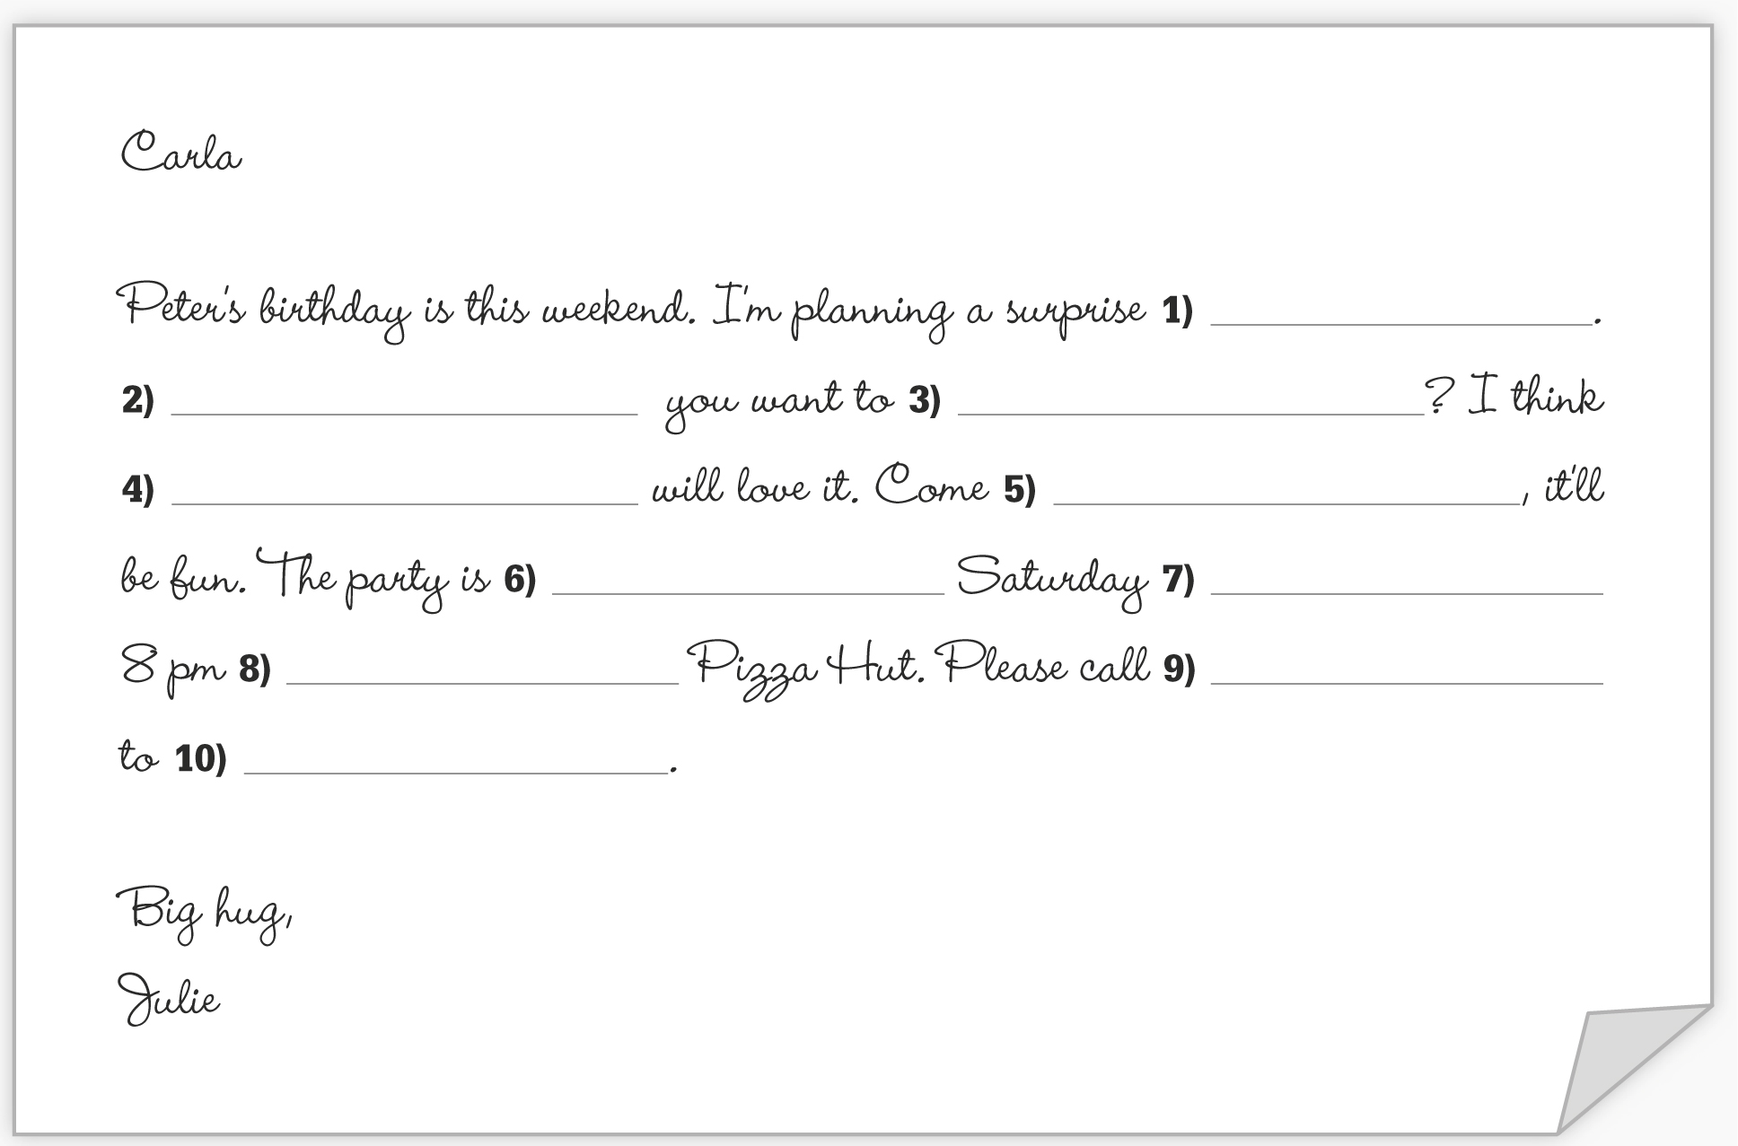

.

4) will love it. Come 5) , it’ll be fun. The party is 6) Saturday 7)
8 pm 8) Pizza Hut. Please call 9)
to 10) .

Big hug, Julie

(Adapted from: Cambridge Tests)

C. Read Peter’s message.



Write him a biography with the info he gave you for his blog.

