10 Minutes

PART 1
Each student interacts with the teacher answering some personal questions.

PART 2
Students interact with each other. Students ask and answer questions using prompt material.

STUDENT A
Here is some information about a fashion show. Look at this information and answer your partner’s questions.

FASHION SHOW

Come and see Mercedes-Benz Fashion Week

Lincoln Center between West 62nd and 65th Streets and Columbus and Amsterdam Avenues in New York
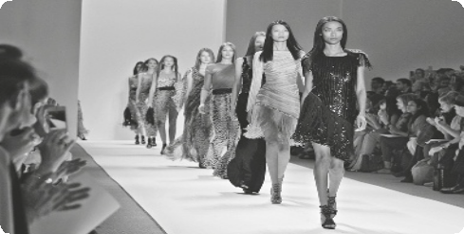

Start 9.00 am Last event 8.00 pm

September 5 – 12

Dress code: smart-casual

Entrance: 35$

STUDENT A
You don’t know anything about this clothes shop. So ask student B some questions about it. Use these words to help you.


CLOTHES SHOP

• name?

• where?

• Sunday?

• opening times / ?

• accessories?

(Adapted from: Cambridge Tests)

Swoosh · 8.˚ ano Evaluation tests




10 Minutes

PART 1
Each student interacts with the teacher answering some personal questions.

PART 2
Students interact with each other. Students ask and answer questions using prompt material.

STUDENT B
You don’t know anything about this fashion show. So ask student A some questions about it. Use these words to help you.

FASHION SHOW

• where?

• when?

• start / ?

• dress code?

• cost / $?

STUDENT B
Here is some information about a clothes shop. Look at this information and answer your partner’s questions.

MAGIC DESIGN

CLOTHES, SHOES and ACCESSORIES For you!
30% discount

Monday – Saturday 9 am – 6 pm

Next to the museum

(Adapted from: Cambridge Tests)

