Unit 3

Healthy eating habits
Test B


School: Name: Class: No.:
Date: / / Mark:
Enc. Educação: Teacher:

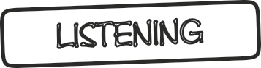

A. You will hear a news item on the radio about healthy eating habits.
For items 1 to 5, choose the correct information.

15 Minutes



Topic of the programme | Healthy eating habits for teens
Diet should be high in | Fruits and 1. vegetables / meat
Diet should be rich in | 2. things / nutrients like calcium and iron
Things teens should do to improve their diet | Eat healthy meals and snacks and maintain a healthy 3. lifestyle / weight
Teens should avoid eating | 4. junk food / restaurant food
Instead of fizzy drinks teens should drink | 5. water / fresh juice

B. You will hear a conversation between two friends.
Choose the correct option.

1. They decide to have lunch at .

(a) Pizza hut (b) McDonalds (c) a local restaurant

2. For starters they order .

(a) a salad (b) soup (c) nothing

3. For their main course they decide to share

(a) a pizza (b) a lasagne (c) a curry dish

4. They order some to drink.

(a) zero coke (b) sparkling water (c) still water

5. The meal costs .

(a) 7,5€ (b) 10€ (c) 15€



20 Minutes

Read the text carefully.

A Food Standards Agency study shows teenage girls eat more unhealthily than any other group in the population – a government research revealed this week. The study wanted to discover what the nation is eating. The results reveal that despite million-pound government initiatives to encourage us all to eat more healthily, obesity levels in the UK are broadly
5 unchanged from a decade ago.
The research was commissioned by the government’s food watchdog, the Food Standards Agency (FSA), which said it was worried about girls between 11 and 18 failing to eat enough foods essential for growth and good health.
When they did eat, they consumed food and drink high in sugar and fat such as processed
10 foods, sweets, chocolate and fizzy drinks, the FSA said, and failed to eat enough with important nutrients such as iron and calcium – found in leafy green vegetables and dairy products – which are essential for strong bones and to prevent anaemia. The survey found that among those of secondary school age, 46% were failing to get the minimum recommended amount of iron or magnesium, and fewer than one in 10 (7%) were eating the minimum recommended
15 five portions of fruit and vegetables a day.
Dr Alison Tedstone, the FSA’s head of nutritional science, said the issue was “an area of concern” and added: “Broadly, teenage girls particularly don’t eat enough. Overall they are a group of the population
whose diets are poor.
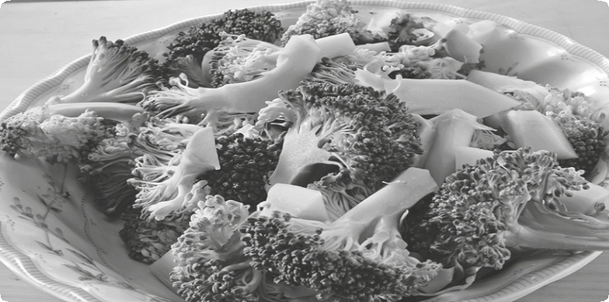

20 Young children’s diets are generally OK, adults generally are a similar picture, adolescents generally are poor. That’s
25 been the picture for a number of years.” The government reacted yesterday and said that it will ban all fast food,
30 chocolates and fizzy drinks in British schools. (Adapted from: www.
theguardian.com)

A. Choose (X) the best title for the text.

1. British eating habits.

2. British teens’ eating habits.

3. Food and drinks at schools.

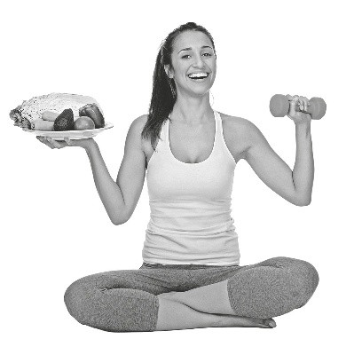

B. Read the text again and choose the correct option for items 1 to 4.

1. In line 2 “revealed” means:

(a) showed (b) presented

2. In line 15 “portions” means:

(a) meals (b) servings

3. In lines 16-17 “an area of concern” means:

(a) something that is worrying (b) the place where people are concerned

4. In line 23 “picture” means:

(a) reality (b) drawing

C. Decide if the following statements are right (R) or wrong (W) according to the text.

1. Teenage girls eat the healthiest in Britain.

2. The government has invested a lot of money to try to
teach people in the UK to improve their eating habits.

3. This study was done by the Food Standards Agency.

4. Children will be able to eat junk food at schools.

D. Match the questions with the answers in the box below.

1. Which age group of girls are failing to eat well?

2. What are these girls eating?

3. What are young children’s diets like?

4. Is this a recent reality?
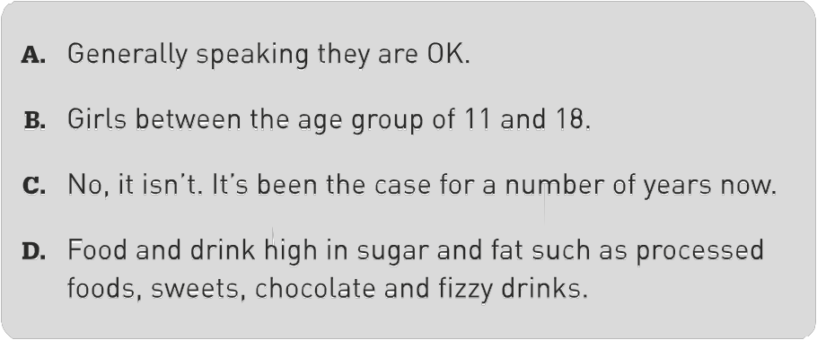

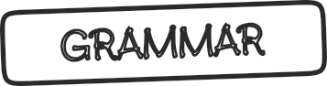

A. Choose the correct answer.

1. I need to withdraw some money / moneys from the cash machine.

2. He gave me some advice / advices which were really helpful.

3. I bought two hamburger / hamburgers for us.

4. Avoid eating food which has a lot of sugar / sugars.

B. Choose the appropriate form of the verbs do or make.

Yesterday I (1) did / made my homework very quickly because I wanted to go and help my mother (2) do / make the shopping. Before we left, mum (3) did / made a list with the things that she needed so that we could (4) do / make a cake for my birthday. Mum made the suggestion that we should bake a chocolate cake. I adore chocolate!
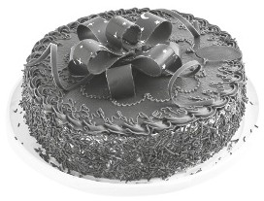

10 Minutes

C. Fill in the blanks with: much, many or a lot of.

1. Some teenagers don’t eat vegetables.

2. You shouldn’t eat too rice and potatoes because it’s very fattening for you.

3. We bought ice cream so that there would be enough for everyone.

4. My dad is on a diet. The doctor says that he can’t eat too cheese.

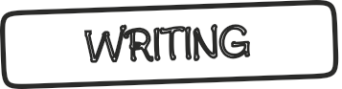 35 Minutes

A. Complete the following dialogue with the expressions in the box below.


Customer: Waiter, please?
Waiter: Would you like (1) ?
Customer: Yes, for starters (2)
some vegetable soup, please.
Waiter: Certainly. And for your (3) ? Customer: I think that I’d like a small ham and cheese pizza. Waiter: What (4) ? Customer: I’d like some freshly squeezed orange juice please. Waiter: What about (5) ? Customer: Oh yes, I’d like a chocolate mousse, please.

