Unit 3



Key for Schools
Healthy eating habits

School: Name: Class: No.:
Date: / / Mark:
Enc. Educação: Teacher:

15 Minutes


A. You will hear five short conversations. For each conversation, circle the appropriate picture (A-C).

1. What does Mark have for breakfast every day?

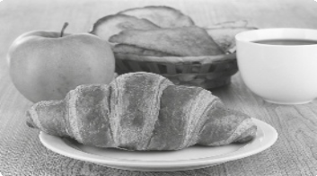

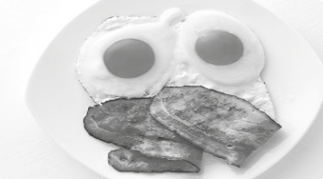

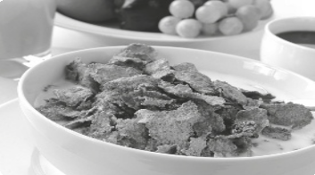

A B C

2. Jenny thinks it’s important to eat fruit. How many portions of fruit does she eat every day?

A B C

3. What is Jane’s favourite food?

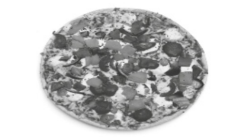

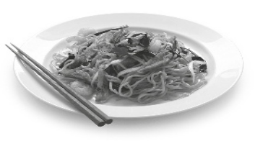

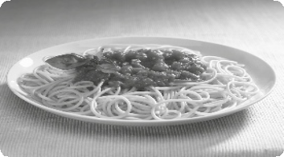

A B C

4. What does Henry not eat?

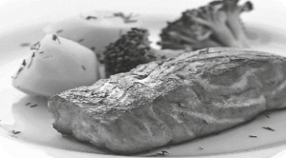

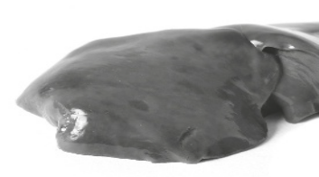

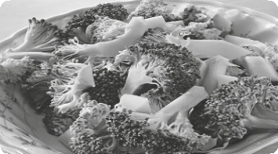

A B C

5. How often does Maria’s family eat out every month?

A B C

B. You will hear a woman making a reservation at a restaurant. Complete the reservation form below.

NANDO’s RESTAURANT – reservation forms

Name | Kathleen Jones
Day | 1.
Time | 2.
Table for | 3.
Meal ordered | 4.
Special request | 5.

(Adapted from: Cambridge Tests)


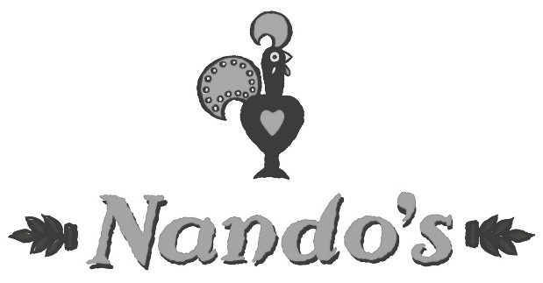



30 Minutes

A. Read the sentences and choose the appropriate word for each space.

1. Yesterday I had a soup for at the restaurant.
(a) starters (b) dessert (c) side order

2. Fruit is an example of a healthy .
(a) meal (b) dinner (c) snack

3. Waiter, can you please bring the so I can order.
(a) receipt (b) bill (c) menu

4. What would you like to ? How about some lemonade?
(a) drink (b) drinks (c) eat

5. Last night I had ice cream for dessert.
(a) some (b) much (c) many

6. To make a salad you need .
(a) meat (b) lettuce (c) soup

7. After a meal some people like to eat .
(a) breakfast (b) dessert (c) a starter

8. It’s a good idea to make a if you want to eat out.
(a) complaint (b) request (c) reservation

9. I ate a cake for tea today.
(a) box of (b) packet of (c) slice of

10. I don’t know what to choose. Can you please a suggestion?
(a) do (b) make (c) tell

B. Choose the appropriate reply for each of the following conversations.

1. Have you decided yet? | A. Yes, we’d like the cod.  B. The menu please.  C. Can you bring the bill?
2. I hate liver. | A. So will I.  B. Neither do I.  C. So do I.
3. What do you think of fried food? | A. It’s healthy for you.  B. It’s unhealthy for you.  C. They’re healthy for you.
4. I feel like eating fish. | A. Why don’t you order the chicken?  B. Try the steak then.  C. How about the salmon then?
5. I love spicy food. | A. Especially Indian curry.  B. Especially plain vegetables.  C. Especially sweet pork.
(Adapted from: Cambridge Tests)

C. Read the article about a healthy breakfast. Then circle the best word for each space.

A Healthy Breakfast

Doctors say that the most important meal (1) the day is the meal (2) starts the day. Yes, you guessed it. This means that breakfast is very important for our health. They defend that we (3) eat something in the first hour after (4) get up. When we wake up our bodies haven’t eaten (5) hours and they need energy to start (6) day. They say that the secret to a healthy lifestyle begins with a healthy breakfast. So, we should always eat something even if it’s (7)__ a tiny snack like a liquid yoghurt or a fibre biscuit or two. If you’re not hungry first thing in the morning, you can always eat something (8)__ is filling a few hours later. They suggest that you take a sandwich with you to eat (9) you feel hungry. For those (10)____ _ eat breakfast when they wake up every day, doctors suggest that they eat a continental breakfast. In other words: fresh bread or toast with a slice of ham or cheese or some milk and cereal. A good idea is to also eat some fruit to get lots of vitamins into your body early in the morning! Avoid eating fatty foods and cakes for breakfast!

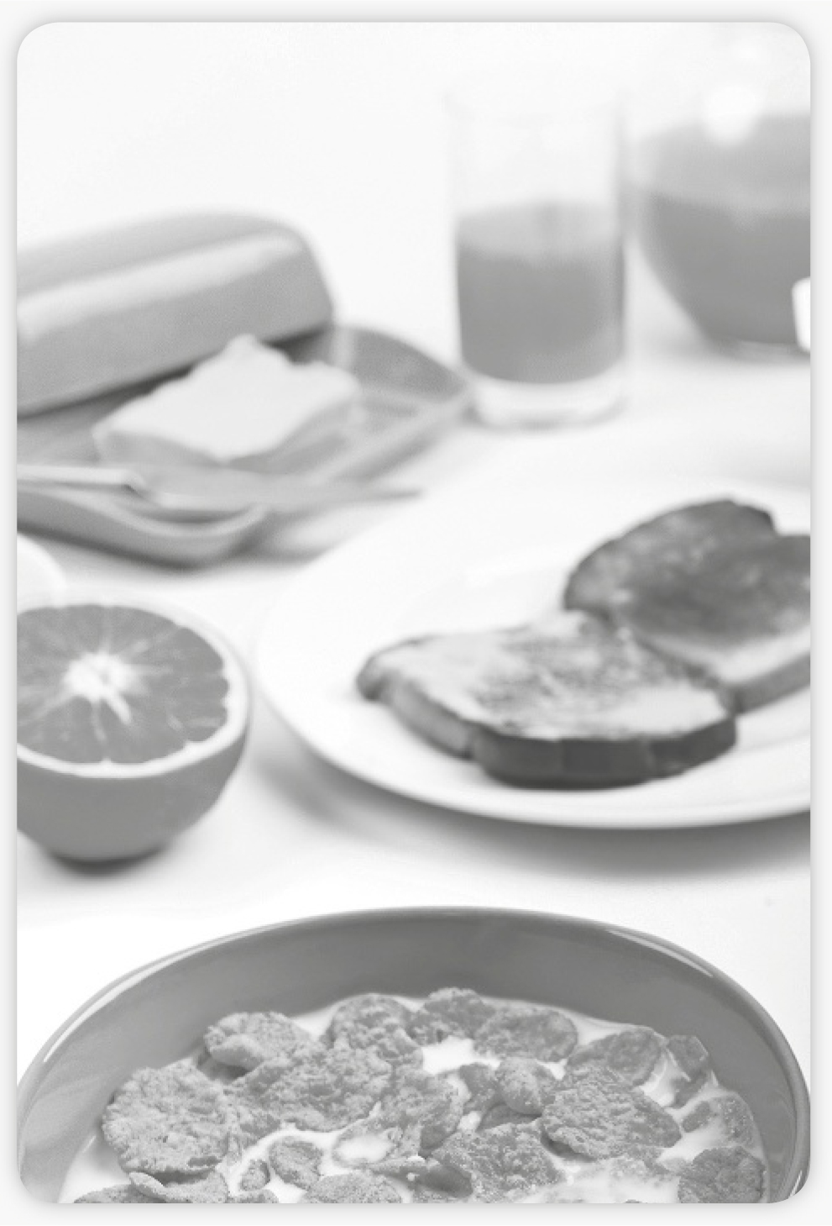

1. (a) of (b) at (c) on

2. (a) who (b) which (c) whose

3. (a) can’t

(b) should

(c) will

4. (a) they (b) he (c) we

5. (a) for

(b) after

(c) on
6. (a) already

(b) only

(c) all

7. (a) too (b) just (c) most

8. (a) which

(b) who

(c) whose

9. (a) when (b) unless (c) while

10. (a) which (b) whose (c) who

D. Read the article about what famous people eat.

What the Stars really eat

Chef Kate McAloon lets us in on the food secrets of her celebrity clients. She is the choice chef for several A-list celebrities, including Miranda Kerr and husband Orlando Bloom, Gwyneth Paltrow and husband Chris Martin, Steven Spielberg and his wife Kate Capshaw, Meg Ryan, Courteney Cox and David Arquette. McAloon is the woman behind the delicious food served at their Hollywood dinner parties and Sunday soirees, as well as the dishes on their dinner tables at family meal times. “Food is one of the greatest joys in our lives if we eat properly,” McAloon says.
So what is it about her food that makes it so special? McAloon says: “It’s always healthy and clean, but it’s the flavour that distinguishes my food and I get it from using lots of fresh herbs and spices and good quality fresh products like fresh vegetables, meat and fish.”
Chef McAloon began cooking for Orlando Bloom after Gwyneth Paltrow introduced them at one of her fabulous parties. We asked her about what the stars really like to eat and here is what she told us: “Kerr loves wild salmon, lots of fresh veggies and salads, cacao powder and coconut. Bloom loves turkey burgers. He’s always asking me to make some for him. Although they have their favourite dishes, they do eat a bit of everything. I make sure that they have a varied and healthy diet with lots of fruit and vegetables. I avoid making fried food for them, as it’s not a healthy option.”
We asked her what is the secret of pleasing celebrities and she answered that you can’t be afraid of mixing ingredients and trying out new things but that every few days you have to cook something that they really love like a good old turkey burger.

(Adapted from: www. teenink.com)

Decide if the sentences are right (R) or wrong (W) according to the text.

1. Chef McAloon cooks for lots of celebrities.

2. One of her clients is Tom Cruise and his family.

3. Chef McAloon is responsible for making the food at the star’s dinner parties and Sunday soirees.

4. Her food is special because it is very expensive.

5. Orlando Bloom introduced Chef McAloon to Gwyneth Paltrow.

6. Kerr loves eating wild salmon and fresh vegetables.

7. She makes lots of fried food for her stars.

E. Quote a sentence from the text that presents the magic formula for making stars happy.



A. Read a review about a typical English pub and an email from a friend.

35 Minutes

Review of a Gastropub: The Crawley Lamb Inn

Pros:
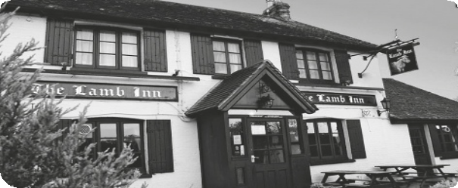

• Friendly staff

• Good selection at a variety of prices

• Well prepared, fresh food

• Attractive interior with a large fireplace

Cons:

• Reservations required if you arrive with a dog

• Food is prepared to order so it can take a bit longer

Address: Witney, Oxfordshire OX29 9TW

www.lambinn.com

The review above presents some opinions. Complete your diary with the following
information:

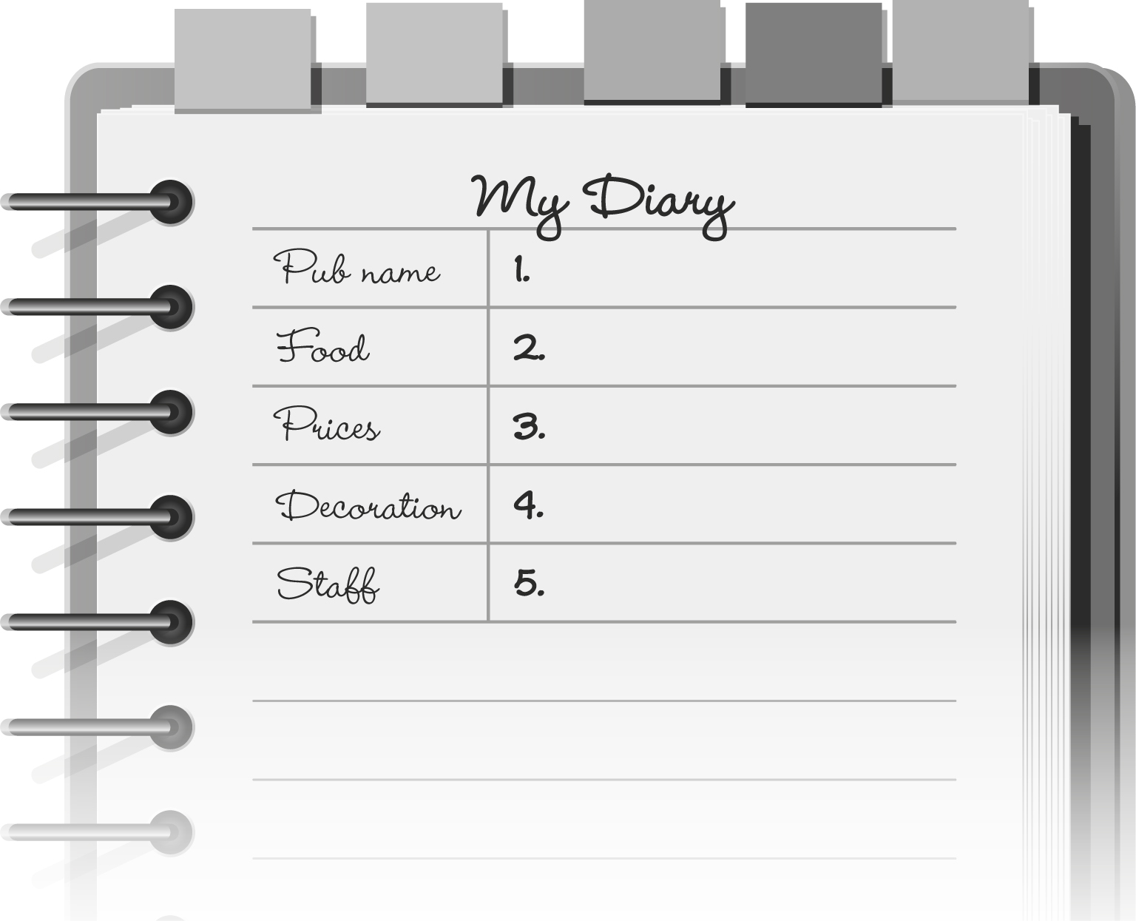

(Adapted from: Cambridge Tests)

B. Complete the following email.



To :
jake.smith@gmail.com

Cc:

Subject:
Birthday visit

Attach a file

3 B I U TT

Insert

T

Invitation

1
T
2
3

T

« Plain text

Spelling check

Hi Jake!

I’m so excited to come and visit you for 1. birthday. I have lots 2. ________ plans for us to do together. For my birthday lunch, I’d love to go to a typical English pub. 3. you know of 4. that is good? It’s my first time in England and I want to do all the things that the locals do. Can you suggest a fantastic pub
5. lunch?

Your American friend, Jerry

Send Save now Discard

C. Now imagine Jerry has decided to visit you in Portugal and he is dying to hear from you. Write a short email in which you answer his questions and tell him about a good restaurant to eat in Portugal. Write 50-80 words.



To :

Cc:

Subject:

Attach a file

B I U TT
Insert

T
Invitation

1
T
2
3

T

« Plain text

Spelling check

Send Save now Discard

