10 Minutes

PART 1

Each student interacts with the teacher answering some personal questions.

PART 2

Students interact with each other. Students ask and answer questions using prompt material.

STUDENT A

Here’s some information about a restaurant. Look at this information and answer your partner’s questions.





STUDENT A

You don’t know anything about this restaurant. So ask student B some questions about it. Use these words to help you.

•

•

•

•

•

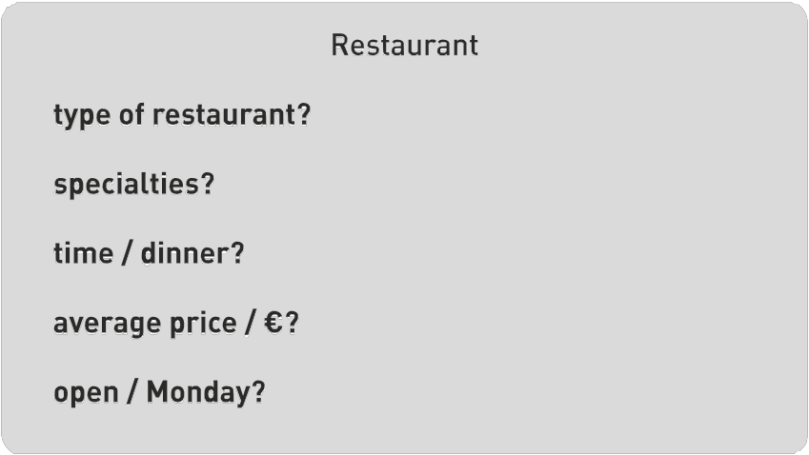

(Adapted from: Cambridge Tests)

Swoosh · 8.˚ ano Evaluation tests


10 Minutes

PART 1

Each student interacts with the teacher answering some personal questions.

PART 2

Students interact with each other. Students ask and answer questions using prompt material.

STUDENT B

You don’t know anything about this restaurant. So ask student A some questions about it. Use these words to help you.

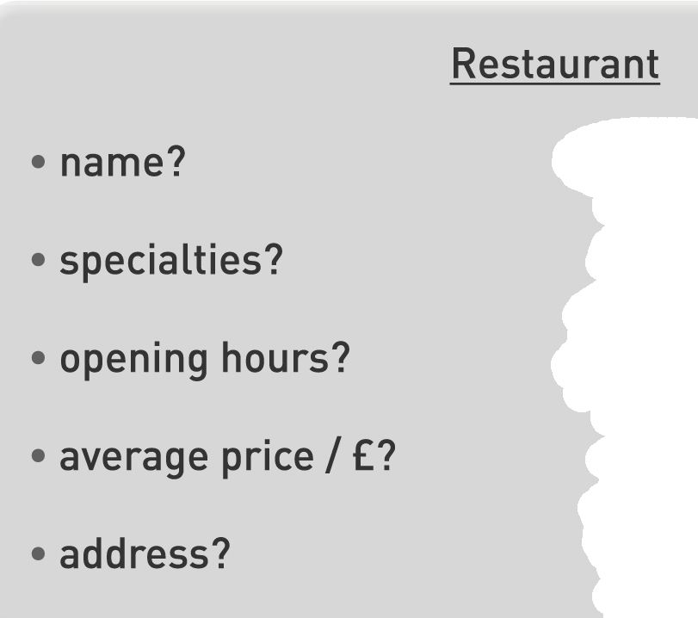



STUDENT B

Here’s some information about a restaurant. Look at this information and answer your partner’s questions.

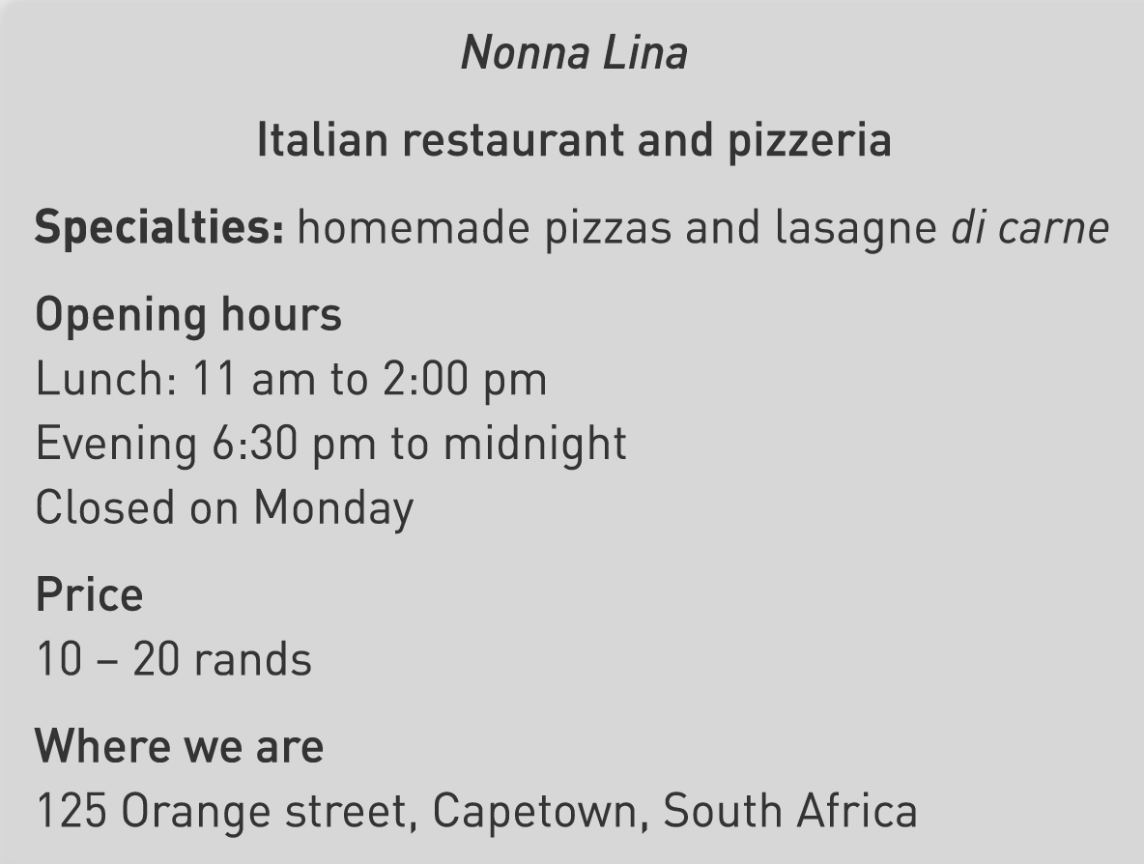


(Adapted from: Cambridge Tests)
o E o



