Unit 4



The Environment

Test A
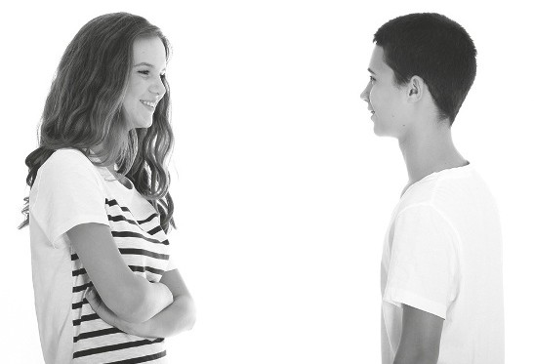

School: Name: Class: No.:
Date: / / Mark:
Enc. Educação: Teacher:

15 Minutes


A. You will hear the director talk about the documentary series Planet Earth. For items
1 to 5, fill in the missing information.
PLANET EARTH 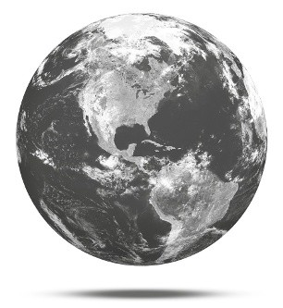
TYPE OF FILM | DOCUMENTARY
Director | 1. Fothergill
Number of episodes | 2.
Commissioned by | 3.
Year it started | 4.
Cost | 5.

B. You will hear a conversation between two friends about what they plan to do to help the planet. Choose the correct option.

1. Kate and Pete had an interesting lesson.

(a) Biology (b) Science (c) History

2. Kate plans to start .

(a) reusing things (b) reducing the things she uses (c) recycling

3. Pete thinks that Kate’s family should buy .

(a) energy saving lamps (b) rechargeable batteries (c) a recycling bin

4. He invites Kate to participate in a .

(a) conference
(b) clean up campaign
(c) manifestation

5. They are meeting at .

(a) 8:30 am (b) 9:00 am (c) 9:30 am

20 Minutes

Read the text carefully.

SW

© P
ort
o
Edi
or a

GIFTED KIDS CAN CHANGE THE WORLD
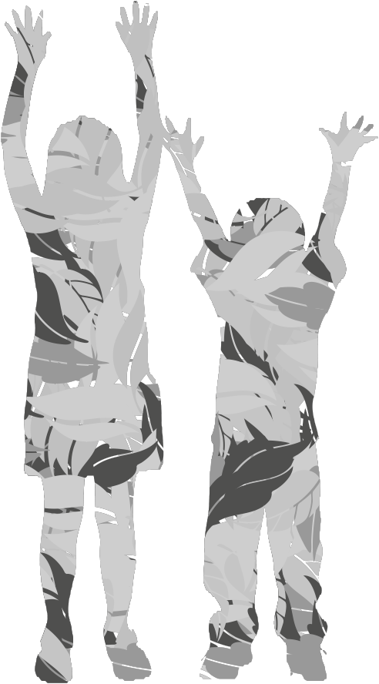

8TF
t

Gifted kids are different individuals. They are those who can see different things and solve the problem in their own way. Gifted kids can help fight against poverty and world hunger. They can
5 also work to protect and keep the environment clean as well as defend children’s rights to a healthy planet.
This may sound impossible but it isn’t really. It can be started by doing simple things at home,
10 then at school and finally at a community level.
Gifted kids like you and me can save the community by helping in various ways. We can all do simple things like – watering plants that give us fresh air, collecting donations for animals
15 in need or extinction and recycling the things that we don’t need any more.

This may sound simple but it’s actually a very important step to reducing the amount of the Earth’s resources that we use up every day. If we







20 can help the planet, then we are really working towards guaranteeing that our future is better.

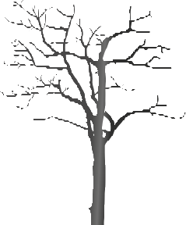

So what can gifted kids do again? Well, they can save water by turning off the tap while brushing their teeth and not taking long baths,



25 but rather short showers. They can save the electricity by turning the lights off when they are not in a room. They can save the environment by not burning trees. They can save the animals by giving them shelter. In addition, they can save





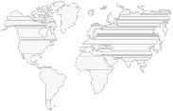

30 mother Earth by not dumping garbage into the
sea. In short, they can change their habits and become environmentally friendly. And who knows – perhaps they can even persuade adults to do the same!

Adapted from: www.teenink.com

A. Match the parts of the sentences according to the text. Some are not necessary.

1. Gifted kids can

2. Y
ou should start by ecycling is a simple
erhaps kids can even influenc


3. R

4. P e
a) buying green products.

b) doing simple things at home.

c) yet effective way of saving the planet’s resources.

d) having things that belonged to others.

e) change the world.

f) adults to become more environment friendly.

B. Find a word in the text which means:

1. find a solution for (paragraph 1) –

2. more than one (paragraph 2) –

3. making sure that (paragraph 3) –

4. a safe place to live in (paragraph 4) –

C. Decide if the following sentences are right (R) or wrong (W) according to the text.

1. Gifted kids are those who help the environment.

2. Doing small things isn’t enough to help the planet.

3. Our future depends on the state of the environment.

4. It’s difficult to convince others to help.

D. Label the following environmentally friendly actions according to their descriptions in the text.

a



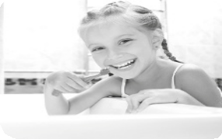

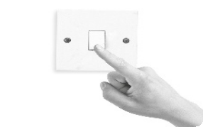



















1.
2.
3.
4.

10 Minutes


A. Put the verbs in brackets in the appropriate tense.

1. If we (not save) endangered animals, they will become extinct.

2. Unless we protect the planet, our future (not be) good.

3. If he (want) to, he will make a difference.

4. The planet (die) if we don’t do something soon.

5. If we all (use) cars, we will pollute the air.

6. Governments listen when we (protest).

B. Complete the sentences with the appropriate preposition for the phrasal verb look.

1. I can’t find my keys. Can you help me look them?

2. My idol is my older brother. I really look him.

3. Mum asked me to look the baby while she went shopping.

4. If you don’t know the meaning of a word, look it in the dictionary.

5. We are really looking Christmas this year. I can’t wait!

6. When you walk to school look crazy drivers and walk on the pavement.

C. Choose the correct verb.

1. When I was on holiday I sleep until late.

(a) can (b) could

2. The children at that school wear uniforms!

(a) have to (b) could

3. I study for the test. I don’t want to get a bad mark.

(a) would (b) have to

4. Excuse me, you tell me where the post office is?

(a) must (b) could

5. Tom speak French well.

(a) can (b) have to

6. They say you drink and drive.

(a) must (b) mustn’t

35 Minutes


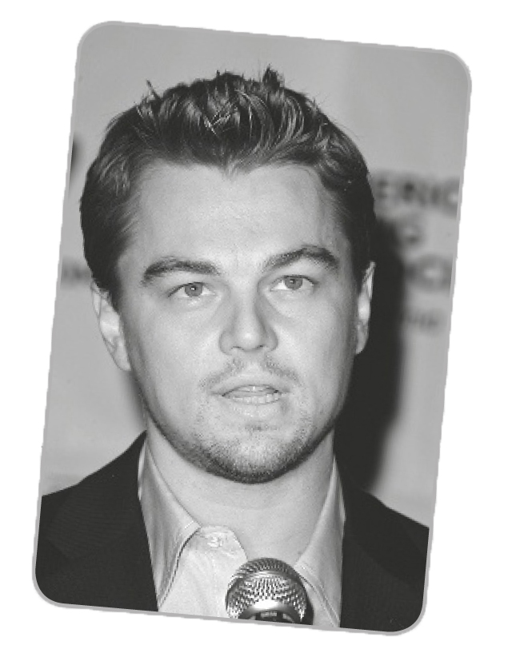A. Write a short text about Leonardo DiCaprio, a star who fights to protect the environment. Use the information below to help you (30–50 words).
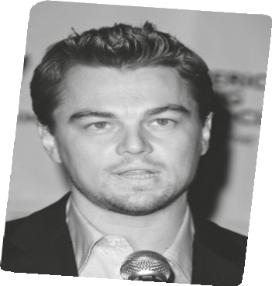

Short introduction | Name – Leonardo DiCaprio  Date of birth – 11 November 1974  Place of birth – Los Angeles, California
Physical description | Hair – blond Eyes – blue Height – 1,83
Qualities and traits | • tolerant, hardworking  • co-wrote, produced and narrated the global warming documentary The 11th Hour
Qualities and traits | • created a foundation that deals with environmental causes including access to clean water, renewable energy and forest preservation

B. Read the beginning of a story about the environment, then finish the story in any way you like (30-50 words).


It was a hot day in the middle of July so I decided to go to the beach. When I got there I saw that there was a dolphin that was trapped in the shallow water. I didn’t know what to do so I…
__________________________________________________________________________________________________________________________________________________________________________________________________________________________________________________________________________________________________________________________________________________________________________________________________________________

