Unit 4

The Environment
Test B
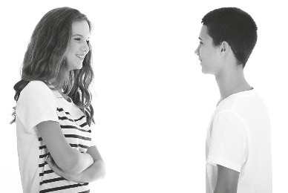

School: Name: Class: No.:
Date: / / Mark:
Enc. Educação: Teacher:

15 Minutes


A. You will hear the director talk about the documentary series Planet Earth. For items
1 to 5, circle the missing information.


TYPE OF FILM | DOCUMENTARY
Director | 1. Adrian / Alastair Fothergill
Number of episodes | 2. 11 / 15
Commissioned by | 3. CBC / BBC
Year it started | 4. 2005 / 2010
Cost | 5. most expensive / cheapest documentary ever made

B. You will hear a conversation between two friends about what they plan to do to help the planet.

1. Kate and Pete had an interesting lesson.

(a) Biology (b) Science (c) History

2. Kate plans to start .

(a) reusing things (b) reducing the things she uses (c) recycling

3. Pete thinks that Kate’s family should buy .

(a) energy saving lamps (b) rechargeable batteries (c) a recycling bin

4. He invites Kate to participate in a .

(a) conference (b) clean up campaign (c) manifestation

5. They are meeting at .

(a) 8:30 am (b) 9:00 am (c) 9:30 am





20 Minutes

Read the text carefully.

GIFTED KIDS CAN CHANGE THE WORLD


Gifted kids are different individuals. They are those who can see different things and solve the problem in their own way. Gifted kids can help fight against poverty and world hunger. They can also work to protect and keep the environment clean
5 as well as defend children’s rights to a healthy planet.
This may sound impossible but it isn’t really. It can be started by doing simple things at home, then at school and finally at a community level. Gifted kids like you and me can save the community by helping in various ways. We can all do simple
10 things like – watering plants that give us fresh air, collecting donations for animals in need or extinction and recycling the things that we don’t need any more.









This may sound simple but it’s actually a very important step to reducing the amount of the Earth’s resources that we use up



15 every day. If we can help the planet, then we are really working towards guaranteeing that our future is better.



So what can gifted kids do again? Well, they can save water by turning off the tap while brushing their teeth and not taking long baths, but rather short showers. They can save the


20 electricity by turning the lights off when they are not in a room.
They can save the environment by not burning trees. They can save the animals by giving them shelter. In addition, they can save mother Earth by not dumping garbage into the sea. In short, they can change their habits and become environmentally friendly. And who knows – perhaps they can even persuade adults to do the same!

Adapted from: www.teenink.com

A. Match the parts of the sentences according to the text.

1. Gifted kids

2. You should start by

3. Recycling

4. Perhaps kids can even
(a) doing simple things at home.

(b) is a simple yet effective way of saving the planet’s resources.

(c) can change the world.

(d) influence adults to become more environment friendly.

B. Match the expressions with the words in the box.

1. find a solution for
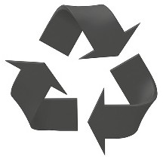

2. more than one

3. making sure that

4. a safe place to live in

(a) various (b) shelter (c) solve
(d) guaranteeing

C. Decide if the following sentences are right (R) or wrong (W) according to the text:

1. Gifted kids are those who help the environment.

2. Doing small things isn’t enough to help the planet.

3. Our future depends on the state of the environment.

4. It’s difficult to convince others to help.

D. Label the following environmentally friendly actions according to their descriptions in the text. Use the words in the box to help.

























1.
2.
3.
4.


10 Minutes

A. Choose the appropriate option.

1. If we save / don’t save endangered animals, they will become extinct.

2. Unless we protect / don’t protect the planet, our future will not be good.

3. If he want / wants to, he will make a difference.

4. The planet die / will die if we don’t do something soon.

B. Complete the sentences with a preposition in the box below. Not all are needed.

1. I can’t find my keys. Can you help me look them?

2. My idol is my older brother. I really look him.

3. Mum asked me to look the baby while she went shopping.

4. I didn’t know the meaning of the word so I looked it in the dictionary.

C. Choose the correct verb.

1. When I was on holiday I sleep until late.

(a) can (b) could

2. The children at that school wear uniforms!

(a) have to (b) would

3. I study for the test. I don’t want to get a bad mark.

(a) would (b) must

4. Excuse me, you tell me where the post office is?

(a) must (b) could

35 Minutes


A. Read the beginning of a story about the environment then finish the story in any way you like (30–50 words).


It was a hot day in the middle of July so I decided to go to the beach. When I got there I saw
that there was a dolphin that was trapped in the shallow water. I didn’t know what to do so I…
__________________________________________________________________________________________________________________________________________________________________________________________________________________________________________________________________________________________________________________________________________

