Unit 4

The Environment

School: Name: Class: No.:
Date: / / Mark:
Enc. Educação: Teacher:

A. Write the words in the box below under the corresponding picture.

(Escreve as palavras da caixa por baixo das imagens correspondentes.)

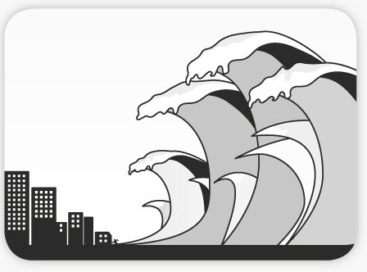


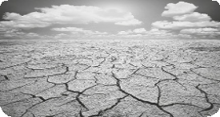

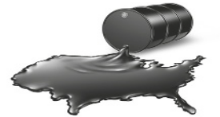

1.

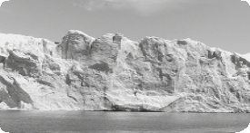

5.
2.

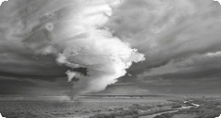

6.
3.



7.
4.

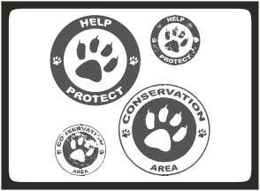

8.

B. Complete the gaps with a word in the box.

(Completa os espaços com palavras da caixa.)

 | 1. | We are running out of oil so we need to start using energies.
 | 2. | is when the temperature of the Earth increases.
 | 3. | is rain that contains dangerous chemicals.
 | 4. | The effect is caused by pollution and rising temperatures.
 | 5. | We need to protect in countries like Brazil.
 | 6. | help cause acid rain.

Swoosh · 8.˚ ano Evaluation tests




C. Look at the clues below and complete the crossword. Use the words in the box to help you.

(Lê as pistas e completa as palavras cruzadas. Usa as palavras da caixa como ajuda.)
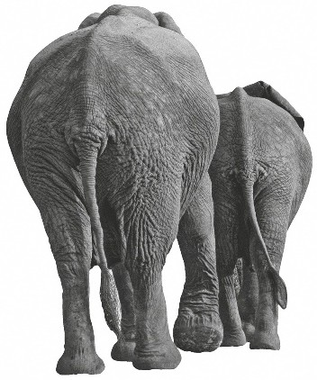

2

1

4

5
H
3 U 10
R 7
R 9
6 I
C 12
A N
E 8
11

ACROSS → | DOWN ↓
1. animals which have big ears and a trunk  3. the amount of heat/cold that we feel every day  4. the result of an increase in the Earth’s temperature  6. an accident involving oil and water  8. species that are in danger  11. something that we write on and can recycle  12. a person who fights for the environment | 2. to keep safe  5. a very strong wind  7. different types of plants and animals  9. rain with dangerous chemicals  10. use again

