Unit 4



The Environment
Key for Schools

School: Name: Class: No.:
Date: / / Mark:
Enc. Educação: Teacher:



15 Minutes

A. You will hear five short conversations. For each conversation, circle the appropriate picture (A–C).

1. What is Sophie going to do to protect the Environment?

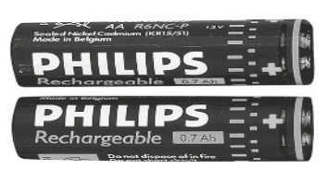

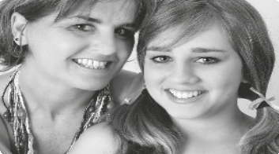

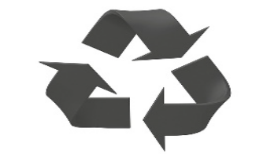

A B C

2. How much can you donate to this environmental organisation?

50€
15€
5€

A B C

3. What is this school going to do?

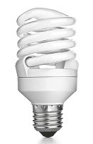

A B C
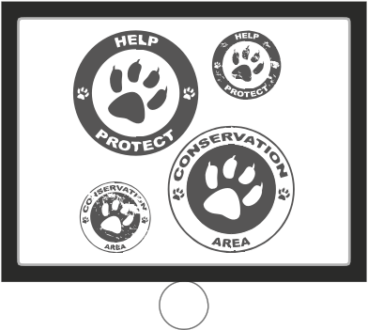

4. How many wild Asian elephants are there in the world today?

600-700 000
15-25 000
35-45 000

A B C

5. Which environmental effect is mentioned?

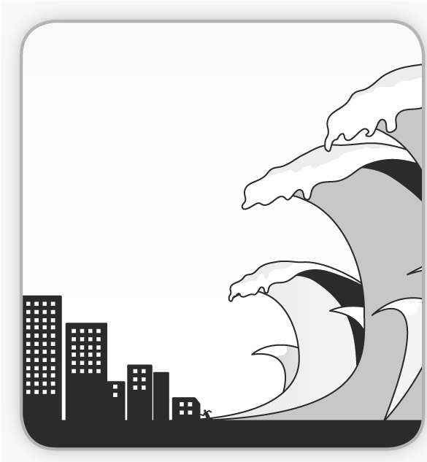
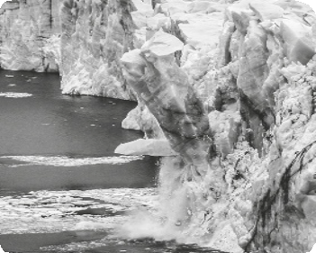

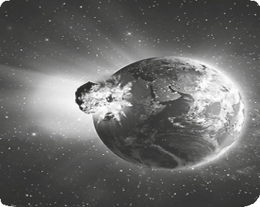

A B C

B. You will hear a scientist talking about the effects of global warming. Listen and complete the table.

SCIENTIFIC REPORT
Scientist’s name |  | Michael Studinger
Current job |  | Works for the 1.
Topic of talk |  | 2.
Global Warming is caused by |  | 3.
• Fossil fuels release |  | 4. , methane and  5. gases into the atmosphere

(Adapted from:
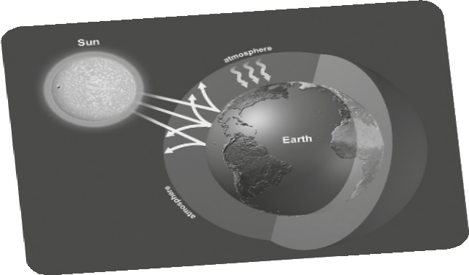

Cambridge Tests)

30 Minutes

A. Which notice (A–G) would you put up in the following cases (1–5)? Write the correct letter in the corresponding box. Some are not necessary.

1. You want people to switch off the lights.

2. People should beware of exhaust fumes.

3. You want to recruit volunteers.

4. This box is only for recycling glass. A
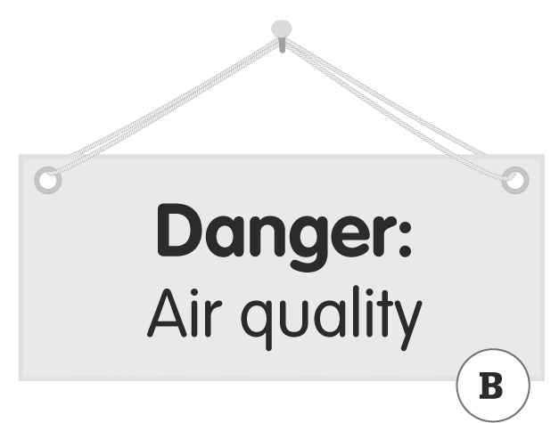
5. Drive carefully and mind the wild animals.



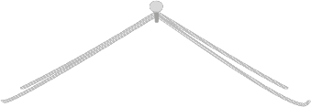

Glass museum


Closed from
12.30 – 2.30 pm C D

B

F

E


Volunteers
needed
G

B. Choose the appropriate reply for each of the following conversations.

(Adapted from: Cambridge Tests)
1. If we don’t protect the environment, | A. we won’t be in danger.  B. it’s dangerous.  C. we will all be in danger.
2. Do you know what acid rain is? | A. Pardon? What did you say? B. Excuse me, can I get past.  C. I’m sorry.
3. We’re recycling now. | A. Neither are we.  B. So are we.  C. That’s right.
4. What’s the ozone layer? | A. It’s like an umbrella that protects the Earth from the sun.  B. It’s very easy.  C. Yes, I understand.
5. How many elephants are there? | A. Not any.  B. Not much.  C. Not many.


C. Read the sentences and choose the appropriate word for each space.

1. There are many on the planet nowadays.

A. danger species B. endanger species C. endangered species D. species danger

2. Do you worry protecting the Environment?

A. for B. of C. over D. about

3. Are you an fan?

A. environment B. environmental C. environmentally D. environments

4. What state do you think the planet is ?

A. in B. on C. up D. about

5. Elephants are animals which are danger.

A. in B. on C. under D. about

6. What do you think governments must to protect the planet?

A. to do B. do C. doing D. did

7. Everybody says I take my father. We have the same eyes and ears.

A. over B. back C. after D. off

8. If temperatures continue to rise, icebergs .

A. will melt B. melts C. melts D. won’t melt

9. we recycle, we will waste the planet’s resources!

A. If B. When C. Unless D. After

10. I think you should turn devices when they are not in use.

A. on B. off C. of D. back

D. Read this article about the environment and choose the appropriate word.

It is hard for one 1) person / persons to make a change, but 2) after / when all of us get together we 3) can / shouldn’t make a notable impact on our society.
First, start by 4) get / getting all the “one persons” together in your school.
5) Better / Best yet, get all those people together and start your school’s very own Environmental Club! That’s what we 6) do / did at Auburn High School. 7) Our / Its club started because kids wanted to clean up our Earth. They 8) realize / realized the impetus has to begin with cleaning up the environment closest to you.
One program we started was a clean-up of our school’s outdoor campus. We were disgusted with the amount of pollution we found scattered 9) on / around our school. So we decided to do something about it and make our efforts noticeable to the rest of the student body. We arranged to pick up trash during lunch and after school. We put the trash on display so the 10) whole / only school could enjoy the garbage collage they created.

E. Read this article about saving the environment.

Saving The Environment: One Home At A Time!

Pollution can be seen not only throughout the world, but also in our own homes. It comes from household chemicals, the amount of water people use and the waste people produce and throw away. What can be done to stop this pollution? Surprisingly, a person can help save the environment by doing simple things.
First, we need to recycle, which saves landfill space for other waste and allows products to be used over and over again. Recycling just one aluminium soda can save the energy equivalent of half that can filled with gasoline. Recycling can also reduce the number of trees cut down to produce paper products. It takes very little effort; it is not hard to place plastic and glass bottles, aluminium cans and paper in a bin. Anyone can do it.
Then, we need to watch the amount of water used in the home. Water can be conserved by taking short showers instead of baths, repairing leaky taps, using the dishwasher or the washing machine only when it is fully loaded, or simply turning the tap off while brushing your teeth. Even though there is plenty of water on Earth, only a very small percentage is fit for human consumption. We need to help save this water every way we can. Water is a valuable resource that can be wasted as easily as it can be conserved and we can all start doing this in our own homes.

Decide if the sentences are right (R) or wrong (W) according to the text.

1. There is also pollution in our homes.

2. A cause of pollution is household chemicals.

3. Recycling leads to less landfill space for other waste.
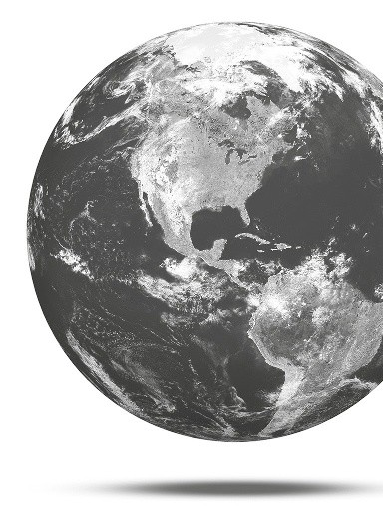

4. Recycling a can of soda can save energy.

5. Recycling doesn’t save trees.

6. It is very difficult to recycle.

7. It is difficult to save water at home.

8. It is acceptable to use the dishwasher when it’s not full.

9. You can recycle plastic, glass and aluminium.

10. There is lots of water on the Earth for us to use.



35 Minutes

A. Rewrite the sentences using the word given without changing the meaning. Use between two and three words.

1. It is possible for everyone to recycle. (can)

Everyone .

2. It is forbidden to copy in tests. (mustn’t)

You in tests.

3. I think it’s a good idea to use rechargeable batteries. (should)

I think we rechargeable batteries.

4. If we don’t pressure governments, they won’t pass environmentally
friendly laws. (unless)

governments, they won’t pass environmentally friendly laws.

5. I’m going to take care of an abandoned dog. (look)

I’m going to an abandoned dog.

B. Complete this letter. Write one word for each space.

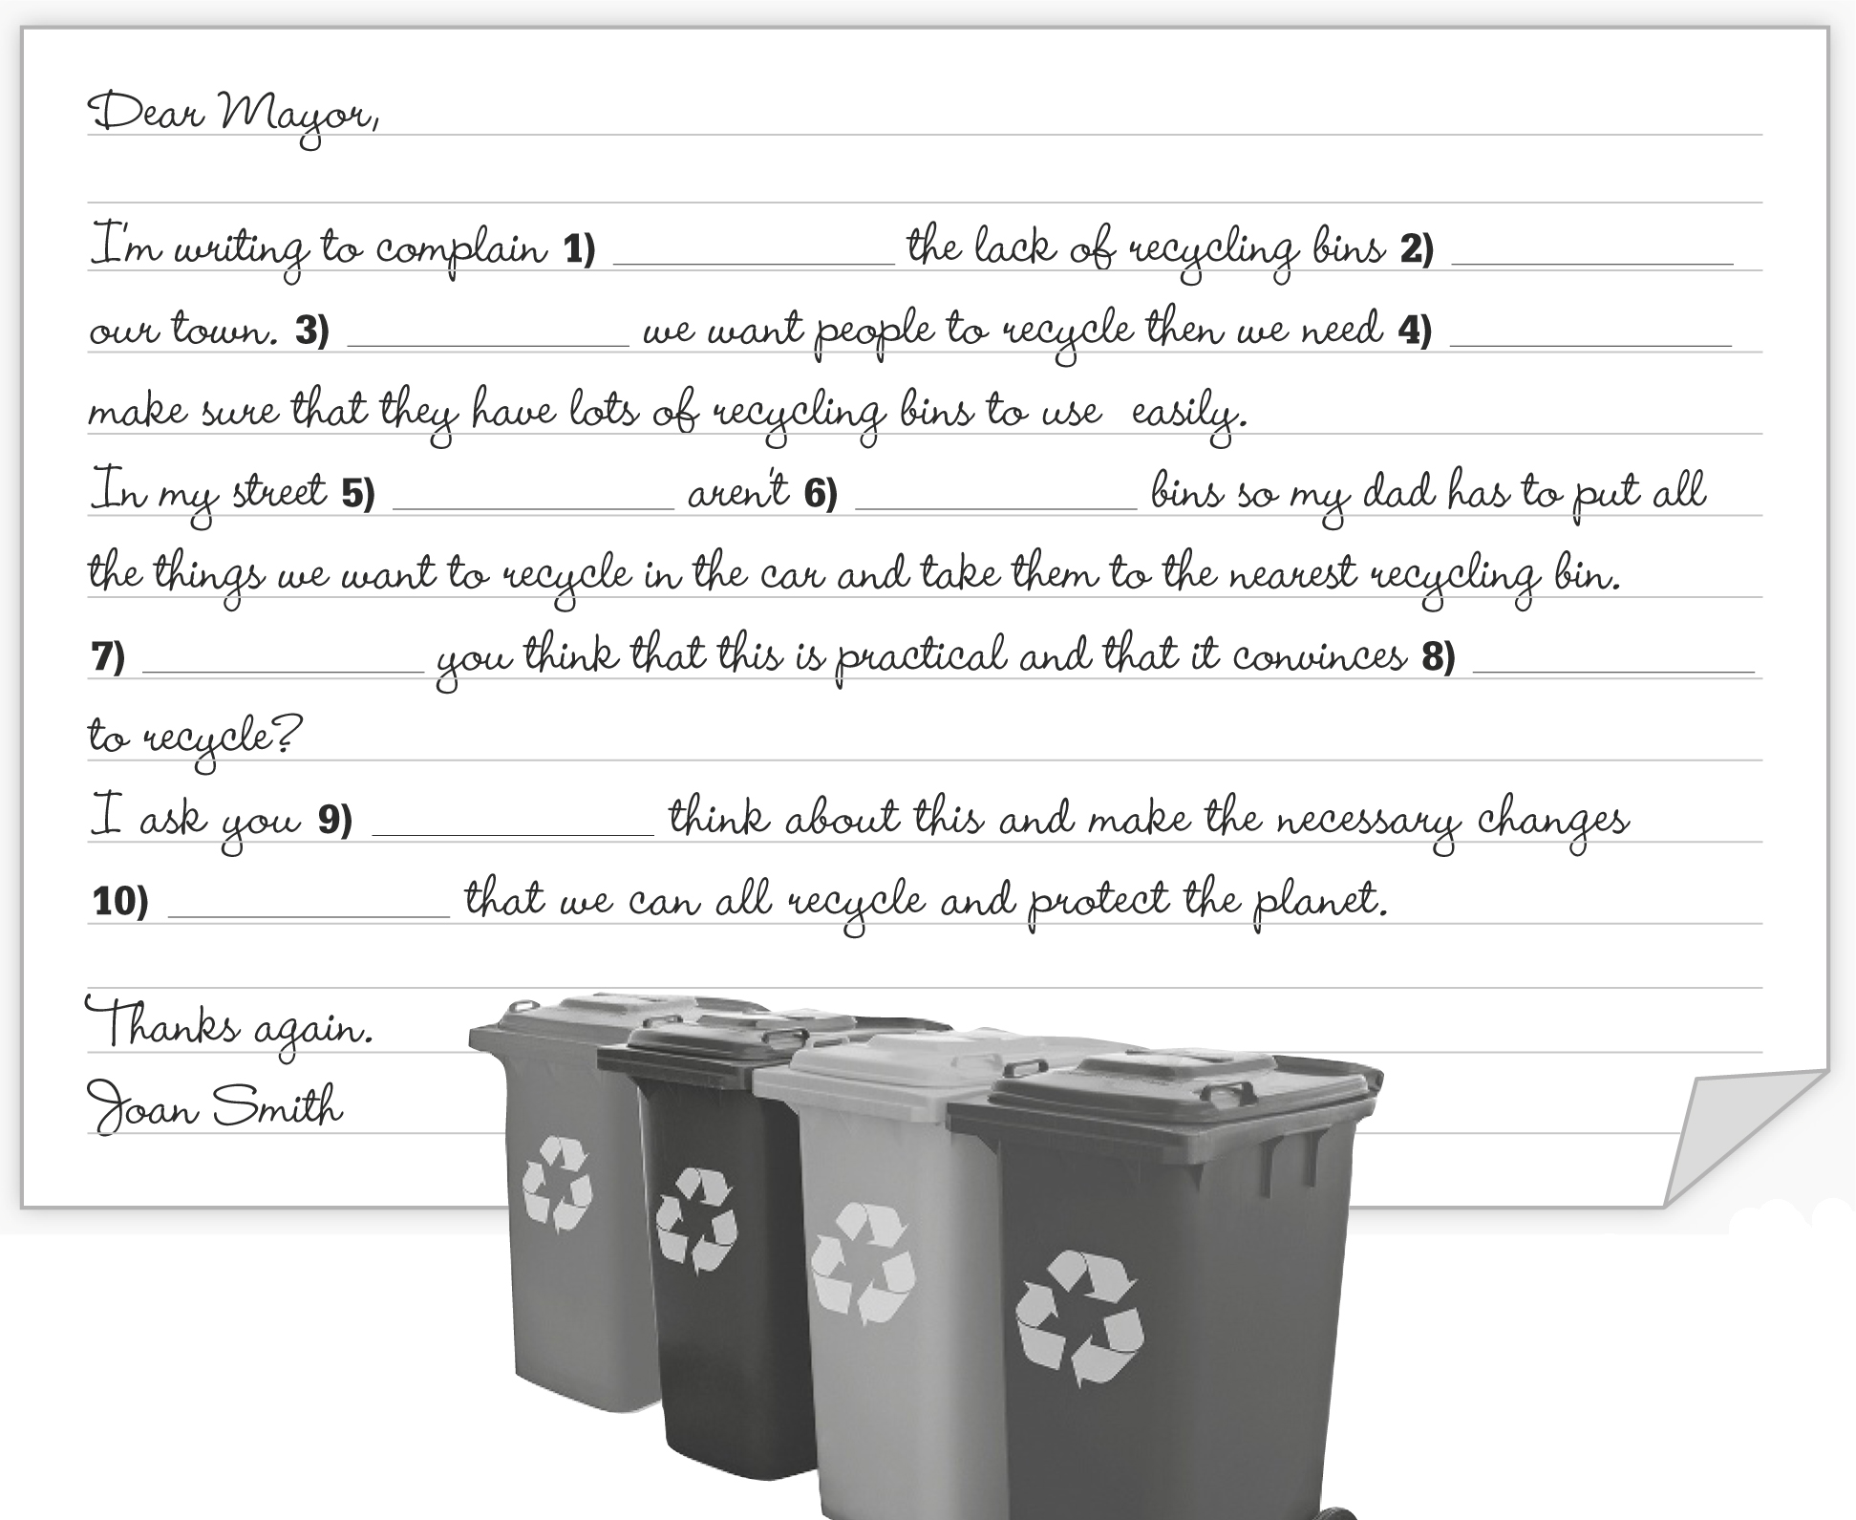

(Adapted from:
Cambridge Tests)

C. Read a story about protecting the elephants.



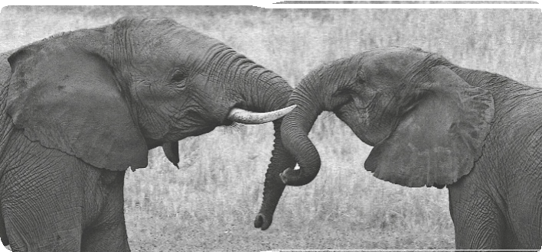

When Mario was small, he wanted to protect the planet. Time passed and he went to university and became a journalist. One day, he wrote
a very shocking story about
hunters and the African elephants. He managed to publish his story. Now everyone is trying to save the elephants because
of him.

Write a short story of your own about the environment in 30–50 words.





(Adapted from: Cambridge Tests)

