10 Minutes

PART 1
Each student interacts with the teacher answering some personal questions.

PART 2
Students interact with each other. Students ask and answer questions using the prompt material.

STUDENT A
Here’s some information about an environmental film festival. Look at this information and answer your partner’s questions.

ENVIRONMENTAL FILM FESTIVAL

A vast collection of films about the Environment





ENTRANCE: 5$

March 18–30



Washington DC Morning session

9.00 am – 11.30 pm

Afternoon session

3.00 pm – 5.30 pm

STUDENT A
You don’t know anything about this conference. So ask student B some questions about it. Use these words to help you.

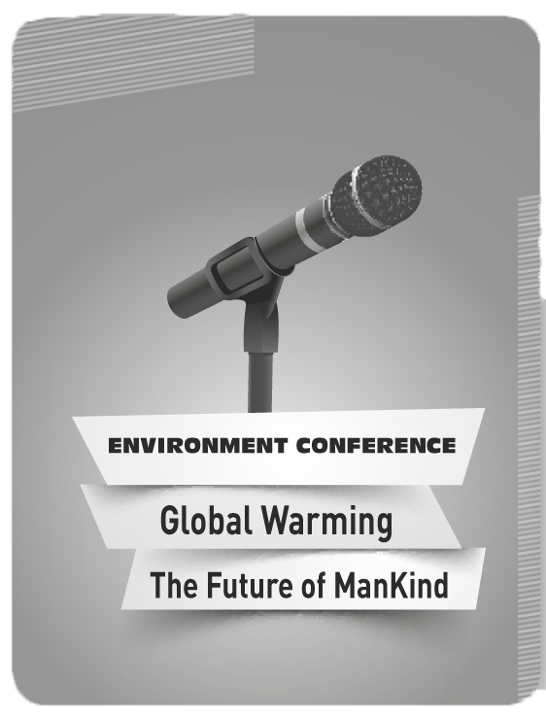
ENVIRONMENT CONFERENCE

• where?

• when / day?

• guest speaker?

• entrance fee?

• start / ?

(Adapted from: Cambridge Tests)
Swoosh · 8.˚ ano Evaluation tests


10 Minutes

PART 1
Each student interacts with the teacher answering some personal questions.

PART 2
Students interact with each other. Students ask and answer questions using the prompt material.

STUDENT B
You don’t know anything about this film festival. So ask student A some questions about it. Use these words to help you.

FILM FESTIVAL

• what / about?

• when?







• where?

• session times?

• cost / $?

STUDENT B
Here’s some information about a conference. Look at this information and answer your partner’s questions.

ENVIRONMENT CONFERENCE

Parque das Nações – Lisbon

April 12



Guest Speaker: Al Gore

Starts 9.30 am – Finishes 4.00 pm

Free admittance

Lunch provided



(Adapted from: Cambridge Tests)

