

Unit 5

Places to visit
Swoosh · 8.˚ ano Evaluation tests
Test A



School: Name: Class: No.:
Date: / / Mark:
Enc. Educação: Teacher:

15 Minutes


A. You will hear a tour guide talking about the Buckingham Palace. For items 1 to 5, fill in the missing information.

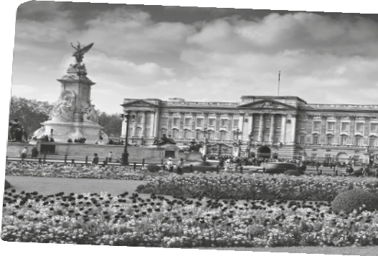

BUCKINGHAM PALACE
Original name | Buckingham House
Where it is (city) | 1.
Year it was built | 2.
Year it became the official royal palace | 3.
How many rooms | 4.
Number of visitors each year | 5.

B. You will hear a conversation between two friends about a trip to London.
Choose the correct option.

1. Becky went to London yesterday .


(a) morning (b) afternoon (c) evening

2. She went to London by .

(a) car (b) bus (c) underground

3. Becky and her friends ate .

(a) Japanese food (b) Indian food (c) Italian food

4. Becky says the restaurant was .

(a) full (b) expensive (c) quiet

5. After the meal, Becky and her friends .

(a) sat and talked (b) went to the cinema (c) walked by the water

20 Minutes

SW

© P
ort
o
Edi
or a

Read the text carefully.

THE WONDERS OF PARIS
8TF
t
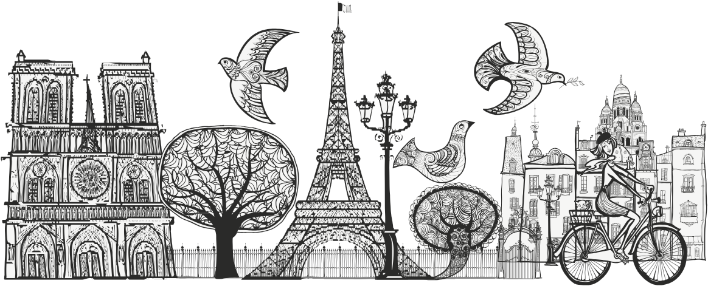

‘The city of lights’, ‘the city of romance’, ‘the culinary capital of the world’, all these are just names Paris, in France, is known by. Over seven million people visit this city each year. Paris is one of the most amazing places you will ever visit. There are so many phenomenal things to see and do you’ll never get bored.
5 The most prominent landmark in Paris would have to be the Eiffel Tower. More than seven million people visit the Eiffel Tower each year. For a small fee you can ride the elevator to the top. The view from the top is spectacular. If you want to do some exercise, you can take the stairs that go from the ground to the second platform. Many people like to go to the Eiffel Tower at night because it is all lit up.
10 The Arc De Triomphe and Versailles are some of Paris’s other famous landmarks. The Arc De Triomphe honours all the soldiers who fought for France, particularly during Napoleon Bonaparte’s reign. Under the Arch lies the Tomb of an Unknown Soldier, which honours all of France’s soldiers who have never been identified. And then there is Versailles which is one of the most extravagant buildings in the world. It is a humongous palace with
15 over 700 rooms, 67 staircases, 2000 windows, and 1250 fireplaces. The whole property is
19,262 acres.
There are also famous museums in Paris. Some of the more well known ones are the Louvre and the Musee de L’Air et de L’espace. The Louvre was originally a royal palace but became a museum in 1793. Outside the museum there is a substantial glass pyramid. Inside
20 there are heaps of exhibits including artefacts from Egypt, Greece, and Rome. The Mona
Lisa by Leonardo Da Vinci is also displayed there.
In conclusion, visiting Paris, in France, truly is a memorable experience. Paris is one of the most beautiful cities in the world you can possibly visit. There are so many phenomenal things to see and do that you will never get bored.

Adapted from: www.teenink.com

Swoosh · 8.˚ ano Evaluation tests

A. Match the parts of the sentences according to the text. Some expressions are not necessary.

1. There are amazing places (a) a very luxurious palace.

2. The view from the top of (b) an old castle.

3. Versailles is (c) the Eiffel Tower is fantastic.

4. The Louvre is (d) a very famous museum.

(e) to visit in Paris.

(f) where we can meet people.

B. Read the text again and find words that mean the following:

1. In paragraph 1 a word that means “tired and impatient”.

2. In paragraph 2 a word that means “an amount of money”.

3. In paragraph 3 a word that means “huge, very big”.

4. In paragraph 4 a word that means “a lot of something”.

C. Name the place where you can see:

1. the Mona Lisa, a painting by Leonardo Da Vinci –

2. the Tomb of an Unknown Soldier –

3. a breathtaking view of Paris –

4. many rooms, windows and fireplaces –

D. Label the following landmarks according to their descriptions in the text.
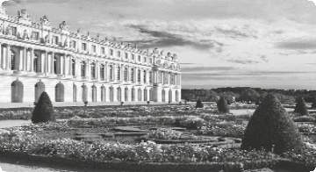

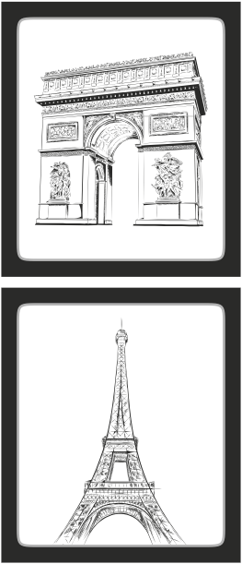

1.

2.

3.
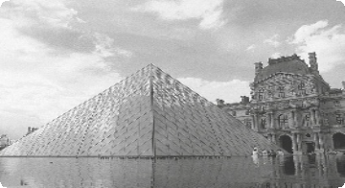

4.

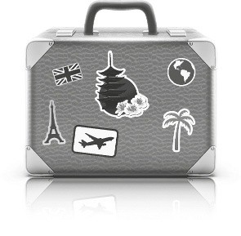

10 Minutes


A. Complete the sentences with the Present Perfect.

1. (you / see) the news lately? Travelling is getting expensive.

2. Jane (study) French so that she can travel to France.

3. Peter (go) to France. I don’t know if he has come back yet.

4. I (not / visit) the Louvre yet.

5. There (be) many earthquakes lately.

6. I (travel) to Paris three times.

B. Complete the sentences with the adverbs given in the box below. One is not necessary.

1. Have you been to Paris?

2. She has been up the Eiffel Tower before. It’s her first time today.

3. I haven’t seen her May.

4. I’ve lived in Paris almost five years.

5. I haven’t finished my homework , so I can’t go out now.

6. Is Peter in? – No, he has gone to school. He left only two minutes ago.

C. Choose between the Past Simple or the Present Perfect.

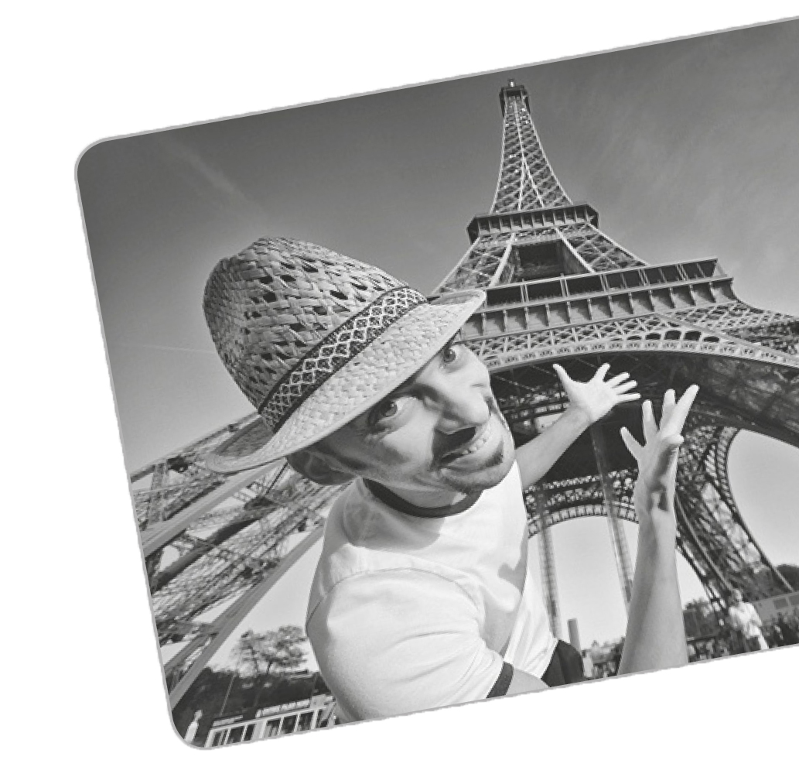1. He as a tour guide for 15 years. He lo

(a) worked (b) has worked

2. to France last year?

(a) Did you go (b) Have you gone

3. I you lately! Are you ok?

(a) didn’t see (b) haven’t seen

4. I many postcards when I was in Paris.

(a) bought (b) have bought

5. They from France last week.

(a) returned (b) have returned

6. your homework? Not yet!

(a) Did you finish (b) Have you finished



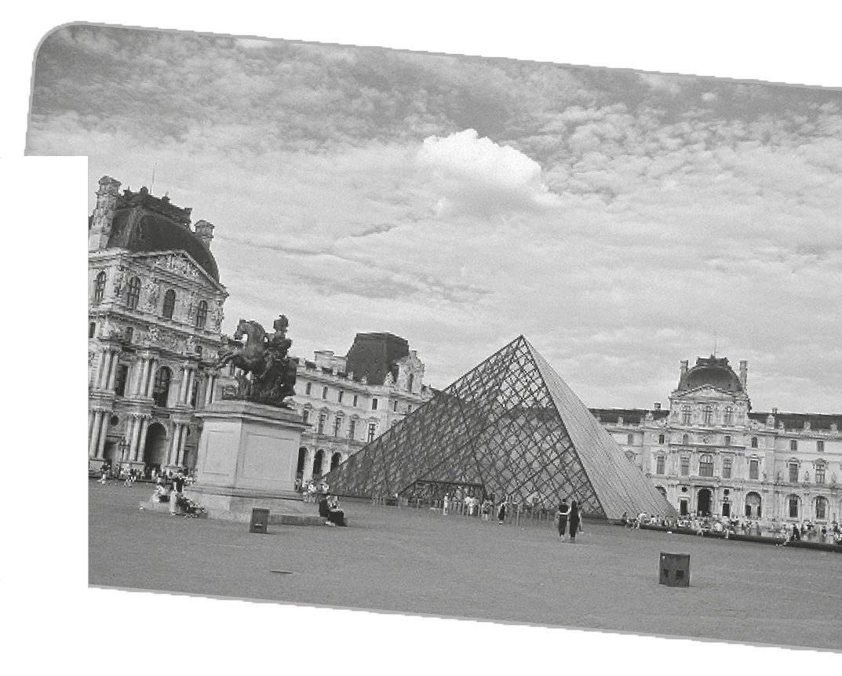
A. Write a short text about the Louvre.
Use the information below to help you.
Swoosh · 8.˚ ano Evaluation tests

35 Minutes

What • Museum

Where • Paris – France

Built • the late 12th century

Open
as museum

Other information

• 10 August 1793
• an exhibition of 537 paintings

• world’s largest museums
• more than 8 million visitors each year

B. This is part of a letter you received from your French friend Jacques.

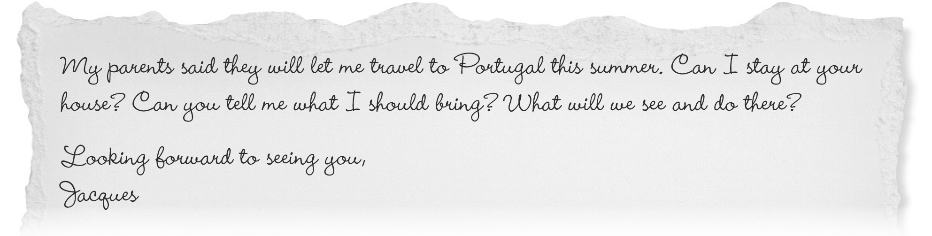

Write a letter answering Jacques’s questions (50-80 words).

