Unit 5

Places to visit
Test B

School: Name: Class: No.:
Date: / / Mark:
Enc. Educação: Teacher:



A. You will hear a tour guide talking about the Buckingham Palace.
For items 1 to 5, choose the best option.

15 Minutes

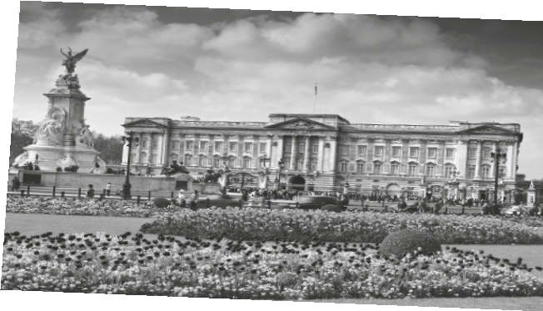

BUCKINGHAM PALACE

Original name Buckingham House / Queen’s House

Where it is (city) 1. London / Westminster

Year it was built 2. 1707 / 1705

Year it became the official
royal palace 3. 1837 / 1937

How many rooms 4. 715 / 775

Number of visitors each year 5. 5 000 / 50 000

B. You will hear a conversation between two friends about a trip to London.
Choose the correct option.

1. Becky went to London yesterday .

(a) morning (b) afternoon (c) evening

2. She went to London by .

(a) underground (b) car (c) bus

3. Becky and her friends ate .

(a) Indian food (b) Japanese food (c) Italian food

4. Becky says the restaurant was .

(a) expensive (b) full (c) quiet

5. After the meal, Becky and her friends .

(a) sat and talked (b) walked by the water (c) went to the cinema

Swoosh · 8.˚ ano Evaluation tests




20 Minutes

Read the text carefully.

a or
Edit o
ort
P
© SW8TF

THE WONDERS OF PARIS
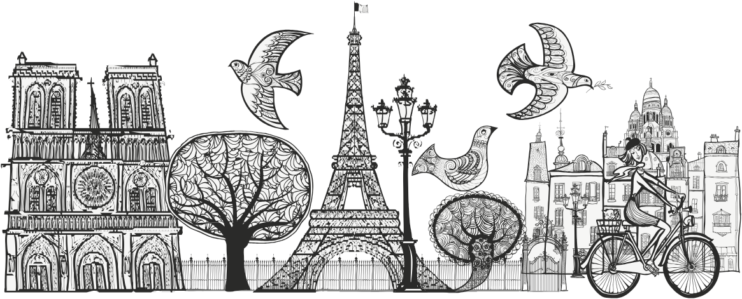

‘The city of lights’, ‘the city of romance’, ‘the culinary capital of the world’, all these are just names Paris, in France, is known by. Over seven million people visit this city each year. Paris is one of the most amazing places you will ever visit. There are so many phenomenal things to see and do you’ll never get bored.
5 The most prominent landmark in Paris would have to be the Eiffel Tower. More than seven million people visit the Eiffel Tower each year. For a small fee you can ride the elevator to the top. The view from the top is spectacular. If you want to do some exercise, you can take the stairs that go from the ground to the second platform. Many people like to go to the Eiffel Tower at night because it is all lit up.
10 The Arc De Triomphe and Versailles are some of Paris’s other famous landmarks. The Arc De Triomphe honours all the soldiers who fought for France, particularly during Napoleon Bonaparte’s reign. Under the Arch lies the Tomb of an Unknown Soldier, which honours all of France’s soldiers who have never been identified. And then there is Versailles which is one of the most extravagant buildings in the world. It is a humongous palace with
15 over 700 rooms, 67 staircases, 2000 windows, and 1250 fireplaces. The whole property is
19,262 acres.
There are also famous museums in Paris. Some of the more well known ones are the Louvre and the Musee de L’Air et de L’espace. The Louvre was originally a royal palace but became a museum in 1793. Outside the museum there is a substantial glass pyramid. Inside
20 there are heaps of exhibits including artefacts from Egypt, Greece, and Rome. The Mona
Lisa by Leonardo Da Vinci is also displayed there.
In conclusion, visiting Paris, in France, truly is a memorable experience. Paris is one of the most beautiful cities in the world you can possibly visit. There are so many phenomenal things to see and do that you will never get bored.

Adapted from: www.teenink.com

A. Match the parts of the sentences according to the text.

1. There are amazing places (a) the Eiffel Tower is fantastic.

2. The view from the top of (b) a very famous museum.

3. Versailles is (c) a very luxurious palace.

4. The Louvre is (d) to visit in Paris.

B. Match the words from the text with the corresponding meanings on the right.

1. bored (line 4) (a) huge, very big

2. fee (line 6) (b) tired and impatient

3. humongous (line 14) (c) a lot of something

4. heaps (line 20) (d) an amount of money

C. Name the place where can you see:

1. many rooms, windows and fireplaces –

2. the Mona Lisa, a painting by Leonardo Da Vinci –

3. a breathtaking view of Paris –

4. the Tomb of an Unknown Soldier –

D. Label the following landmarks according to their descriptions in the text.
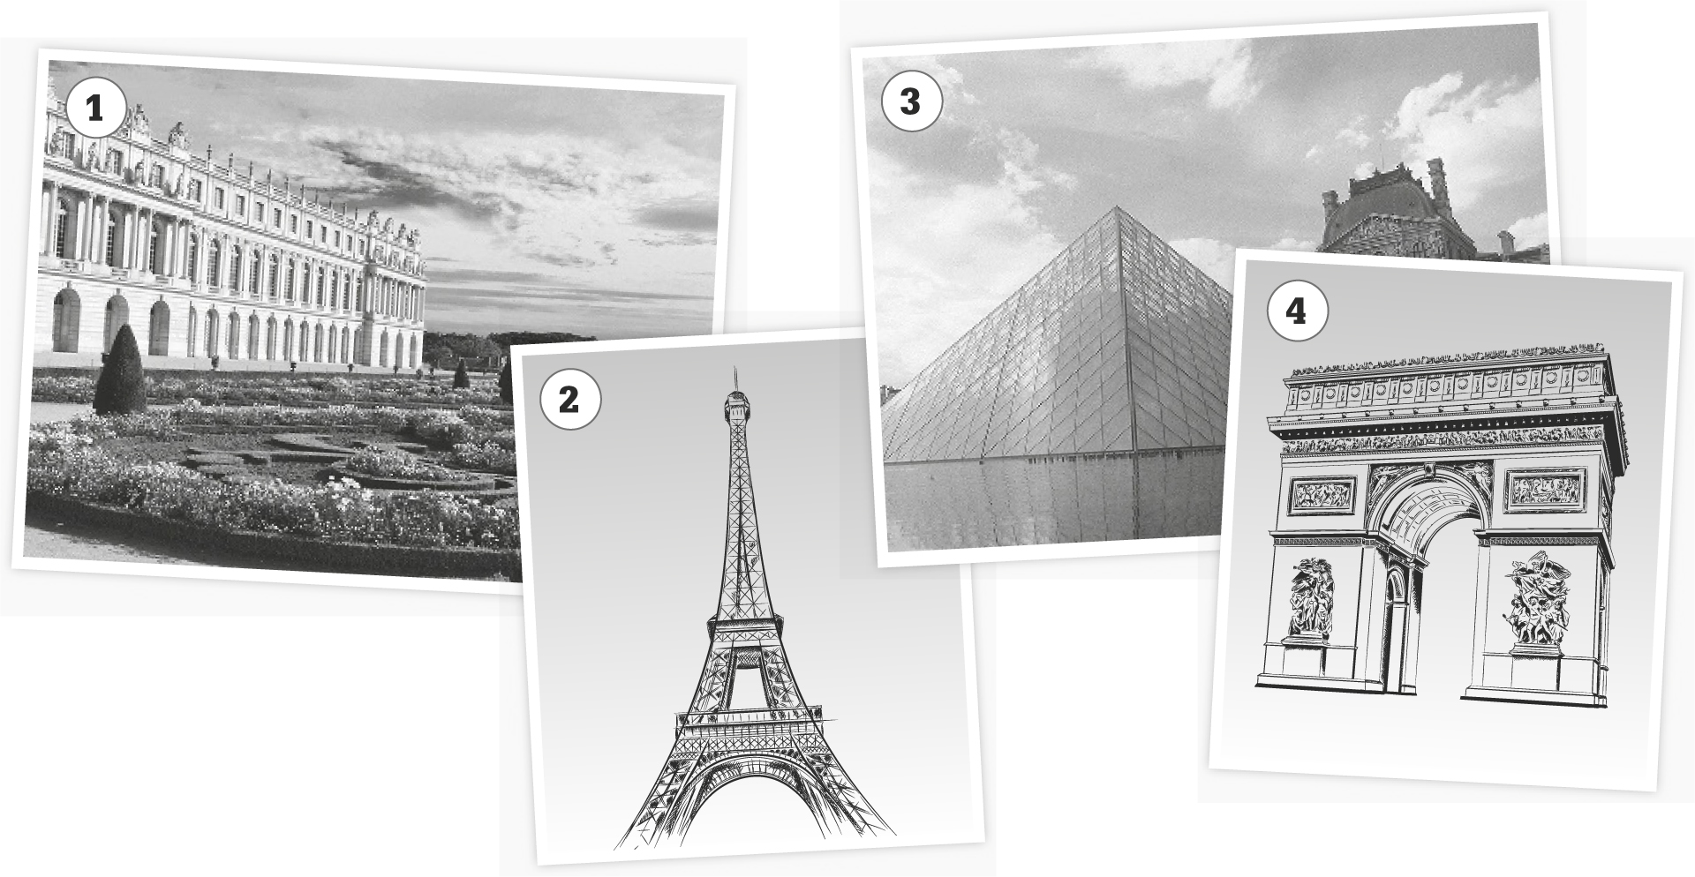

1 3

4

2

1.
2.
3.
4.

Swoosh · 8.˚ ano Evaluation tests

 10 Minutes

A. Choose the appropriate form of the Present Perfect.

1. Have you seen / Has you seen the news lately? Travelling is getting expensive.

2. Jane have studied / has studied French so that she can travel to France.
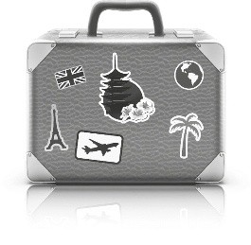

3. Peter have go / has gone to France. I don’t know if he has come back yet.

4. I haven’t visit / haven’t visited the Louvre yet.

B. Choose the appropriate expression.

1. Have you ever / for / yet been to Paris?

2. She has just / never / for gone up the Eiffel Tower before. It’s her first time today.

3. I haven’t seen her for / just / since May.

4. I’ve lived in Paris for / already / since almost 5 years.

C. Choose between the Past Simple or the Present Perfect.

1. He as a tour guide for 15 years. (a) worked (b) has worked

2. to France last year? (a) Did you go (b) Have you gone

3. I you lately! Are you ok? (a) didn’t see (b) haven’t seen

4. I many postcards last year. (a) bought (b) have bought

 35 Minutes

A. This is part of a letter you received from your French friend Jacques. Write him a letter answering his questions (30–50 words).



