Unit 5

Places to visit



Key for Schools

School: Name: Class: No.:
Date: / / Mark:
Enc. Educação: Teacher:



15 MINUTOS

A. You will hear five short conversations. For each conversation, circle the appropriate picture (A–C).

1. Which postcard did Sophie receive from her parents?

A B C
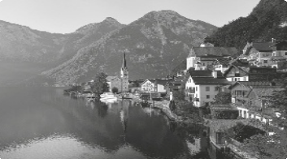

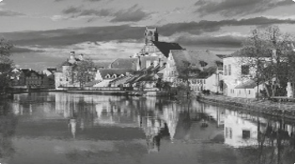

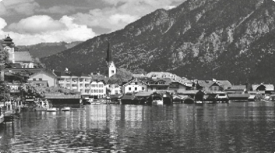

2. When will Jack go on holiday?

August
July
June

A B C

3. Where are Susan and Rachel going to meet each other?

A B C
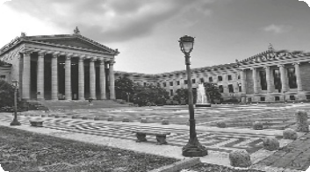

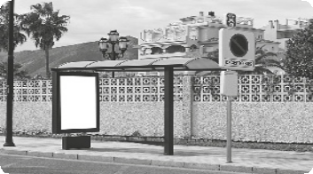

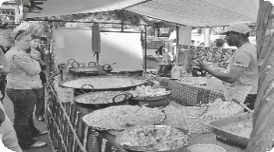

4. What time will the train to Manchester leave?

11:15
09:15
02:00


A B C

5. How will Peter travel to London?

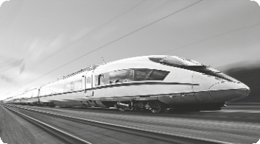





A B C

B. You will hear a tour guide talking with some tourists about Oporto, in Portugal.
Listen and complete the table.

Guide’s name Maria
TOUR GUIDE

Bank opens from 1.

Until 2.

Closed on 3.

Bus to city centre:

• Number 4.
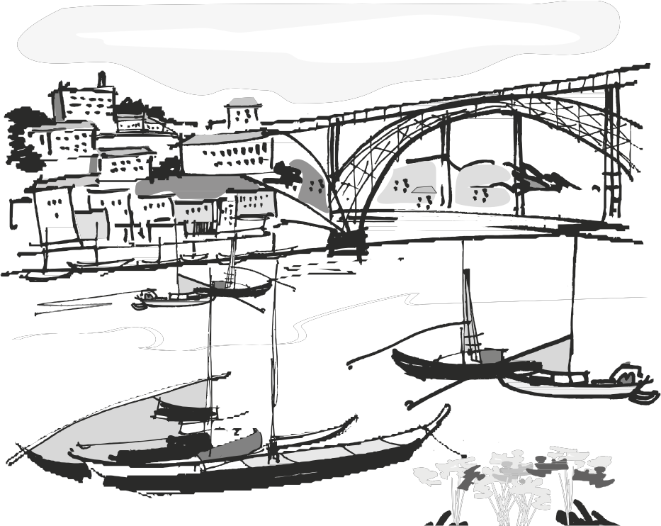

• Cost 5.

(Adapted from:
Cambridge Tests)

30 Minutes

A. Which notice (A–G) says the same as sentences 1–5? Write the correct letter in the corresponding box. Some are not necessary.

1. It’s not for adults.

2. We can help you day and night.

3. You can have lunch here.
A
4. Confirm the time the visit begins.
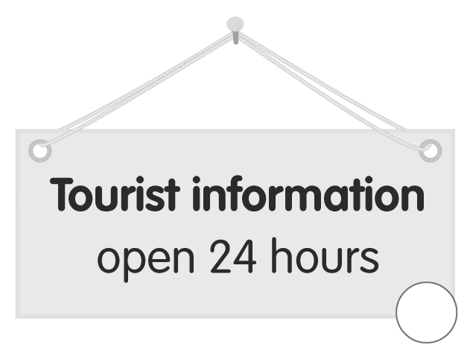
5. Come here to book a holiday.



YOUTH CAMPSITE Under 16s only
D

C
B

F


Tour starts in
LUNCH
10 minutes
E G G
G

B. Choose the appropriate reply for each of the following conversations.

1. We have just arrived from London. | A. It’s not here.  B. It’s enough.  C. Did you enjoy it?
2. I have to leave now. | A. It’s too early.  B. Where have you been?  C. How long was the trip?
3. Why didn’t you come to the museum yesterday? | A. I didn’t see them there.  B. It was a great day.  C. I had to do something.
4. Have you ever been to England? | A. That’s great.  B. Yes, I do.  C. Never.
5. How long did the journey take? | A. About 300 kilometres.  B. Almost two hours.  C. Last week.
(Adapted from: Cambridge Tests)

C. Read the sentences and choose the appropriate word for each space.

1. I shouldn’t have said that, sorry! I’d like to take it .
A. over B. back C. after D. off

2. Have you been to Scotland?
A. for B. since C. ever D. already

3. My father has worked in London two years. Now he is back.
A. for B. since C. ever D. already

4. Hurry up! The plane is about to take .
A. over B. back C. after D. off

5. Last year I to Scotland with my parents.
A. travel B. travelled C. have travelled D. am travelling

6. I’ve known Peter 2004.
A. since B. for C. ever D. already

7. Everybody says I take my father. We have the same eyes and ears.
A. over B. back C. after D. off

8. Sorry. I haven’t finished my homework , so I can’t go to the cinema.
A. never B. ever C. yet D. just

9. I really visiting the museums in town. They were so interesting!
A. wanted B. enjoyed C. saw D. entered

10. I was extremely because I learnt a lot in the tour.
A. interesting B. pleasant C. nice D. happy

D. Read this article about Couch Surfing and choose the appropriate word.



Thousands of people around the world (1) had / have / having a new hobby – Couch Surfing. In almost (2) all / some / every country, you will find people that enjoy hosting other people at their homes. “Couch Surfing is a cheap way of finding free accommodation and learning about a new culture,” (3) say / says / saying Trent Collins. It’s very easy and you can even travel (4) at / to / in groups. It’s the (5) best / better / good way to make new friends. Around the world (6) here / there / they are about 600.000 members.

When (7) has / is / did Couch Surfing begin? Casey Fenton states it started fourteen years (8) after / ago / since when he found a very cheap flight from Boston (9) of / at / to Iceland. He then emailed 1.500 students from the University of Iceland asking if he could stay. He received more (10) than / in / to 50 offers of accommodation. On the return flight to Boston, he began to develop the idea of the Couch Surfing project.

E. Read this article about Lino Pires.

LINO PIRES, A FAMOUS PORTUGUESE IN WARWICKSHIRE

Born near Castelo Branco, Lino Pires only emigrated to England in 1960 because his brother-in-law did not accept a proposition to finance the purchase of a café. In the UK, he found the opportunity to have a business of his own.
Lino Pires bought the local pub in Priors Hardwick, a small village in Warwickshire, in 1973 from a customer in a bar at two in the morning. He sealed the deal with a handshake and then asked where the pub was. When he arrived at the pub, he found a tavern, for just 10 or 12 guests. His wife was worried, but Lino Pires was confident. Over 20 extensions were built over the years. Some walls were constructed with old stone belonging to a church bought in ruins. The rooms are decorated with antiques from the region and also from Portugal. The tearoom is full of newspaper clippings, trophies, photographs and autographs.
In 40 years, the Butcher’s Arms has become famous in the region, receiving more people than the 100 who inhabit the village each day. At the weekend, the number reaches up to 500 per day. The food is described by Lino Pires as “pure”, with fresh ingredients and cooked to order, without resorting to shortcuts such as microwaves.
Lino Pires has a recipe to integrate Portuguese people coming to the UK: “Invite the English into your home. We can’t complain about the British being cold! We are the ones coming here and we have to make the effort to adjust to the English people. This has always been my philosophy and my wife’s too. She would bake a cake and invite a neighbour for coffee. That’s how we started to have as many friends here as
we do in Portugal.”
(Adapted from: www.portugalinuk.com)

Decide if the sentences are right (R) or wrong (W) according to the text.

1. Lino Pires travelled to England to look for a job opportunity.

2. The local pub he bought in Priors Hardwick in 1973 was very big.

3. His wife was confident when she saw the pub.

4. He rebuilt the pub into a bigger restaurant several times.

5. The name of the restaurant is the Butcher’s Arms.

6. The Butcher’s Arms is only famous in Priors Hardwick.

7. The pub is located in a village where more than 500 people live.

8. The secret of his food is using the microwave and fresh ingredients.

9. Lino Pires gives some advice to Portuguese people who want to emigrate to England.
10. Lino and his wife started to have many friends because they invited people to their home.

35 Minutes


A. Rewrite the sentences using the word given without changing the meaning.
Use between two and four words.

1. The last time I travelled abroad was three years ago. (for)

I haven’t three years.

2. It’s 2014 and I hadn’t been to England for three years. (since)

I haven’t 2011.

3. Mary went to Warwickshire last year. (ago)

Mary went to Warwickshire .

4. Lino is the most hardworking person I’ve ever seen. (never)

I have such a hardworking person before.

5. Mike joined the cooking club two years ago. (for)

Mike has been in the cooking .

B. Complete this letter. Write one word for each space.

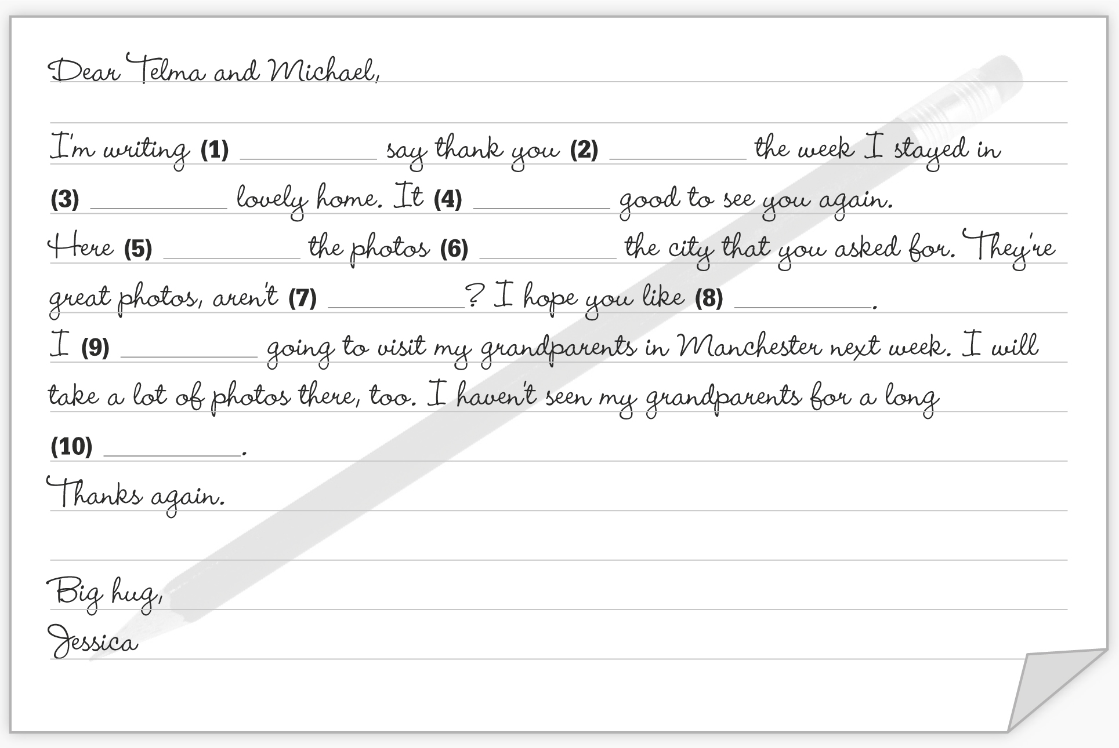

Dear Telma and Michael,

I’m writing (1) say thank you (2) the week I stayed in (3) lovely home. It (4) good to see you again. Here (5) the photos (6) the city that you asked for. They’re great photos, aren’t (7) ? I hope you like (8) . I (9) going to visit my grandparents in Manchester next week. I will take a lot of photos there, too. I haven’t seen my grandparents for a long (10) . Thanks again.

Big hug, Jessica

(Adapted from: Cambridge Tests)

C. Read Julie’s postcard. Write her a postcard answering her questions.

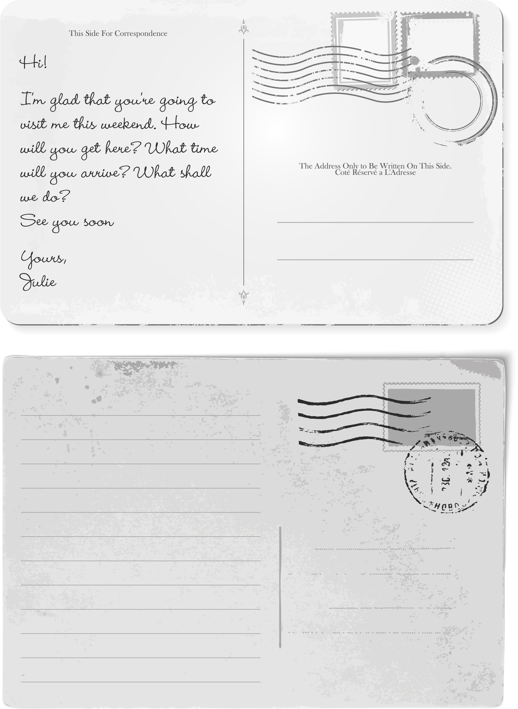

Hi!

I’m glad that you’re going to visit me this weekend. How will you get here? What time will you arrive? What shall we do?
See you soon

Yours, Julie

(Adapted from: Cambridge Tests)

